|  |  |
| --- | --- |
|  | **MINISTRY OF EDUCATION AND TRAINING** |

**FPT UNIVERSITY**

|  |  |
| --- | --- |
| Capstone Project Document | |
| **Scrap Collector** | |
| **Group 3 - JS** | |
| **Group members** | Nguyễn Duy Đạt – SE63093 (Leader)  Tiết Lê Bảo Khánh – SE62247  Nguyễn Hoàng Anh Trung – SE62282  Nguyễn Hoàng Nhân – SE63259 |
| **Supervisor** | Lại Đức Hùng |
| **Ext. Supervisor** | N/A |
| **Project Code** | SC |

– **Ho Chi Minh City, 13 January, 2020** –

**Table of contents**

A. Introduction 17

1. Project Information 17

2. Introduction 17

3. Current Situation 17

4. Problem Definition 17

5. Proposed Solution 18

5.1 Feature functions 18

5.2 Advantages and disadvantages 18

6. Functional Requirements 18

7. Role & Responsibility 19

B. Software Project Management Plan 19

1. Problem Definition 19

2. Project Organization 22

3. Project Management Plan 25

4. Coding Convention 25

C. Software Requirement Specification 26

1. User Requirement Specification 26

2. System Requirement Specification 27

3. Software System Attribute 88

4. Conceptual Diagram 89

D. Software Design Description 90

1. Design Overview 90

2. System Architectural Design 91

3. Component Diagram 92

4. Detailed Description 93

5. Interface 127

5.1 User Interface Design 127

5.1.1 Login 127

5.1.2 Menu Manager 128

5.1.3 Manage Staff 129

5.1.4 Manage Website 130

5.1.5 Menu Staff 131

5.1.6 Sitemap 133

5.1.7 Spelling test 134

5.1.8 Grammar test 135

5.1.9 Broken page test 136

5.1.10 Broken links test 137

5.1.11 Missing file test 138

5.1.12 Prohibited content test 139

5.1.13 Mobile layout test 140

5.1.14 Speed test 141

5.1.15 Javascript error test 143

5.1.16 Favicon test 144

5.1.17 Cookie test 145

5.1.18 Server behavior test 146

5.1.19 Contact detail test 147

5.1.20 Redrection test 148

5.1.21 Page test 149

6. Database Design 150

6.1. Entity relationship diagram (ERD) 150

6.2. Data Dictionary 151

7. Algorithms 157

E. System Implementation & Test 168

1. Introduction 168

2. Data Relationship Diagram 169

3. Test Plan 171

3.1. Features To Be Tested 171

3.2. Features Not To Be Tested 172

4. System Testing Test Case 172

F. Software User’s Manual 187

G. Appendix 201

**List of tables**

Table 1 - Role & Responsibility 14

Table 2 - Hardware Requirements for Server 17

Table 3 - Hardware requirement for PC 17

Table 4 - Software Requirement 18

Table 5 - Roles & Responsibilities Details 19

Table 6 - Tools and techniques 20

Table 7 <Guest> Login use case specification 23

Table 8 - <Guest> Test broken links use case specification 24

Table 9 - <Guest> Test missing file use case specification 26

Table 10 - <Staff> Determine specific pages to test use case specification 29

Table 11 - <Staff> View Sitemap use case specification 30

Table 12 - <Staff> View pages referencing to the specific page use case specification 32

Table 13 - <Staff> Test spelling use case specification 34

Table 14 - <Staff> Test Grammar use case specification 35

Table 15 - <Staff> Test prohibited for website's content use case specification 37

Table 16 - <Staff> Test broken links use case specification 38

Table 17 - <Staff> Test broken pages use case specification 40

Table 18 - <Staff> Test missing file use case specification 42

Table 19-<Staff> Test the mobile layout use case specification 43

Table 20 - <Staff> Measure the speed of each page use case specification 45

Table 21 - <Staff> Test JavaScript errors use case specification 46

Table 22- <Staff> Test favicon use case specification 48

Table 23 - <Staff> Test cookies use case specification 49

Table 24 - <Staff> Test server behavior use case specification 51

Table 25 - <Staff> Test contact details on the website use case specification 52

Table 26 - <Staff> View all pages that contain the contact defined use case specification 54

Table 27 - <Staff> Test redirection use case specification 55

Table 28 - <Staff> Test pages use case specification 57

Table 29 - <Staff> Create report use case specification 58

Table 30 <Staff> View history reports use case specification 60

Table 31 - <Manager> Build sitemap use case specification 62

Table 32 - <Manager> View sitemap use case specification 64

Table 33 - <Manager> View pages referencing on the specific page use case specification 65

Table 34 - <Manager> Add new website use case specification 67

Table 35 - <Manager> Delete website use case specification 68

Table 36 - <Manager> Create new staff use case specification 70

Table 37 - <Manager> Delete staff use case specification 71

Table 38 <Manager> Assign staff use case specification 72

Table 39 <Manager> Add new word website's dictionary use case specification 74

Table 40<Manager> Delete word website's dictionary use case specification 75

Table 41 <Manager> Add new warning word use case specification 77

Table 42 <Manager> Delete warning word use case specification 78

Table 43 <Manager> Edit warning word use case specification 80

Table 44 <Manager> View all reports use case specification 81

Table 45 Conceptual Diagram Data Dictionary 83

Table 46 Front End Component Diagram Dictionary 85

Table 47 Back End Component Diagram Dictionary 86

Table 48 Class Diagram Dictionary 89

Table 49<Class Diagram Attributes> Account 90

Table 50 <Class Diagram Methods> Account 90

Table 51 <Class Diagram Attributes> Role 90

Table 52<Class Diagram Methods> Role 90

Table 53<Class Diagram Attributes> Website 91

Table 54 <Class Diagram Methods> Website 91

Table 55 <Class Diagram Attributes> Dictionary 91

Table 56 <Class Diagram Methods> Dictionary 91

Table 57 <Class Diagram Attributes> Sitemap 92

Table 58 <Class Diagram Methods> Sitemap 92

Table 59 <Class Diagram Attributes> Warningword 92

Table 60 <Class Diagram Methods> Warningword 92

Table 61 <Class Diagram Attributes> Topic 93

Table 62 <Class Diagram Methods> Topic 93

Table 63 <Class Diagram Attributes> Page 93

Table 64 <Class Diagram Methods> Page 94

Table 65 <Class Diagram Attributes> Version 94

Table 66 <Class Diagram Attributes> GrammarReport 95

Table 67 <Class Diagram Attributes> SpellingReport 95

Table 68 <Class Diagram Methods> SpellingReport 95

Table 69 <Class Diagram Attributes> WarningWordReport 96

Table 70 <Class Diagram Attributes> PageReport 96

Table 71 <Class Diagram Attributes> ContactReport 97

Table 72 <Class Diagram Attributes> BrokenLinkReport 97

Table 73 <Class Diagram Attributes> RedirectionReport 97

Table 74 <Class Diagram Attributes> BrokenPageReport 98

Table 75 <Class Diagram Attributes> MissingFileReport 98

Table 76 <Class Diagram Attributes> FaviconReport 99

Table 77 <Class Diagram Attributes> SpeedReport 99

Table 78 <Class Diagram Attributes> JavascriptReport 99

Table 79<Class Diagram Attributes> MobileLayoutReport 100

Table 80<Class Diagram Attributes> CookieReport 100

Table 81<Class Diagram Attributes> ServerBehaviorReport 101

Table 82 <Fields> Login 120

Table 83 <Buttons/Hyperlinks> Login 120

Table 84 <Buttons/Hyperlinks> Menu Manage 121

Table 85 <Fields> Manage Staff 122

Table 86 <Buttons/Hyperlinks> Manage Staff 122

Table 87 <Fields> Manage Website 123

Table 88 <Buttons/Hyperlinks> Manage Website 124

Table 89 <Buttons/Hyperlinks> Menu Staff 126

Table 90 <Fields> Sitemap 127

Table 91 <Buttons/Hyperlinks> Sitemap 127

Table 92 <Fields> Spelling Test 127

Table 93 <Buttons/Hyperlinks> Grammar Test 128

Table 94 <Fields> Grammar Test 128

Table 95 <Buttons/Hyperlinks> Grammar Test 129

Table 96 <Fields> Broken Pages Test 129

Table 97 <Buttons/Hyperlinks> Broken Pages Test 130

Table 98 <Fields> Broken Links Test 130

Table 99 <Buttons/Hyperlinks> Broken Links Test 131

Table 100 <Fields> Missing File Test 132

Table 101 <Buttons/Hyperlinks> Missing File Test 132

Table 102 <Fields> Prohibited Content Test 133

Table 103 <Buttons/Hyperlinks> Prohibited Content Test 133

Table 104 <Fields> Mobile Layout Test 134

Table 105 <Buttons/Hyperlinks> Mobile Layout Test 134

Table 106 <Fields> Speed Test 135

Table 107 <Buttons/Hyperlinks> Speed Test 135

Table 108 <Fields> JavaScript Errors Test 136

Table 109 <Buttons/Hyperlinks> JavaScript Errors Test 136

Table 110 <Fields> Favicon Test 137

Table 111 <Buttons/Hyperlinks> Favicon Test 138

Table 112 <Fields> Cookie Test 138

Table 113 <Buttons/Hyperlinks> Cookie Test 139

Table 114 <Fields> Server Behavior 139

Table 115 <Buttons/Hyperlinks> Server Behavior 139

Table 116 <Fields> Contact Details 140

Table 117 <Buttons/Hyperlinks> Contact Details Test 141

Table 118 <Fields> Redirection Test 141

Table 119 <Buttons/Hyperlinks> Redirection Test 141

Table 120 <Fields> Page Test 142

Table 121 <Buttons/Hyperlinks> Page Test 142

Table 122 Entity Relationship Diagram Dictionary 145

Table 123 Physical Diagram Dictionary 164

Table 124 <Test case> Manage Page Option 166

Table 125<Test case> Broken Links Test 167

Table 126 <Test case> Broken Pages Test 168

Table 127 <Test case> Prohibited Content Test 169

Table 128 <Test case> Mobile Layout Test 169

Table 129 <Test case> Speed Test 170

Table 130 <Test case> Javascript Errors Test 171

Table 131 <Test case> Cookie Law Test 172

Table 132 <Test case> Server Behavior Test 173

Table 133 <Test case> Missing File Test 174

Table 134 <Test case> Favicon Test 175

Table 135 <Test case> Contact Details Test 176

Table 136 <Test case> Redirection Test 176

Table 137 <Test case> Pages Test 177

Table 138 <Test case> Spelling Test 178

Table 139 <Test case> Grammar Test 179

Table 140 - Hardware requirement for server 180

Table 141 - Software requirement for server 181

Table 142 - Add Staff Steps 183

Table 143 - Edit Staff Steps 183

Table 144 - Delete Staff Steps 184

Table 145 - Make new version Steps 185

Table 146 - View Sitemap Steps 185

Table 147 - Assign website steps 186

Table 148 - Add warning word steps 187

Table 149 - Edit warning word steps 189

Table 150 - Select website steps 189

Table 151 - Add page option steps 191

Table 152 - Rename or Delete page option steps 192

Table 153 - Do a test function steps 193

**List of Figures**

# Introduction

## Project Information

* Project name:  **Scrap Collector**
* Project Code: **SC**
* Product Type: **Mobile Application, Website Application**
* Start Date: **January 13rd, 2020**
* End Date: **--**

## Introduction

In this document, we introduce a new solution for those who are doing the job as collecting scraps. Scrap is understood as unusable materials such as iron, aluminum, plastic bottles, cans, etc… which can be recycled. Current job of the scrap collectors is to go around the place where they are living and ask if anybody has scrap to sell. That traditional way is such an inconvenient way for both the collector and the homeowner.

Based on our researches and analysis, we came to a solution for scrap collector and people who want to sell scrap in Viet Nam. We build a system which help the scrap collectors to find near-by scrap posted in the defined radius of 5km or 10km, and based on those location, we help the collector to find out the smartest way to go and collect all the scrap that they have dealt. Beside of that, we also provide a mobile application that help homeowner who want to sell scrap to post scrap and contact the collector easily.

## Current Situation

Now, there is no mobile application that helps both homeowner and collector to organize their work in a smarter way yet. Every day, the collector go around his/her living place to collect scrap, and the homeowner have to wait for the collector. Some large scrap collector service post their contact information onto websites, Facebook pages or E-commerce websites for those who want to sell scrap can contact. The homeowner can call and require the scrap collector service to go to their house or can bring their scrap to the address of that service.

## Problem Definition

Below are the disadvantages of the current situation:

* The collector spends all day outside but cannot find any scrap.
* The collector forgets to go to collect the scrap that has been dealt with the customer.
* The collector cannot optimize his/her routes.
* The homeowner has to wait for the scrap collector to pass by his/her house and call the collector.

## Proposed Solution

Building a mobile application known as a scrap collector helping system named “Scrap Collector”. It helps scrap collectors to enhance their productivity in daily work. The following workflow and features should be implemented:

### **5.1 Feature functions**

* Post scrap and request collector to pick-up
* Search for near-by scraps
* Book scrap
* Negotiate scrap price for better benefit
* Get a pick-up schedule that is optimized based on location and time
* Review collector
* User can contact to others through calling or chatting

### **5.2** **Advantages and disadvantages**

The advantages and disadvantages of the proposed solution:

* **Advantages**:
  + More effective way for the collector to collect scraps
  + The good interaction between the homeowner and the collector
  + Support the homeowner to sell scraps for further recycling instead of throwing scrap
  + Save time and effort for both homeowner and collector
* **Disadvantages**:
  + Only support for scrap collectors in Viet Nam
  + Not all scrap collector has smart phone to take advantage of this application

## Functional Requirements

Function requirements of the system are listed as below:

**6.1 Admin:**

* Admin can create, activate, de-activate or update account.
* Admin can create, activate, de-activate or update category of scrap.
* Admin can activate, de-activate or update scrap posted by customer.

**6.2 Collector:**

* Collector can find near-by scrap with defined radius.
* Collector can view detail of each scrap.
* Collector can contact with the owner customer of the scrap.
* Collector can negotiate the price of scrap with customer.
* Collector can view the list of dealt scrap.
* Collector can find the best route to go to collect scrap.
* Collector can update or de-active account.

**6.3 Homeowner**:

* Homeowner can post scrap for sale.
* Homeowner can contact the collector.
* Homeowner can negotiate price of scrap with collector.
* Homeowner can cancel, update status of posted scrap.
* Homeowner can review collector.
* Homeowner can update or de-activate account.

## Role & Responsibility

|  |  |  |  |  |
| --- | --- | --- | --- | --- |
| **No** | **Full Name** | **Role** | **Position** | **Contact** |
| 1 | Lại Đức Hùng | Project Manager | Supervisor | hungld5@fe.edu.vn |
| 2 | Nguyễn Duy Đạt | Developer | Leader | datndse63093@fpt.edu.vn |
| 3 | Tiết Lê Bảo Khánh | Developer | Member | khanhtlbse62247@fpt.edu.vn |
| 4 | Nguyễn Hoàng Anh Trung | Developer | Member | trungnhase62282@fpt.edu.vn |
| 5 | Nguyễn Hoàng Nhân | Developer | Member | nhannhse63259@fpt.edu.vn |

Table 1 - Role & Responsibility

# Software Project Management Plan

## Problem Definition

* 1. **Name of this Capstone Project**
* Official name: Scrap collector
* Vietnamese name: Ứng dụng hỗ trợ thu mua ve chai
* Abbreviation: SC
  1. **Problem Abstract**
* As current Vietnamese scrap collectors have to waste a lot of time to go around and find who has scrap to sell. This traditional way is ineffective, for example, the collectors don’t know exactly where to go, so they just go around and ask loudly for scrap, which takes their time, their force and harms to their health.
* This project is concern about implementing information technologies and mapping direction algorithms into scrap collectors’ daily work. We call it Scrap Collector Helper System (SC). SC provides the homeowner an easy way to post the scrap they want to sell with detail information and the recommended price. Besides that, SC also provides the collector a feature to find out near-by scrap, book scrap and contact with the homeowner. Moreover, SC helps the collector to save time and force by providing the optimized route to collect all booked scrap. Finally, SC gives homeowner chances to review the collector and those collector with good review will have priority in their work.
  1. **Project Overview**
     1. **Current Situation**

Below are the problems encountered in this project:

* Limit of time: our team has only 4 members and we have to get requirements, complete document, develop product and do the test in just 14 weeks.
* New technique and framework: when applying new framework into capstone project, all members of the team need an amount of time to get used to new techniques.
* Lack of User Interface and User Experience design skill: all team members are studying JS for major, no one has studied about UI and UX designing before.
* Misunderstanding in business logic: the business login of scrap collecting is quite strange with us, and all requirements are given by the mentor, who is not a scrap collector. Although we have observed many scrap collectors, there are still some misunderstood logic.
* Absence of team member: team members can have a conflict in meeting schedule because of sick, class timetable or work schedule, etc…
  + 1. **The Proposed System**

According to the technology researches, we found out that the Dijkstra's Algorithm (Dijkstra's Shortest Path First algorithm) is very capable of resolving the problem of collecting scrap. Because of its popularity and the high applicability, we decided to choose Dijkstra's Algorithm to use in application.

We also build a high available web server to maintain the main system to work 24/7 to make sure that if mobile applications have the need of accessing to the server to get or update the information there will always be available.

We assign responsibility in vertical to make sure if any member in this problem cannot continue to work in our team there will be the least harmful to the project processes.

Our system includes 2 main subsystems:

* An online website for the admins to help them manage user account, category and scrap post.
* A mobile application for homeowner and collector to sell and buy scrap.
  + - 1. **Web application**

Web application is common tool to help admin manage user, category and scrap post. This application is used by administrator team and do followings:

* + Web Manage user account
  + Manage scrap category
  + Manage posted scrap
    - 1. **Mobile application**

Mobile application is a tool to help homeowner and collector to sell and buy scrap. Mobile application provide following features:

* For homeowner:
  + Post Scrap for sale
  + Contact the collector
  + Manage scrap
  + Negotiate scrap price
  + Update information
* For collector:
  + Find near-by scrap
  + Book scrap
  + Contact the homeowner
  + Schedule scrap
  + Negotiate price
    1. **Boundaries of the System**

The system can:

* Allow Admin to manage user accounts .
* Allow Admin to manage list category of scrap.
* Allow Admin to manage scrap posted by homeowner.
* Allow Homeowner to post scrap for sale.
* Allow Homeowner to negotiate scrap price.
* Allow Homeowner to contact the collector.
* Allow Homeowner to review the collector.
* Allow Collector to find near-by scrap.
* Allow Collector to negotiate scrap price.
* Allow Collector to schedule a pickup.
* Allow Collector to contact the homeowner.

The system cannot:

* Help collector make payment online.
  + 1. **Future Plans**

If this application becomes widely used, the team intends to implement these following features:

* Improve security of system by strict validation and authorization filters
* Allow collector to make video call with homeowner to check scrap
* Connect with scrap factory to help collect large amount of scrap
* Widen the scale of application, distribute it to another countries like countries in ASIAN
  + 1. **Development environment**
       1. **Hardware requirements**

**For server**

|  |  |  |
| --- | --- | --- |
| **Hardware** | **Minimum Requirement** | **Recommended** |
| **Internet Connection** | Cable, Wi-Fi (8 Mbps) | Cable, Wi-Fi (50 Mbps or more) |
| **Operation System** | XP, Vista, 7, 10, Window Server 2008 | 10, Window server 2008 |
| **Computer Processor** | Intel® Xeon ® 1.4GHz | Intel® Xeon ® Quad Core (12M Cache, 2.50 GHz) |
| **Computer memory** | 4GB RAM | 32 GB RAM or more |
| **Storage space** | 1GB | 4GB or more |

Table 2 - Hardware Requirements for Server

**For PC**

|  |  |  |
| --- | --- | --- |
| **PC** | **Minimum Requirements** | **Recommended** |
| **Internet Connection** | Cable, Wi-Fi (4 Mbps) | Cable, Wi-Fi (8 Mbps) |
| **Operating System** | Window 7 | Window 7 or more. |
| **Computer Processor** | Intel® Core i3 1.4GHz | Intel® Core i5 2.50GHz |
| **Computer Memory** | 1GB RAM | 2GB RAM or more |
| **Web Browser** | Chromes (v42 or higher) | Chrome latest stable version |

Table 3 - Hardware requirement for PC

* + - 1. **Software requirement**

|  |  |  |
| --- | --- | --- |
| **Software** | **Name / Version** | **Description** |
| **Operation System** | Windows Server 2014 | Operating system and platform for development |
| **Environment** | Java EE 8.0, Node v10, npm v6, react-native v0.61 | Specification for developing web application |
| **Modeling tool** | StarUML | Used to design diagram |
| **IDE** | Visual Studio Code 1.27.2 | Programming tools |
| **DBMS** | PostgreSQL | Used to create & manage the database for system |
| **Source control** | GitHub, GitHub Desktop | Used for source control |
| **Web browser** | Chrome 69 or above | Testing browser |

Table 4 - Software Requirement

## Project Organization

* 1. **Software Process Model**

Our team has chosen to use Scrum model for developing this project. Scrum is one of the implementations of agile methodology. Scrum allows us to focus on delivering deliverables to the customer at the end of every sprint, each sprint lasts about two to three weeks. Below are reasons why our team chooses Scrum model:

* Our team has only 4 members, and tasks are considered to be assigned vertically, which means that each member has to take part in all steps from getting requirements, designing, implementing, testing and managing. So, Scrum is the most suitable model for a medium project like SC.
* User requirements are very difficult to be defined at the first time, and product owner may change requirement or extend scope. In Scrum model, team member can adapt to changes better.
* In the project there are many new technologies that need to be learned. With the Scrum model, the team can learn and develop in parallel to meet deadline.



Figure 1– Software process model

***Reference:***[*https://www.apeironsoftware.com/scrum-roles-artifacts-and-ceremonies/*](https://www.apeironsoftware.com/scrum-roles-artifacts-and-ceremonies/)

* 1. **Roles and responsibilities**

|  |  |  |  |
| --- | --- | --- | --- |
| **No** | **Full name** | **Role in Group** | **Responsibilities** |
| **1** | Lại Đức Hùng | Product Owner | * Specify user requirement * Control the development process * Give out technique and business analysis support |
| **2** | Nguyễn Duy Đạt | Scrum Master | * Managing process * Designing database * Clarifying requirements * Prepare documents * GUI Design * Create test plan * Coding * Testing * Arrange Meeting * Risk Management |
| **3** | Tiết Lê Bảo Khánh | Scrum team member | * Designing database * Clarifying requirements * Prepare documents * GUI Design * Create test plan * Coding * Testing |
| **4** | Nguyễn Hoàng Anh Trung | Scrum team member | * Designing database * Clarifying requirements * Prepare documents * GUI Design * Create test plan * Coding * Testing |
| **5** | Nguyễn Hoàng Nhân | Scrum team member | * Clarifying requirements * Prepare documents * GUI Design * Create test plan * Coding * Testing |

Table 5 - Roles & Responsibilities Details

* 1. **Tools and Techniques**

|  |  |
| --- | --- |
| Tool/Technique | Name |
| Front-end | HTML, CSS, JavaScript, jQuery, React, AngularJS |
| Back-end | JavaEE, SpringBoot framework, JPA, Hibernate |
| IDE | Visual Studio Code |
| DBMS | Firebase, PostgreSQL |
| Source Control | GitHub, GitHub Desktop |
| Modelling tool | StarUML |

Table 6 - Tools and techniques

## Project Management Plan

* + 1. **Product Backlog**
    2. **Sprint Backlog**
    3. **Deliverables**
    4. **All Meeting Minutes**

All sprint meeting minutes could be found here.

## Coding Convention

**Summary**:

* **Naming Convention**:
* Variable names should be short yet meaningful. The choice of a variable name should be designed to indicate to the casual observer the intent of its use.
* Methods should be verbs, in mixed case with the first letter lowercase, with the first letter of each internal word capitalized (Camel case).
* **Indentation**:
* One declaration per line is recommended since it encourages commenting.
* In absolutely no case should variables and functions be declared on the same line.
* Do not put different types on the same line.
* **Declarations Convention:**
  + One declaration per line is recommended since it encourages commenting.
  + Using Java Code Convention from:

<http://www.oracle.com/technetwork/java/codeconvtoc-136057.html>

* + Using Javascript Code Convention from:

<https://google.github.io/styleguide/jsguide.html>

# Software Requirement Specification

## User Requirement Specification

* 1. **Guest Requirement**

*Guest is a person who doesn’t have access to the system. To use all functions, guest must login. These are some functions guest can use:*

* Login.
* Register an account
  1. **Homeowner Requirement**

*Homeowner is an authorized user who has permission to login into the system. With homeowner role, user can use below functions:*

* Post scrap for sale
  1. **Collector Requirement**

*Collector is an authorized user has permission to login into the system under collector role, Collector can use below management functions:*

* Find near-by scrap posts
  1. **Admin Requirement**

*Admin is an authorized user has permission to login into the system under admin role, Admin can use below management functions:*

* Manage user account

## System Requirement Specification

* 1. **External Interface Requirement**
     1. **User Interface**
* GUI should be simple, clear, intuitive, and reminiscent.
* The interface design is an iterate process includes: design, sketching, prototyping, user assessment.
* The User Interface uses language is English.
  + 1. **Hardware Interface**
* Desktop PC.
  + 1. **Software Interface**
* Web application: work with browsers Firefox (v52 or higher), Chromes (v28 or higher), Internet Explorer (v10 or above) or with any web browser that supports HTML5 & CSS3.
  + 1. **Communication Protocol**

Use HTTP protocol 1.1 for communication between:

Web application and web server

* 1. **System Overview Use Case**

Figure 2 - System Overview Use Case

* 1. **List of use case**
     1. **<Guest> Overview Use Case**

Figure 3 - Guest Overview Use Case

* + - 1. **Login**

Figure 4 - <Guest> Login

Table 7 <Guest> Login use case specification

* + - 1. **Register**

Figure 5 - <Guest> Register

Table 8 - <Guest> Register use case specification

* + 1. **<Authourized User> Overview Use Case**
    2. **<Homeowner> Overview Use Case**

Figure 7 - Homeowner Overview Use Case

* + - 1. **Use case 1**
      2. **Use case 2**
    1. **<Collector> Overview Use Case**
    2. **<Admin> Overview Use Case**

## Software System Attribute

#### Usability

Website’s UI is fit for each browser on each device

* Font style: Arial, Sans-serif
* Font size: 12px -26px
* Color: green, black, red, white, blue, Light Slate Grey, Fuego, Honeysuckle…
* Background: White, Catalina Blue, Whisper…

#### 3.2 Reliability

* The information storing on the database is permanent.

#### Availability

* The system must be available at any time 24/7.

#### Security

* Only Administrator has fully access to the Admin Website.
* Input data is validated before saving to database.
* Each user logs in the system will receive a token for authorization.

#### Maintainability

* The system is divided into separated modules for easy maintain.

#### Portability

* Web application can be run on Chrome browser version 42 or later.

#### Performance

* System has successfully test with basic standard

## Conceptual Diagram

Figure 44 Conceptual Diagram

**Data Dictionary**

|  |  |
| --- | --- |
| **Entity Data dictionary: describe all content of all entities** | |
| **Entity Name** | **Description** |
| Authorized User | Abstract entity describes a user in system |
|  |  |
|  |  |
|  |  |
|  |  |
|  |  |
|  |  |
|  |  |
|  |  |

Table 45 Conceptual Diagram Data Dictionary

# Software Design Description

## Design Overview

- This document describes the technical and user interface design of MSSC System. It includes the architectural design, the detailed design of common functions and business functions and the design of database model.

- The architectural design describes the overall architecture of the system and the architecture of each main component and subsystem.

- The detailed design describes static and dynamic structure for each component and functions. It includes class diagrams, class explanations and sequence diagrams for each use cases.

- The database design describes the relationships between entities and details of each entity.

- Document overview:

Section 2: gives an overall description of the system architecture design.

Section 3: gives component diagrams that describe the connection and integration of the system.

Section 4: gives the detail design description which includes class diagram, class explanation, and sequence diagram to details the application functions.

Section 5: describe screens design.

Section 6: describe a fully attributed ERD.

Section 7: describe algorithms

## System Architectural Design

Figure 45 Software Architecture Design

## Component Diagram

Figure 46 Front End Component Diagram

|  |  |
| --- | --- |
| COMPONENT DICTIONARY: DESCRIBES COMPONENTS | |
| NodeJS |  |
| Router | Handle request and response, accept input and convert it to commands for back end. |
| Manager Component | Handle manager activities in the system |
| Staff Component | Handle staff activities in the system |
| Guest Component | Handle guest activities in the system |

Table 46 Front End Component Diagram Dictionary

Figure 47 Back End Component Diagram

|  |  |
| --- | --- |
| COMPONENT DICTIONARY: DESCRIBES COMPONENTS | |
| Rest API |  |
| Controller | Handle requests and responses; accept input and convert it to commands for model and view. |
| Bussiness Servies | Handle system’s business operations |
| Repository | Store Data |

Table 47 Back End Component Diagram Dictionary

## Detailed Description

* 1. **Class Diagram**

Figure 48 Class Diagram

* 1. **Class Diagram Explanation**

|  |  |  |
| --- | --- | --- |
| **CLASS DICTIONARY: DESCRIBE CLASS** | | |
| **Class Name** | **Mapping column with Conceptual diagram** | **Description** |
|  |  |  |
|  |  |  |
|  |  |  |
|  |  |  |
|  |  |  |
|  |  |  |
|  |  |  |
|  |  |  |
|  |  |  |
|  |  |  |
|  |  |  |
|  |  |  |
|  |  |  |
|  |  |  |
|  |  |  |
|  |  |  |
|  |  |  |
|  |  |  |
|  |  |  |
|  |  |  |
|  |  |  |
|  |  |  |
|  |  |  |
|  |  |  |

Table 48 Class Diagram Dictionary

* + 1. **Account**

|  |  |  |  |
| --- | --- | --- | --- |
| **Attribute** | **Type** | **Visibility** | **Description** |
| Id | String | Private | Unique identifier of an account |
| Username | String | Private | Account’s username |
| Password | String | Private | Account’s password |
| Fullname | String | Private | Account’s fullname |
| Address | String | Private | Account’s address |
| Position | String | Private | Account’s position |

Table 49<Class Diagram Attributes> Account

|  |  |  |  |
| --- | --- | --- | --- |
| **Method** | **Redirect Type** | **Visibility** | **Description** |
| doLogin | Object | Public | Login |
| isAuth | Object | Public | Authentication |
| getFullName | Object | Public | Get full name |
| getAllInformation | Object | Public | Get all information |
| editInformation | Object | Public | Edit information |

Table 50 <Class Diagram Methods> Account

* + 1. **Role**

|  |  |  |  |
| --- | --- | --- | --- |
| **Attribute** | **Type** | **Visibility** | **Description** |
| Id | Long | Private | Unique identifier of a role |
| Rolename | String | Private | Role’s name |

Table 51 <Class Diagram Attributes> Role

|  |  |  |  |
| --- | --- | --- | --- |
| **Method** | **Redirect Type** | **Visibility** | **Description** |
| addRole | boolean | Public | Add new role |
| deleteRole | boolean | Public | Delete role |

Table 52<Class Diagram Methods> Role

* + 1. **Website**

|  |  |  |  |
| --- | --- | --- | --- |
| **Attribute** | **Type** | **Visibility** | **Description** |
| Id | Long | Private | Unique identifier of a website |
| Name | String | Private | Website’s name |
| Url | String | Private | Website’s url |
| TimeCreated | Datetime | Private | Website’s time created |
| TimeModified | Datetime | Private | Website’s time modidfied |

Table 53<Class Diagram Attributes> Website

|  |  |  |  |
| --- | --- | --- | --- |
| **Method** | **Redirect Type** | **Visibility** | **Description** |
| generatePage | object | Public | Generate page |
| assignUser | object | Public | Assign user |
| updateSitemap | object | Public | Update sitemap |

Table 54 <Class Diagram Methods> Website

* + 1. **Dictionary**

|  |  |  |  |
| --- | --- | --- | --- |
| **Attribute** | **Type** | **Visibility** | **Description** |
| Id | Long | Private | Unique identifier of a word |
| Word | String | Private | Word |
| WordForm | Integer | Private | Word Form |
| Definition | String | Private | Word’s definition |

Table 55 <Class Diagram Attributes> Dictionary

|  |  |  |  |
| --- | --- | --- | --- |
| **Method** | **Redirect Type** | **Visibility** | **Description** |
| addWord | Void | Public | Add new word |
| editWord | Void | Public | Edit word |
| removeWord | Void | Public | Remove word |

Table 56 <Class Diagram Methods> Dictionary

* + 1. **Sitemap**

|  |  |  |  |
| --- | --- | --- | --- |
| **Attribute** | **Type** | **Visibility** | **Description** |
| Id | Long | Private | Unique identifier of a sitemap |
| Map | String | Private | Sitemap’s map |
| Urlmap | String | Private | Url root |
| TypeMap | Integer | Private | Type map |

Table 57 <Class Diagram Attributes> Sitemap

|  |  |  |  |
| --- | --- | --- | --- |
| **Method** | **Redirect Type** | **Visibility** | **Description** |
| buildSitemap | Void | Public | Build sitemap |
| getAllPage | List | Public | Get all page from sitemap |
| getInternalPages | List | Public | Get all interanl pages |

Table 58 <Class Diagram Methods> Sitemap

* + 1. **WarningWord**

|  |  |  |  |
| --- | --- | --- | --- |
| **Attribute** | **Type** | **Visibility** | **Description** |
| Id | Long | Private | Unique identifier of a warning word |
| Word | String | Private | Warning word |

Table 59 <Class Diagram Attributes> Warningword

|  |  |  |  |
| --- | --- | --- | --- |
| **Method** | **Redirect Type** | **Visibility** | **Description** |
| addWord | Boolean | Public | Add new warning word |
| editWord | Boolean | Public | Edit warning word |
| removeWord | Boolean | Public | Remove warning word |

Table 60 <Class Diagram Methods> Warningword

* + 1. **Topic**

|  |  |  |  |
| --- | --- | --- | --- |
| **Attribute** | **Type** | **Visibility** | **Description** |
| Id | Long | Private | Unique identifier of a topic |
| Name | String | Private | Topic’s name |
| Description | String | Private | Topic’s desription |

Table 61 <Class Diagram Attributes> Topic

|  |  |  |  |
| --- | --- | --- | --- |
| **Method** | **Redirect Type** | **Visibility** | **Description** |
| addTopic | boolean | Public | Add new topic |
| editTopic | boolean | Public | Edit topic |
| removeTopic | Boolean | Public | Remove topic |

Table 62 <Class Diagram Methods> Topic

* + 1. **Page**

|  |  |  |  |
| --- | --- | --- | --- |
| **Attribute** | **Type** | **Visibility** | **Description** |
| Id | Long | Private | Unique identifier of a page |
| Type | Integer | Private | Page’s name |
| Url | String | Private | Page’s url |

Table 63 <Class Diagram Attributes> Page

|  |  |  |  |
| --- | --- | --- | --- |
| **Method** | **Redirect Type** | **Visibility** | **Description** |
| Getter | Attribute Type | Public | Get attribute value |
| Setter | Void | Public | Set attribute value |
| removePage | Void | Public | Remove page |
| checkProhibited | List | Public | Check prohibited word in page |
| checkSpelling | List | Public | Check spelling word on page |
| checkGrammar | List | Public | Check grammar on page |
| checkBrokenLink | List | Public | Check broken link on page |
| checkBrokenPage | List | Public | Check broken page on page |
| checkMissingFile | List | Public | Check missing file on page |
| checkFavicon | List | Public | Check favion on page |
| checkSpeed | List | Public | Measure the speed of page |
| checkMobileLayout | List | Public | Check page’s mobile layout |
| checkJavascript | List | Public | Check javascript error on page |
| checkCookie | List | Public | Check cookie on page |
| checkServerBehavior | List | Public | Check Server Behavior |
| checkRedirection | List | Public | Check page’s redirection |
| checkContact | List | Public | Check contact detail on page |
| checkPage | List | Public | Check page information |

Table 64 <Class Diagram Methods> Page

* + 1. **Version**

|  |  |  |  |
| --- | --- | --- | --- |
| **Attribute** | **Type** | **Visibility** | **Description** |
| Id | Long | Private | Unique identifier of a version |
| Version | Integer | Private | Version |
| Time | Datetime | Private | Time created |

Table 65 <Class Diagram Attributes> Version

* + 1. **GrammarReport**

|  |  |  |  |
| --- | --- | --- | --- |
| **Attribute** | **Type** | **Visibility** | **Description** |
| Id | Long | Private | Unique identifier of a grammar report |
| FoundAt | Long | Private | Grammar error is found at position |
| Excerpt | String | Private | Grammar errors excerpt |
| AppereanceInfo | String | Private | Appereance info |
| Reason | String | Private | Grammar error reason |
| Solution | String | Private | Grammar error solution |
| UserCreated | Long | Private | Staff’s id created |
| TimeCreated | Datetime | Private | Time created |

Table 66 <Class Diagram Attributes> GrammarReport

* + 1. **SpellingReport**

|  |  |  |  |
| --- | --- | --- | --- |
| **Attribute** | **Type** | **Visibility** | **Description** |
| Id | Long | Private | Unique identifier of a spelling report |
| FoundAt | Long | Private | Spelling error is found at |
| WrongWord | String | Private | Wrong word |
| AppereanceInfo | String | Private | Appereance info |
| Reason | String | Private | Spelling error reason |
| Solution | String | Private | Spelling error solution |
| UserCreated | Long | Private | Staff’s id created |
| TimeCreated | Datetime | Private | Time created |

Table 67 <Class Diagram Attributes> SpellingReport

|  |  |  |  |
| --- | --- | --- | --- |
| **Method** | **Redirect Type** | **Visibility** | **Description** |
| addNewWord | boolean | Public | Add new word |

Table 68 <Class Diagram Methods> SpellingReport

* + 1. **WarningWordReport**

|  |  |  |  |
| --- | --- | --- | --- |
| **Attribute** | **Type** | **Visibility** | **Description** |
| Id | Long | Private | Unique identifier of a warning word report |
| Solution | String | Private | Warning word solution |
| AppereanceInfo | String | Private | Appereance info |
| FoundWordId | Long | Private | Found word id |
| UserCreated | Long | Private | Staff’s id created |
| TimeCreated | Datetime | Private | Time created |

Table 69 <Class Diagram Attributes> WarningWordReport

* + 1. **PageReport**

|  |  |  |  |
| --- | --- | --- | --- |
| **Attribute** | **Type** | **Visibility** | **Description** |
| Id | Long | Private | Unique identifier of a page report |
| Url | String | Private | Page’s url |
| CanonicalUrl | String | Private | Page’s canonical url |
| Tittle | String | Private | Page’s title |
| HTTP | Integer | Private | Page’s http code response |
| UserCreated | Long | Private | Staff’s id created |
| TimeCreated | Datetime | Private | Time created |

Table 70 <Class Diagram Attributes> PageReport

* + 1. **ContactReport**

|  |  |  |  |
| --- | --- | --- | --- |
| **Attribute** | **Type** | **Visibility** | **Description** |
| Id | Long | Private | Unique identifier of a contact detail report |
| ContactType | String | Private | Email or phone number |
| AppereanceInfo | String | Private | Page’s url has Contact detail |
| UserCreated | Long | Private | Staff’s id created |
| TimeCreated | Datetime | Private | Time created |

Table 71 <Class Diagram Attributes> ContactReport

* + 1. **BrokenLinkReport**

|  |  |  |  |
| --- | --- | --- | --- |
| **Attribute** | **Type** | **Visibility** | **Description** |
| Id | Long | Private | Unique identifier of a broken link report |
| Url | String | Private | Broken link’s url |
| Issue | String | Private | Broken link’s issue |
| UserCreated | Long | Private | Staff’s id created |
| TimeCreated | Datetime | Private | Time created |

Table 72 <Class Diagram Attributes> BrokenLinkReport

* + 1. **RedirectionReport**

|  |  |  |  |
| --- | --- | --- | --- |
| **Attribute** | **Type** | **Visibility** | **Description** |
| Id | Long | Private | Unique identifier of a redirectios report |
| Url | String | Private | Page’s url is redirection |
| RedirectTo | String | Private | url is redirected |
| HttpCode | Integer | Private | Http code response |
| UserCreated | Long | Private | Staff’s id created |
| TimeCreated | Datetime | Private | Time created |

Table 73 <Class Diagram Attributes> RedirectionReport

* + 1. **BrokenPageReport**

|  |  |  |  |
| --- | --- | --- | --- |
| **Attribute** | **Type** | **Visibility** | **Description** |
| Id | Long | Private | Unique identifier of a broken page report |
| Url | String | Private | Broken page’s url |
| Issue | String | Private | Broken page’s issue |
| UserCreated | Long | Private | Staff’s id created |
| TimeCreated | Datetime | Private | Time created |

Table 74 <Class Diagram Attributes> BrokenPageReport

* + 1. **MissingFileReport**

|  |  |  |  |
| --- | --- | --- | --- |
| **Attribute** | **Type** | **Visibility** | **Description** |
| Id | Long | Private | Unique identifier of a missing file report |
| FileLink | String | Private | File’s link |
| FileType | String | Private | File’s type |
| Url | String | Private | Page’s url has missing file |
| Issues | String | Private | Missing file issues |
| UserCreated | Long | Private | Staff’s id created |
| TimeCreated | Datetime | Private | Time created |

Table 75 <Class Diagram Attributes> MissingFileReport

* + 1. **FaviconReport**

|  |  |  |  |
| --- | --- | --- | --- |
| **Attribute** | **Type** | **Visibility** | **Description** |
| Id | Long | Private | Unique identifier of a favicon report |
| Issue | String | Private | File’s link |
| FiviconType | String | Private | Favicon’s type |
| UserCreated | Long | Private | Staff’s id created |
| TimeCreated | Datetime | Private | Time created |

Table 76 <Class Diagram Attributes> FaviconReport

* + 1. **SpeedReport**

|  |  |  |  |
| --- | --- | --- | --- |
| **Attribute** | **Type** | **Visibility** | **Description** |
| Id | Long | Private | Unique identifier of a speed report |
| LoadTime | Integer | Private | Time to load |
| InteractiveTime | Integer | Private | Time to interactive |
| PageLoadSize | Integer | Private | Page load size |
| UserCreated | Long | Private | Staff’s id created |
| TimeCreated | Datetime | Private | Time created |

Table 77 <Class Diagram Attributes> SpeedReport

* + 1. **JavascriptReport**

|  |  |  |  |
| --- | --- | --- | --- |
| **Attribute** | **Type** | **Visibility** | **Description** |
| Id | Long | Private | Unique identifier of a javascript error report |
| MessageInfo | String | Private | Javscript error message |
| AppereanceInfo | String | Private | Appereance info |
| UserCreated | Long | Private | Staff’s id created |
| TimeCreated | Datetime | Private | Time created |

Table 78 <Class Diagram Attributes> JavascriptReport

* + 1. **MobileLayoutReport**

|  |  |  |  |
| --- | --- | --- | --- |
| **Attribute** | **Type** | **Visibility** | **Description** |
| Id | Long | Private | Unique identifier of a mobile layout report |
| Issues | String | Private | Mobile layout issues |
| Suggestion | String | Private | Mobile layout suggestion |
| AppereanceInfo | String | Private | Appereance info |
| UserCreated | Long | Private | Staff’s id created |
| TimeCreated | Datetime | Private | Time created |

Table 79<Class Diagram Attributes> MobileLayoutReport

* + 1. **CookieReport**

|  |  |  |  |
| --- | --- | --- | --- |
| **Attribute** | **Type** | **Visibility** | **Description** |
| Id | Long | Private | Unique identifier of a cookie report |
| Name | String | Private | Cookie’s name |
| Category | String | Private | Cookie’s category |
| PartyName | String | Private | Party name has cookie |
| PurposeDescription | String | Private | Cookie’s purpose description |
| IsLegal | String | Private | Cookie is legal |
| UserCreated | Long | Private | Staff’s id created |
| TimeCreated | Datetime | Private | Time created |

Table 80<Class Diagram Attributes> CookieReport

* + 1. **ServerBehaviorRepot**

|  |  |  |  |
| --- | --- | --- | --- |
| **Attribute** | **Type** | **Visibility** | **Description** |
| Id | Long | Private | Unique identifier of a server behavior report |
| Issue | String | Private | Server behavior’s issue |
| Description | String | Private | Server behavior’s description |
| UserCreated | Long | Private | Staff’s id created |
| TimeCreated | Datetime | Private | Time created |

Table 81<Class Diagram Attributes> ServerBehaviorReport

* 1. **Interaction Diagram**
     1. **Login**

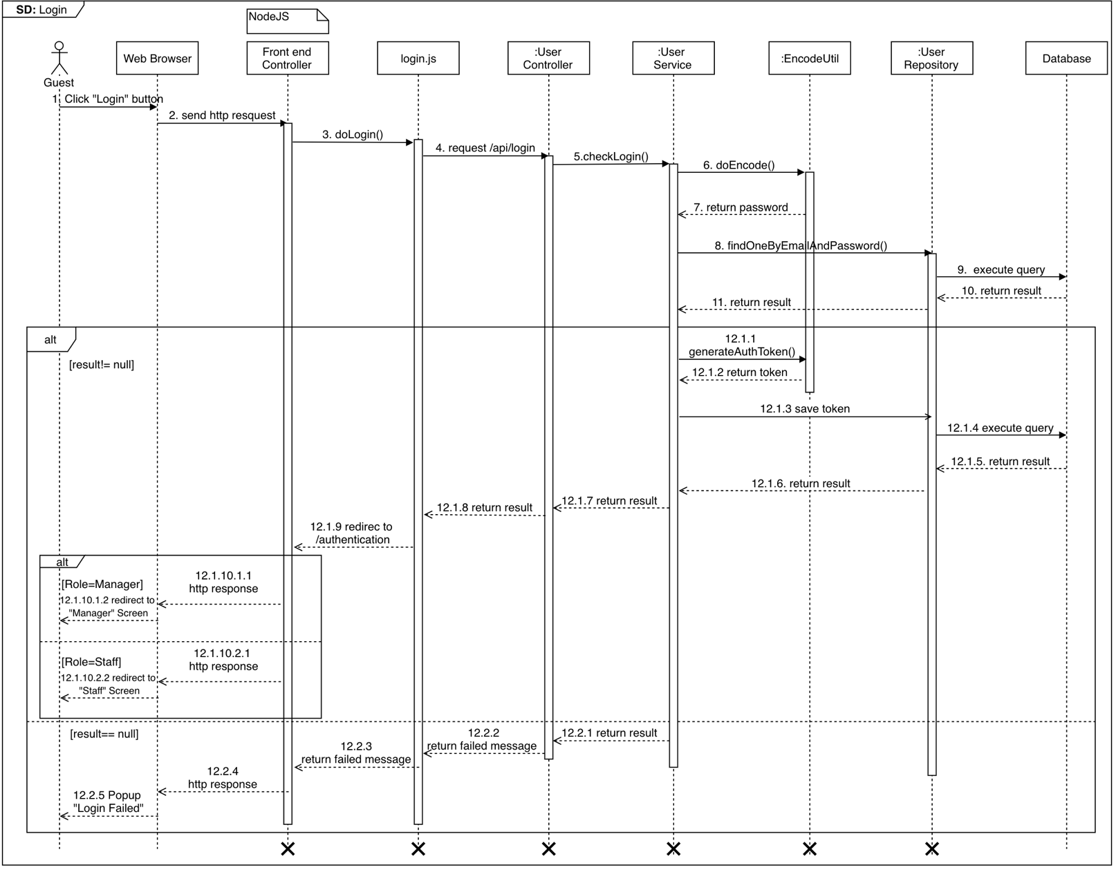

Figure 49 <Sequence Diagram> Guest Login

* + 1. **Test Pages**

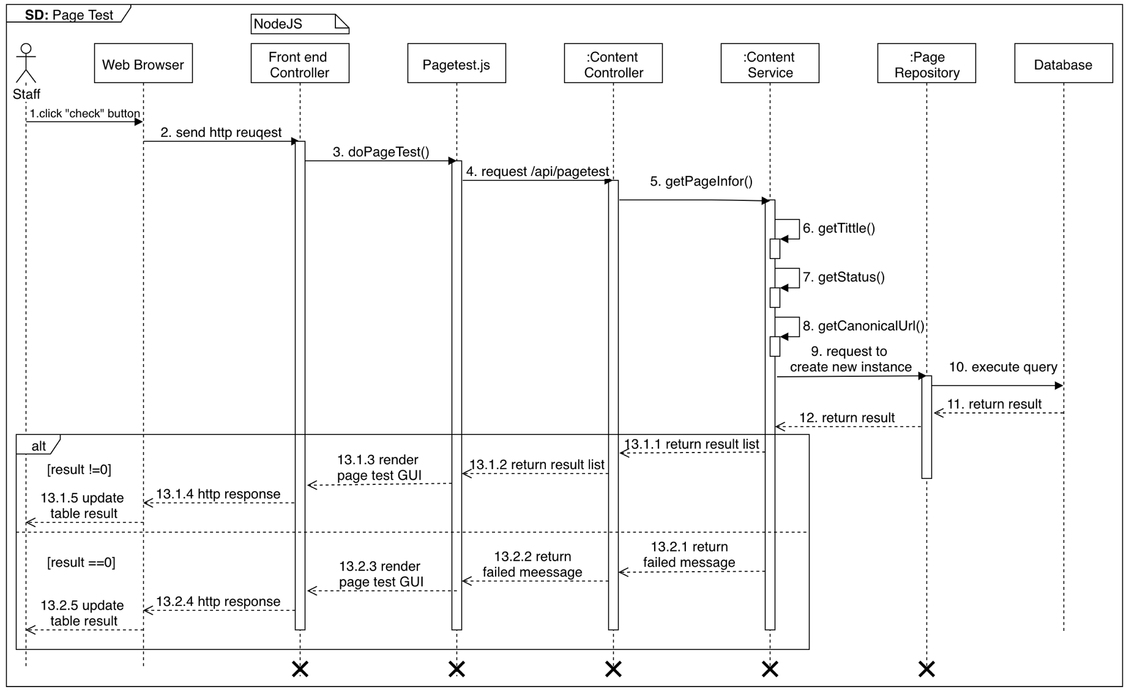

Figure 50 <Sequence Diagram> Staff Test Pages

* + 1. **Test Favicon**

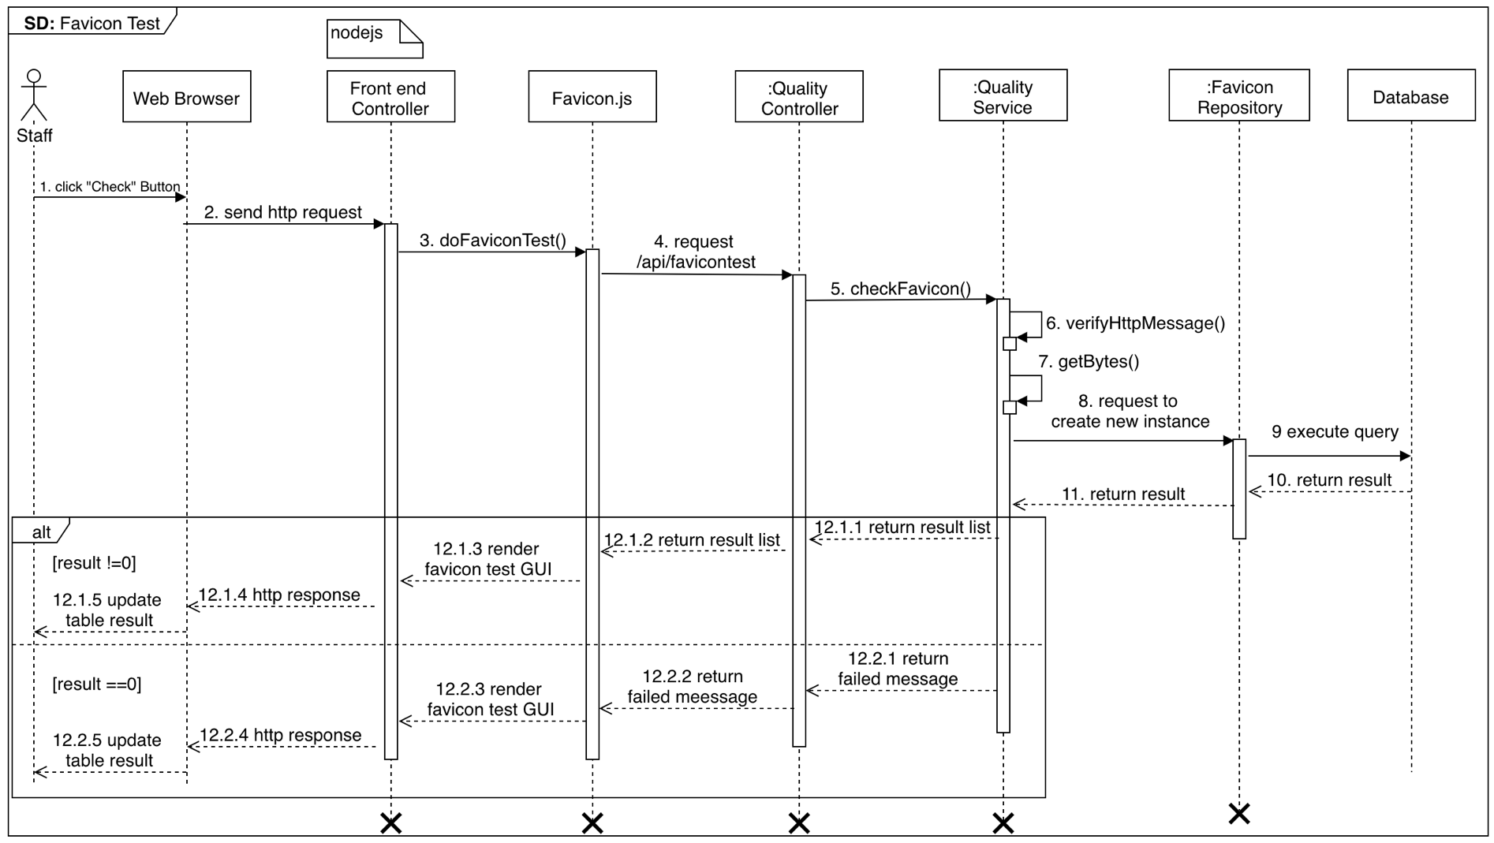

Figure 51 <Sequence Diagram> Staff Test Favicon

* + 1. 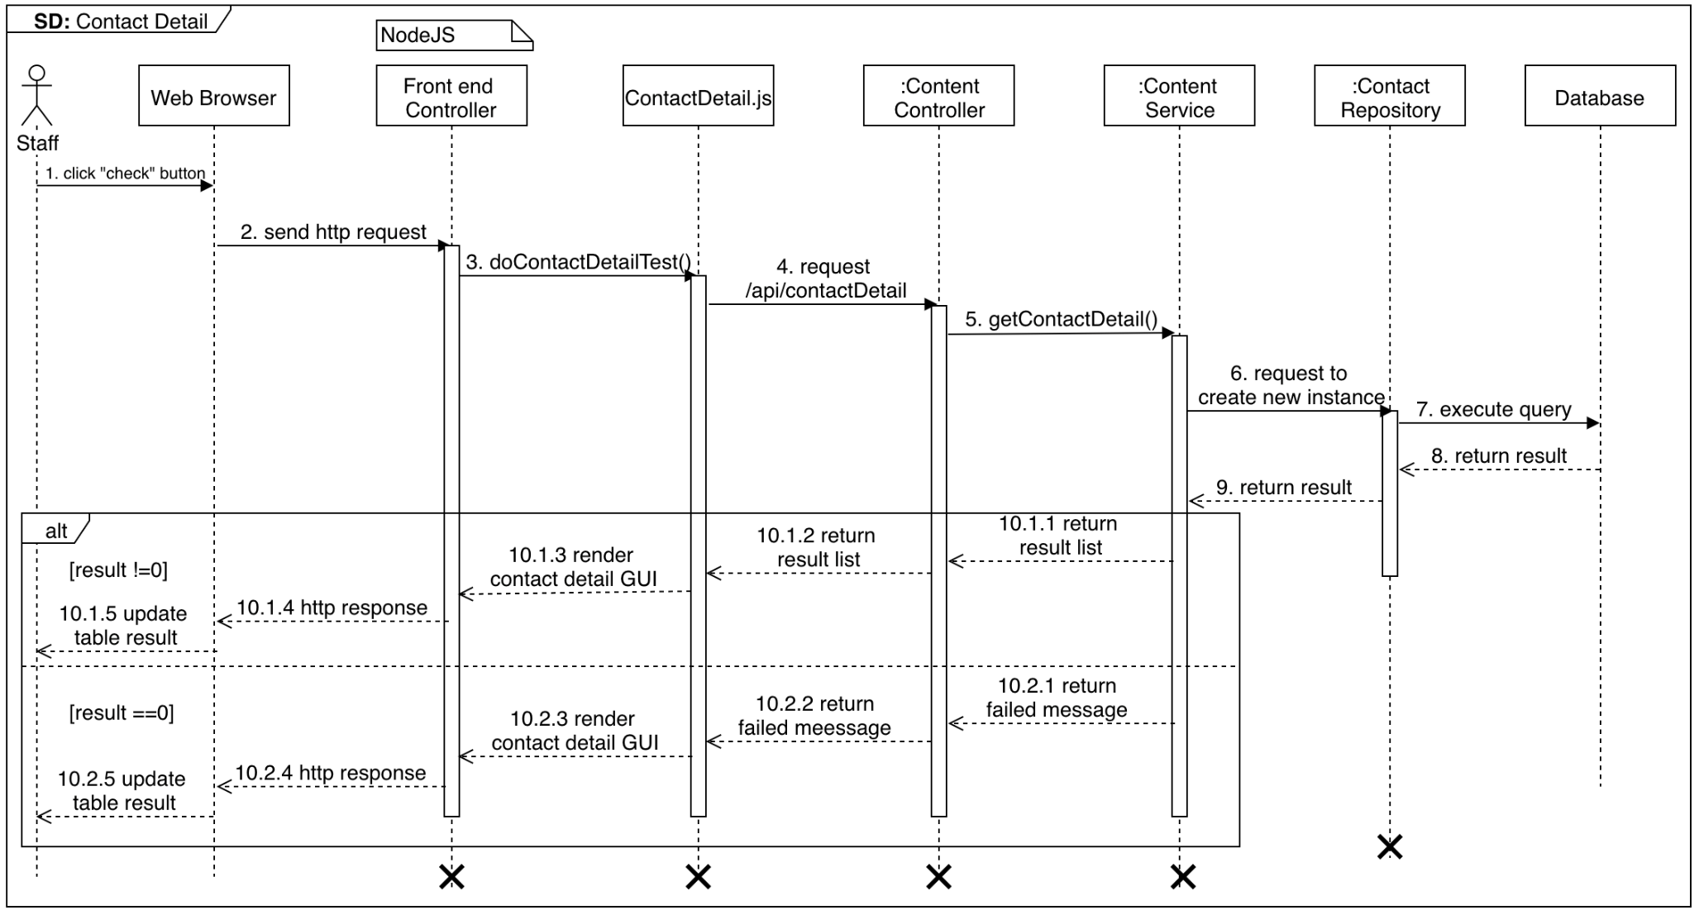**Test Contact Details**

Figure 52<Sequence Diagram> Staff Test Contact Details

* + 1. 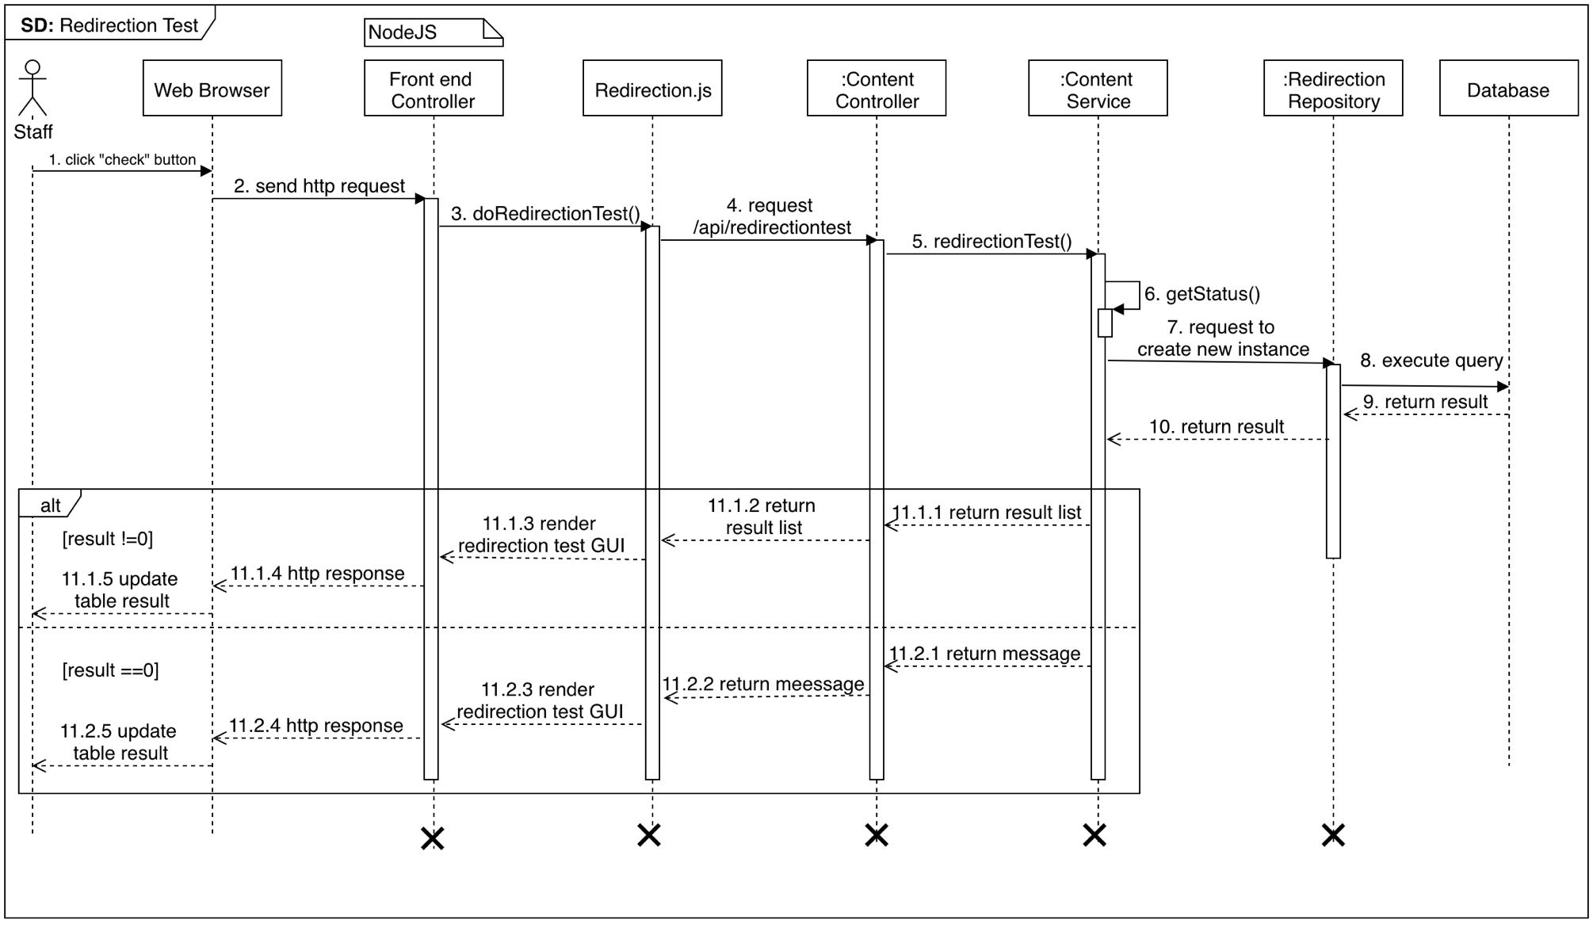**Test Redirection**

Figure 53 <Sequence Diagram> Staff Test Redirection

* + 1. 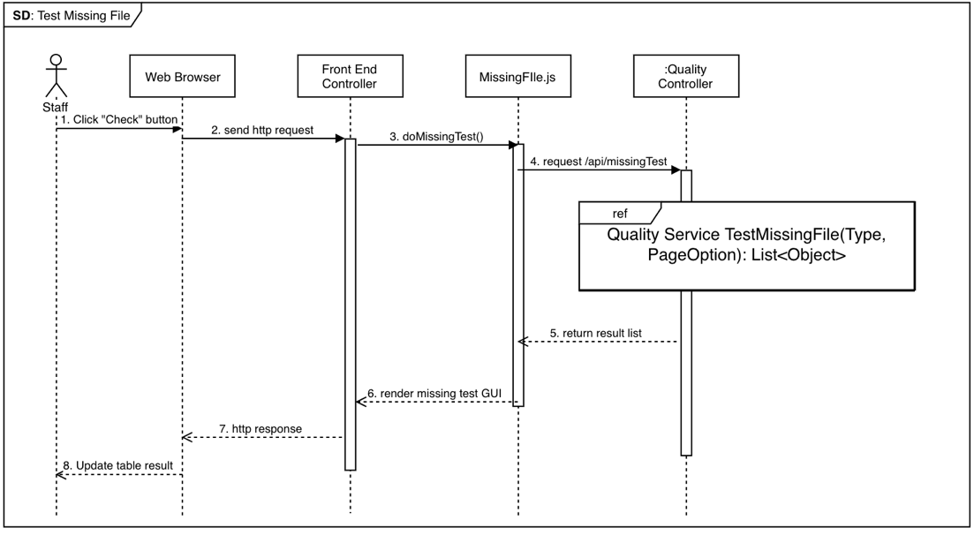**Test Missing File**

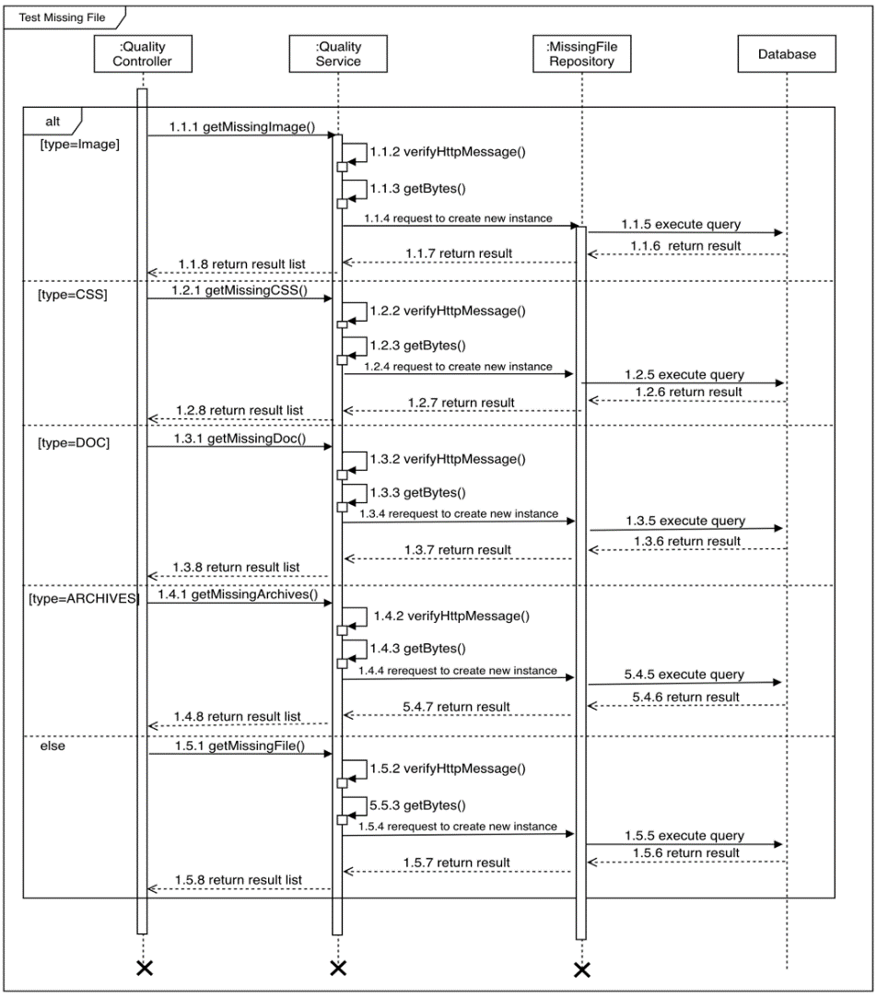

Figure 54 <Sequence Diagram> Staff Test Missing File

* + 1. **Build Sitemap**

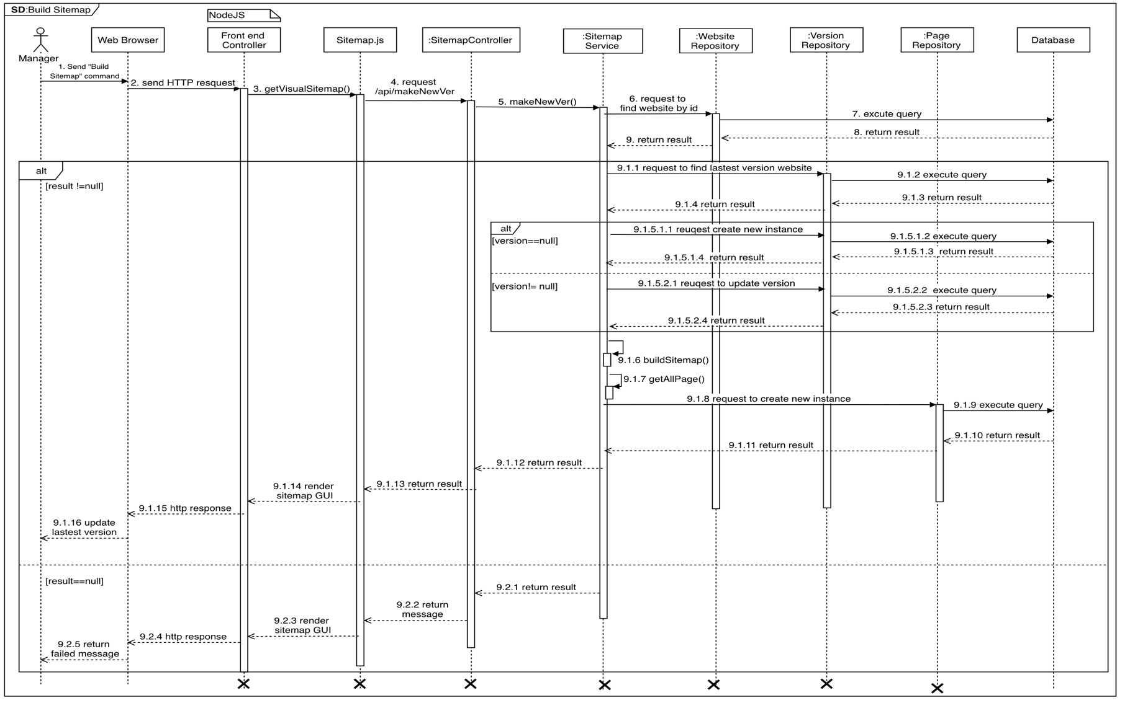

Figure 55 <Sequence Diagram> Manager Build Sitemap

* + 1. 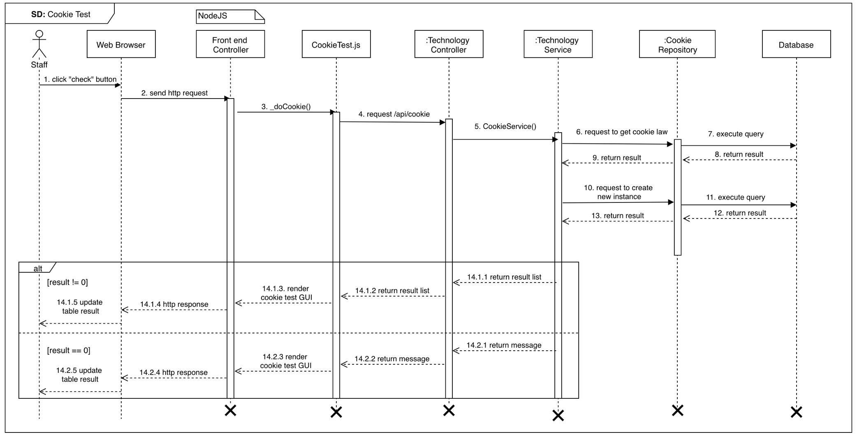**Test Cookie**

Figure 56 <Sequence Diagram> Staff Test Cookie

* + 1. **Test Broken Page**

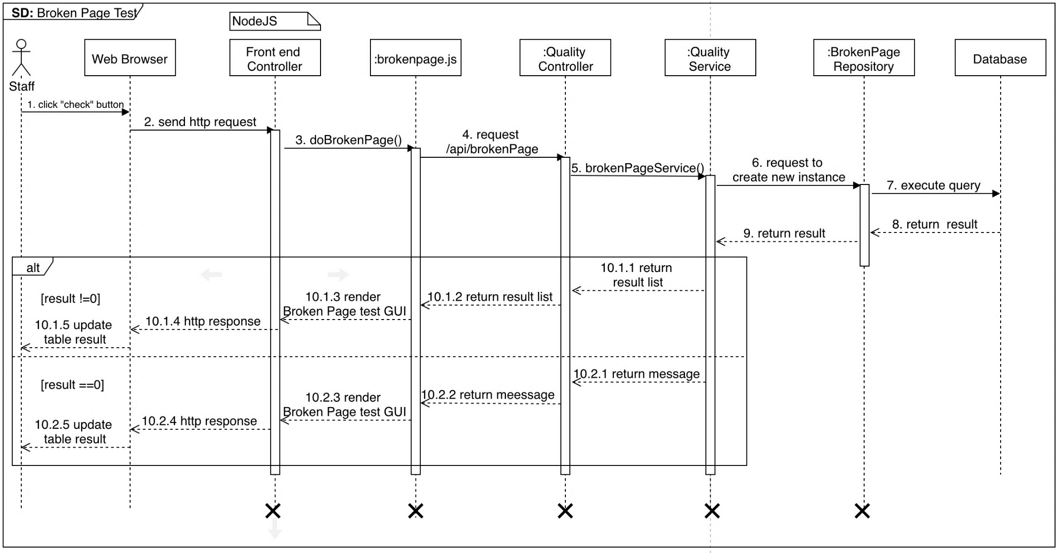

Figure 57 <Sequence Diagram> Staff Test Broken Pages

* + 1. 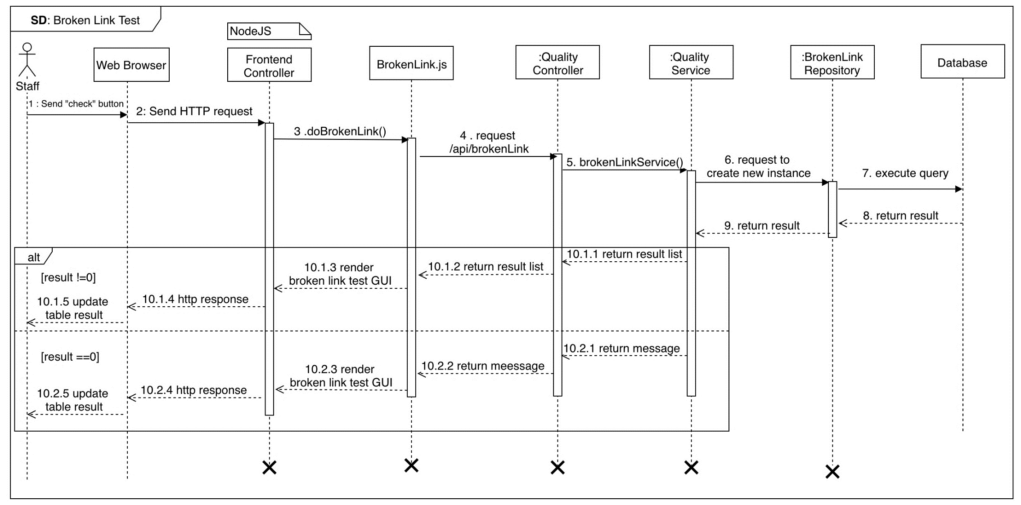**Test Broken Links**

Figure 58 <Sequence Diagram> Staff Test Broken Links

* + 1. **Test Mobile Layout**

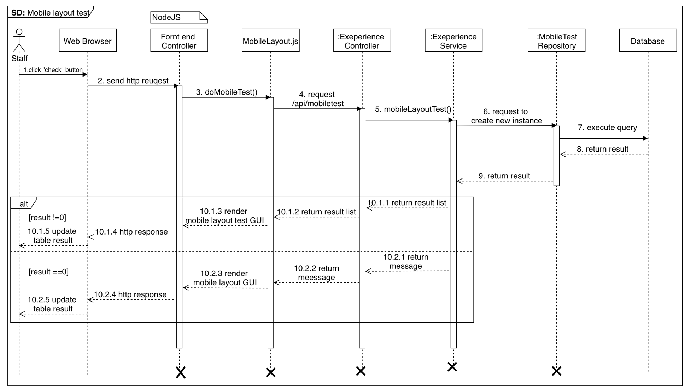

Figure 59 <Sequence Diagram> Staff Test Mobile Layout

* + 1. **Test Javascript errors**

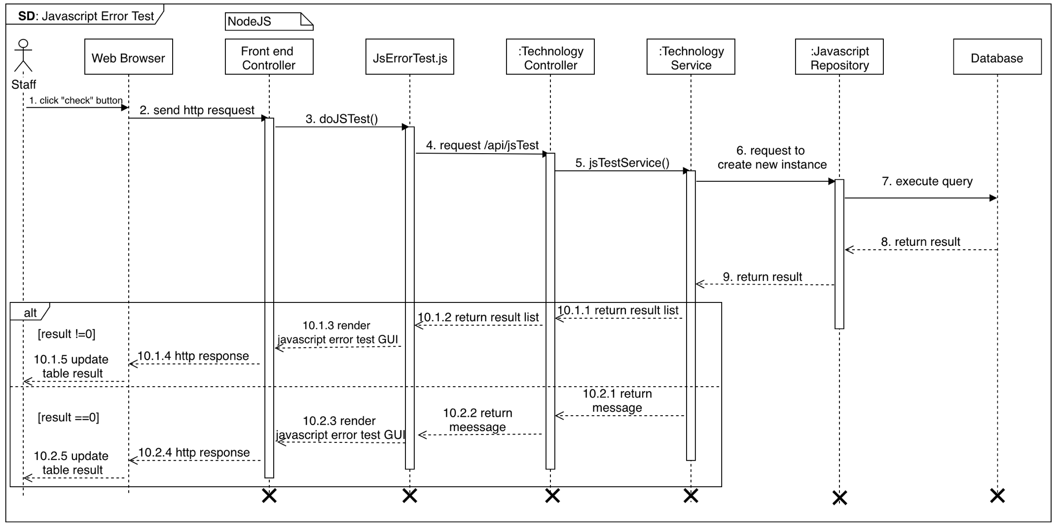

Figure 60 <Sequence Diagram> Staff Test Javascript Errors

* + 1. **Prohibited test**

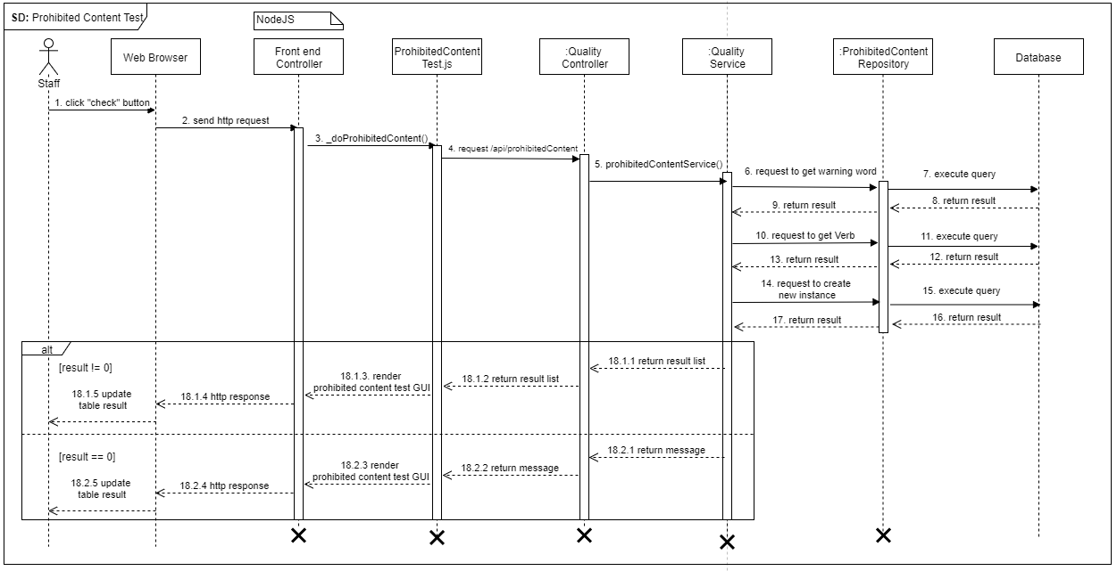

Figure 61 <Sequence Diagram> Staff Test Prohibited

* + 1. 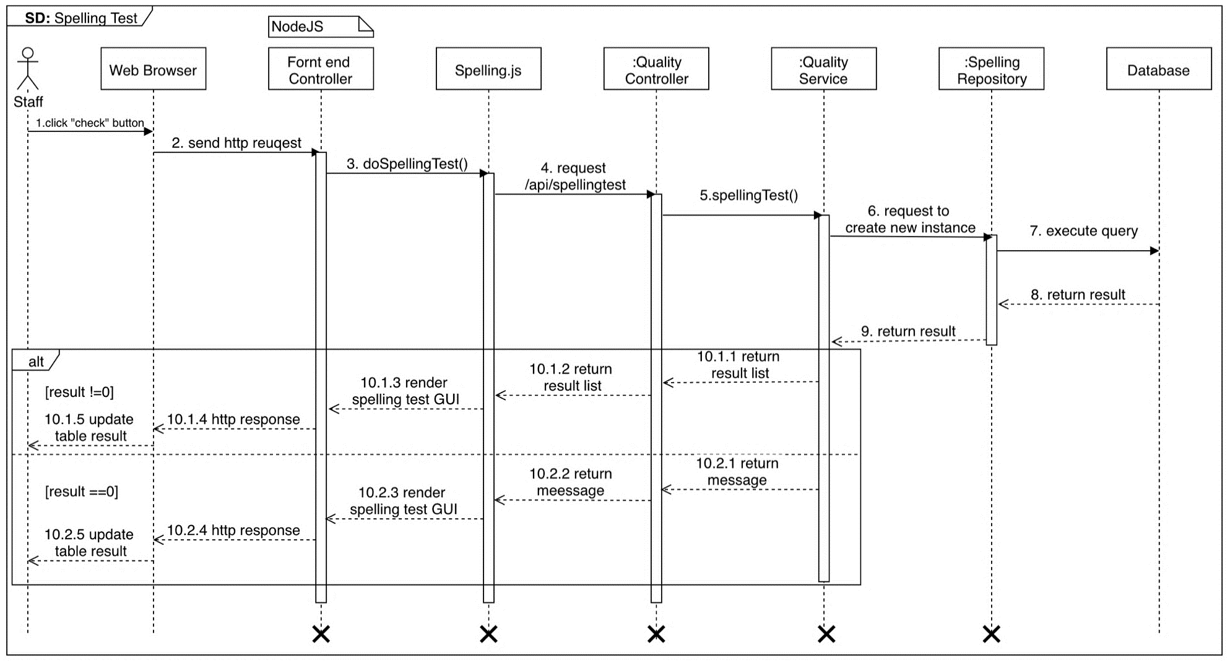**Spelling test**

Figure 62 <Sequence Diagram> Staff Test Spelling

* + 1. **Grammar Test**

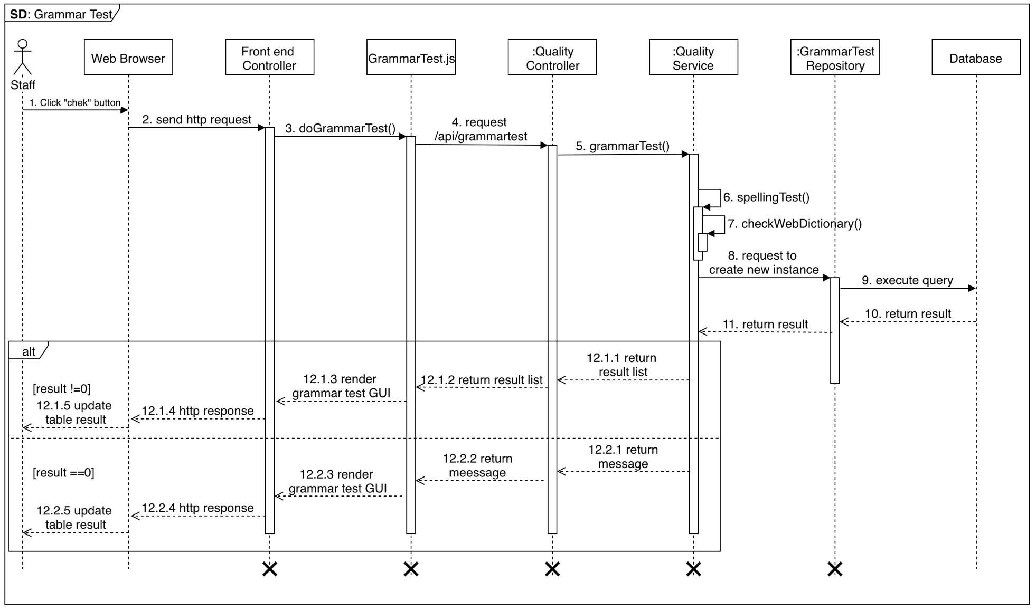

Figure 63 <Sequence Diagram> Staff Test Grammar

* + 1. **Test Server behavior**

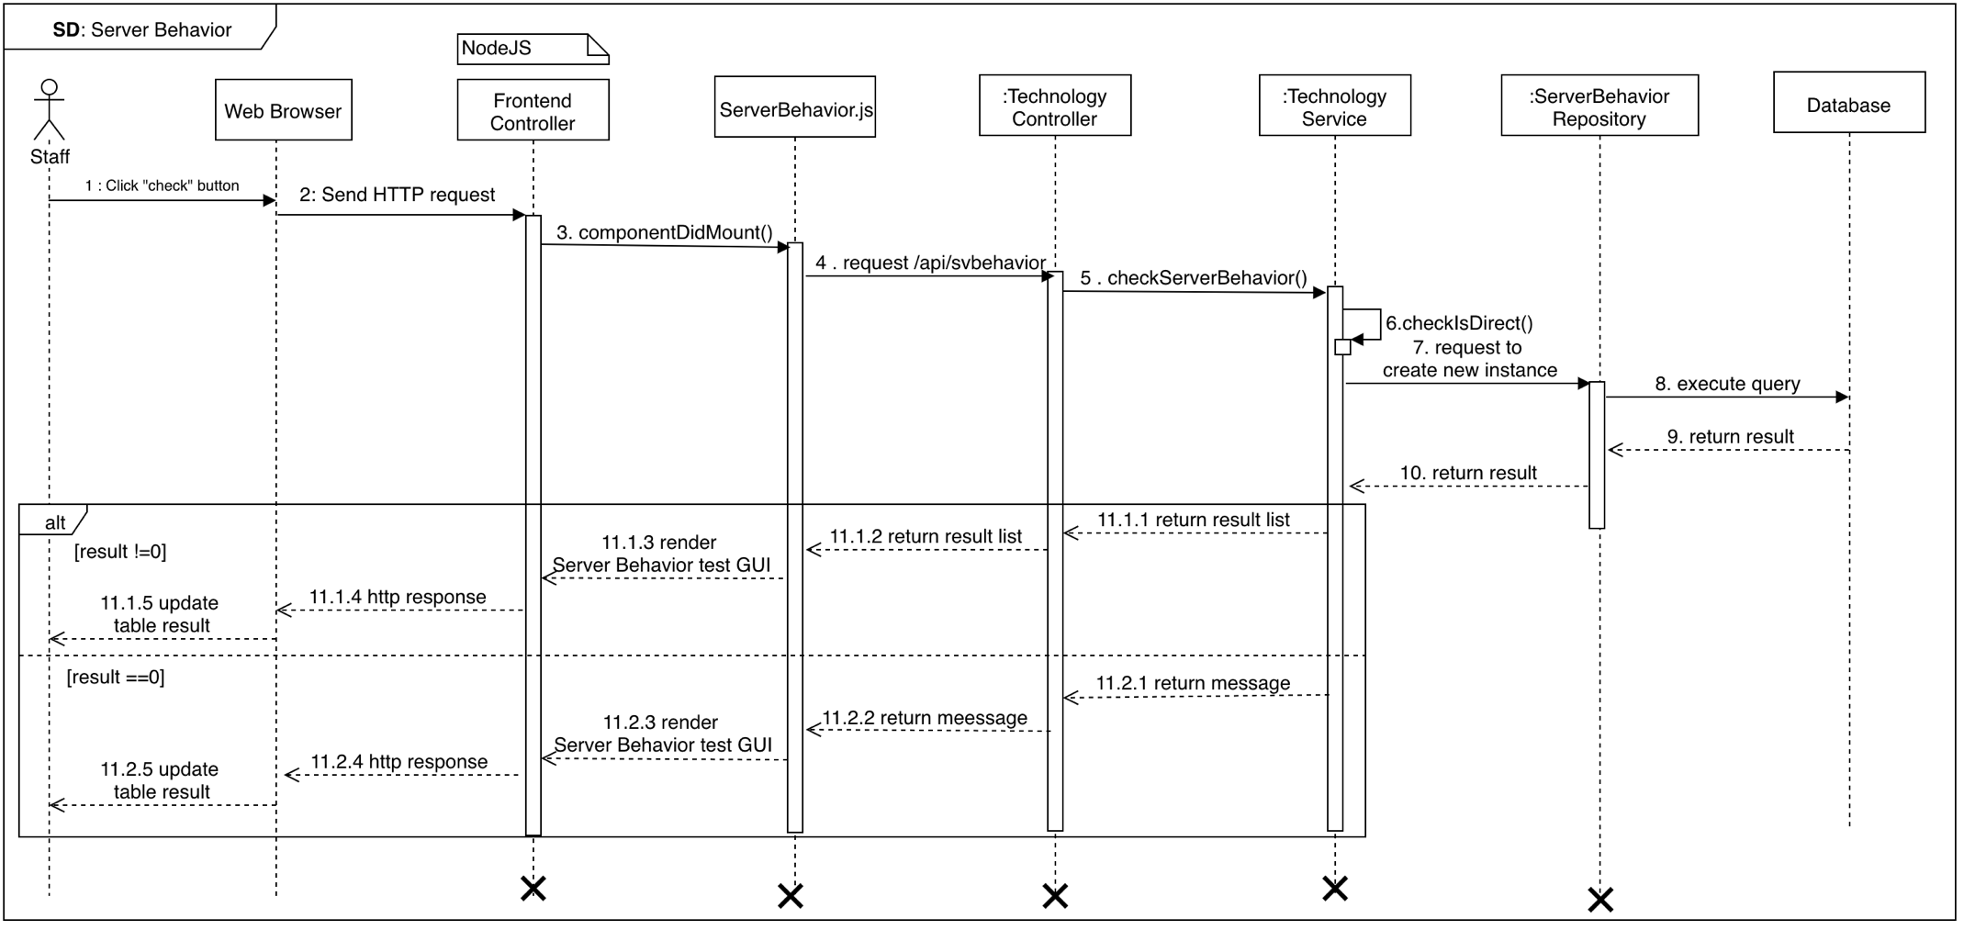

Figure 64 <Sequence Diagram> Staff Test Server Behavior

* + 1. **Measure the speed test**

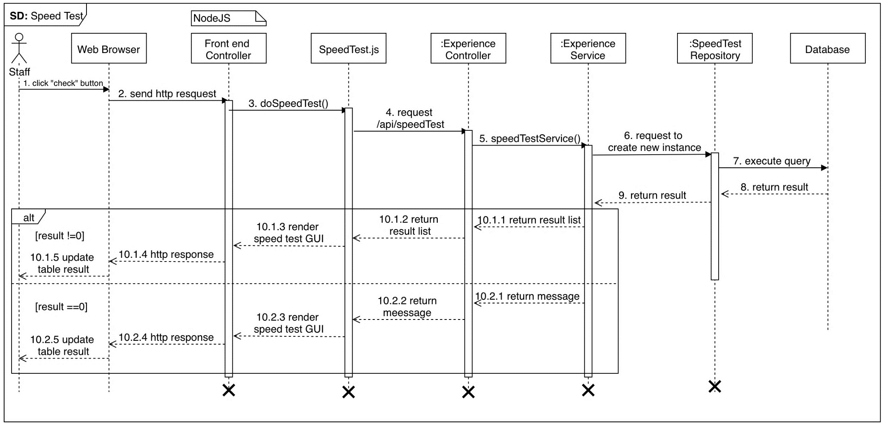

Figure 65 <Sequence Diagram>Staffmeasure the speed test

## Interface

## User Interface Design

## Login

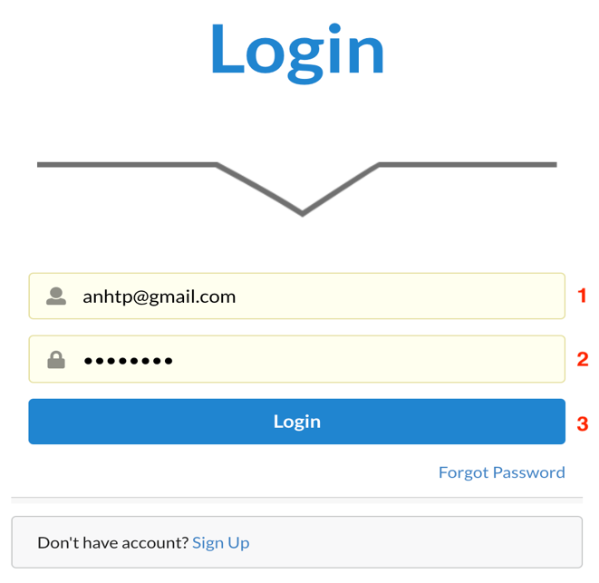

Figure 66 Login

**Fields**

|  |  |  |  |  |  |  |
| --- | --- | --- | --- | --- | --- | --- |
| **No** | **Field Name** | **Description** | **Read only** | **Mandatory** | **Control Type** | **Data Type** |
| 1 | Useranme | Username to login | No | Yes | TextBox | String |
| 2 | Password | Password to login | No | Yes | TexBox | String |

Table 82 <Fields> Login

**Buttons/Hyperlinks:**

|  |  |  |  |  |
| --- | --- | --- | --- | --- |
| **No** | **Function** | **Description** | **Validation** | **Outcome** |
| 3 | Login | Login into the system | Required | Transfer to Dashboard |

Table 83 <Buttons/Hyperlinks> Login

## Menu Manager

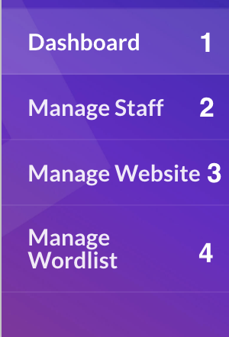

Figure 67 Menu Manager

**Buttons/Hyperlinks:**

|  |  |  |  |  |
| --- | --- | --- | --- | --- |
| **No** | **Function** | **Description** | **Validation** | **Outcome** |
| 1 | Dashboard | Dashboard | User must had been authorized. | Redirect to dashboard |
| 2 | Manage Staff | Manage staff | User must have one of these roles: Manager | Redirect to manage staff page |
| 3 | Manage Website | Manage website | User must have one of these roles: Manager | Redirect to manage website page |
| 4 | Manage Wordlist | Manage wordlist | User must have one of these roles: Manager | Redirect to manage word list page |

Table 84 <Buttons/Hyperlinks> Menu Manage

## Manage Staff

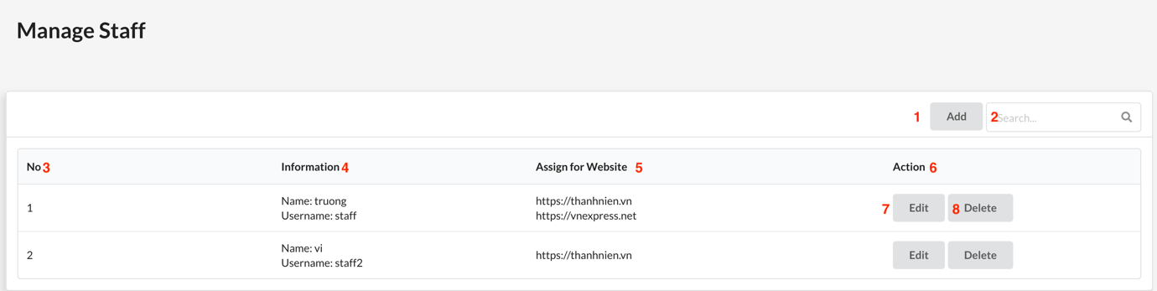

Figure 68 Manage Staff

**Fields**

|  |  |  |  |  |  |  |
| --- | --- | --- | --- | --- | --- | --- |
| **No** | **Field Name** | **Description** | **Read only** | **Mandatory** | **Control Type** | **Data Type** |
| 2 | Search | Search field | No | Yes | TextBox | String |
| 3 | No | Staff’s id | Yes | Yes | Text | String |
| 4 | Information | Staff’s information | Yes | Yes | Text | String |
| 5 | Assign for website | Staff assigned website | Yes | Yes | Text | String |

Table 85 <Fields> Manage Staff

**Buttons/Hyperlinks:**

|  |  |  |  |  |
| --- | --- | --- | --- | --- |
| **No** | **Function** | **Description** | **Validation** | **Outcome** |
| 1 | Add | Add new staff | N/A | Navigate to create staff page |
| 7 | Edit | Edit staff | N/A | Navigate to edit staff page |
| 8 | Delete | Delete staff | N/A | Delete staff  Reload table |

Table 86 <Buttons/Hyperlinks> Manage Staff

## Manage Website

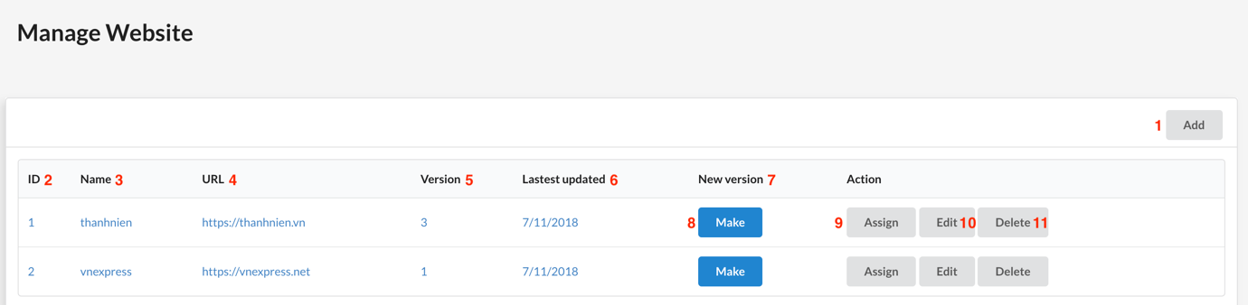

Figure 69 Manage Website

**Fields**

|  |  |  |  |  |  |  |
| --- | --- | --- | --- | --- | --- | --- |
| **No** | **Field Name** | **Description** | **Read only** | **Mandatory** | **Control Type** | **Data Type** |
| 2 | Id | Website id | Yes | Yes | Text | String |
| 3 | Name | Website name | Yes | Yes | Text | String |
| 4 | URL | Website URL | Yes | Yes | Text | String |
| 5 | Version | Website sitemap version | Yes | Yes | Text | String |
| 6 | Last updated | Time of the last sitemap updated | Yes | Yes | Text | String |
| 7 | New Version |  |  |  |  |  |

Table 87 <Fields> Manage Website

**Buttons/Hyperlinks:**

|  |  |  |  |  |
| --- | --- | --- | --- | --- |
| **No** | **Function** | **Description** | **Validation** | **Outcome** |
| 1 | Add | Add new website | N/A | Navigate to add website page. |
| 8 | Make | Make new website’s sitemap | N/A | Reload table |
| 9 | Assign | Assign website for staff | N/A | Navigate to assign website for staff page |
| 10 | Edit | Edit website information | N/A | Navigate to edit website page |
| 11 | Delete | Delete website | N/A | Delete website Reload table |

Table 88 <Buttons/Hyperlinks> Manage Website

## Menu Staff

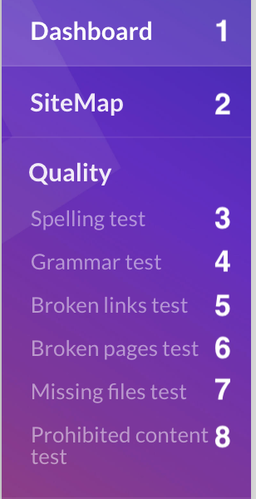 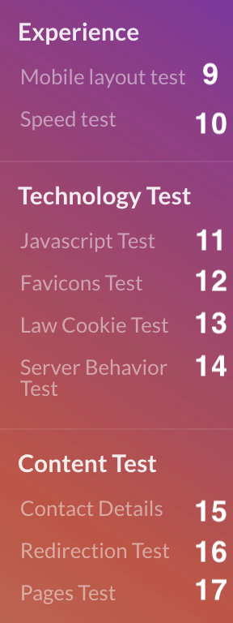

Figure 70 Menu Staff

**Buttons/Hyperlinks:**

|  |  |  |  |  |
| --- | --- | --- | --- | --- |
| **No** | **Function** | **Description** | **Validation** | **Outcome** |
| 1 | Dashboard | Dashboard | User must had been authorized. | Redirect to dashboard |
| 2 | Sitemap | Website sitemap | User must have one of these roles: staff | Redirect to sitemap page |
| 3 | Spelling test | Spelling test | User must have one of these roles: staff | Redirect to spelling test page |
| 4 | Grammar test | Grammar test | User must have one of these roles: staff | Redirect to grammar test page |
| 5 | Broken page test | Broken page test | User must have one of these roles: staff | Redirect to broken page test page |
| 6 | Broken link test | Broken link test | User must have one of these roles: staff | Redirect to broken link test page |
| 7 | Missing file test | Missing file test | User must have one of these roles: staff | Redirect to missing file test page |
| 8 | Prohibited content test | Prohibited content test | User must have one of these roles: staff | Redirect to prohibited content test page |
| 9 | Mobile Layout test | Mobile layout test | User must have one of these roles: staff | Redirect to mobile layout test page |
| 10 | Speed test | Measure the speed of each page | User must have one of these roles: staff | Redirect to Measure the speed of each page page |
| 11 | Javascript test | Javascript error test | User must have one of these roles: staff | Redirect to javascript error test page |
| 12 | Favicon test | Favicon test | User must have one of these roles: staff | Redirect to favion test page |
| 13 | Cookie test | Cookie test | User must have one of these roles: staff | Redirect to cookie test page |
| 14 | Server behavior test | Server behavior test | User must have one of these roles: staff | Redirect to server behavior test page |
| 15 | Contact details | Contact details test | User must have one of these roles: staff | Redirect to contact details test page |
| 16 | Redirection test | Redireaction test | User must have one of these roles: staff | Redirect to redirection test page |
| 17 | Page Test | Page test | User must have one of these roles: staff | Redirect to page test page |

Table 89 <Buttons/Hyperlinks> Menu Staff

## Sitemap

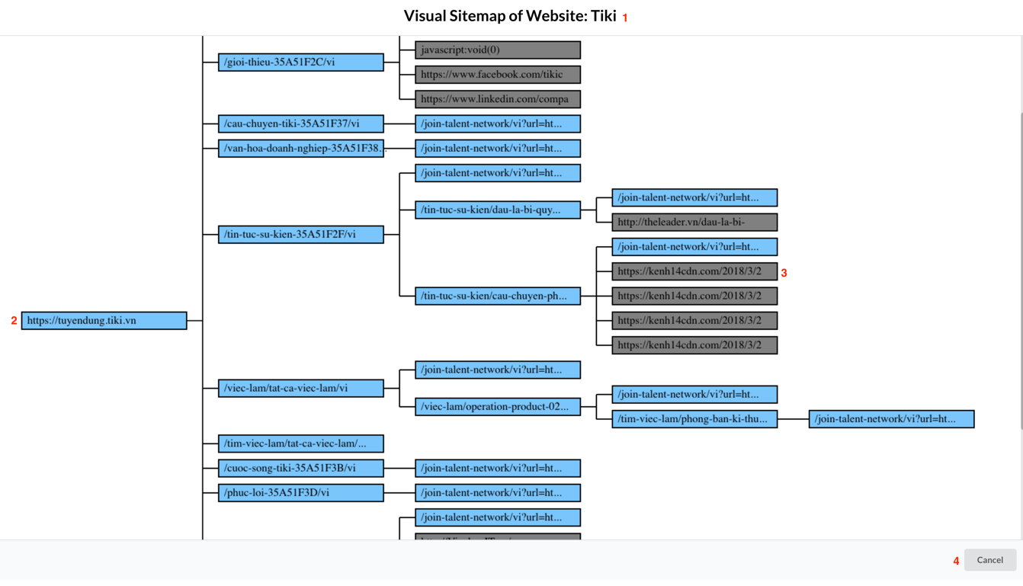

Figure 71 Sitemap

**Fields**

|  |  |  |  |  |  |  |
| --- | --- | --- | --- | --- | --- | --- |
| **No** | **Field Name** | **Description** | **Read only** | **Mandatory** | **Control Type** | **Data Type** |
| 1 | Name Sitemap | Name sitemap | Yes | Yes | Text | String |
| 2 | Internal link | Internal link | Yes | Yes | Text | String |
| 3 | External link | External link | Yes | Yes | Text | String |

Table 90 <Fields> Sitemap

**Buttons/Hyperlinks:**

|  |  |  |  |  |
| --- | --- | --- | --- | --- |
| **No** | **Function** | **Description** | **Validation** | **Outcome** |
| 4 | Cancel | Close sitemap | N/A | Navigate to manage website. |

Table 91 <Buttons/Hyperlinks> Sitemap

## Spelling test

Figure 72 Spelling Test

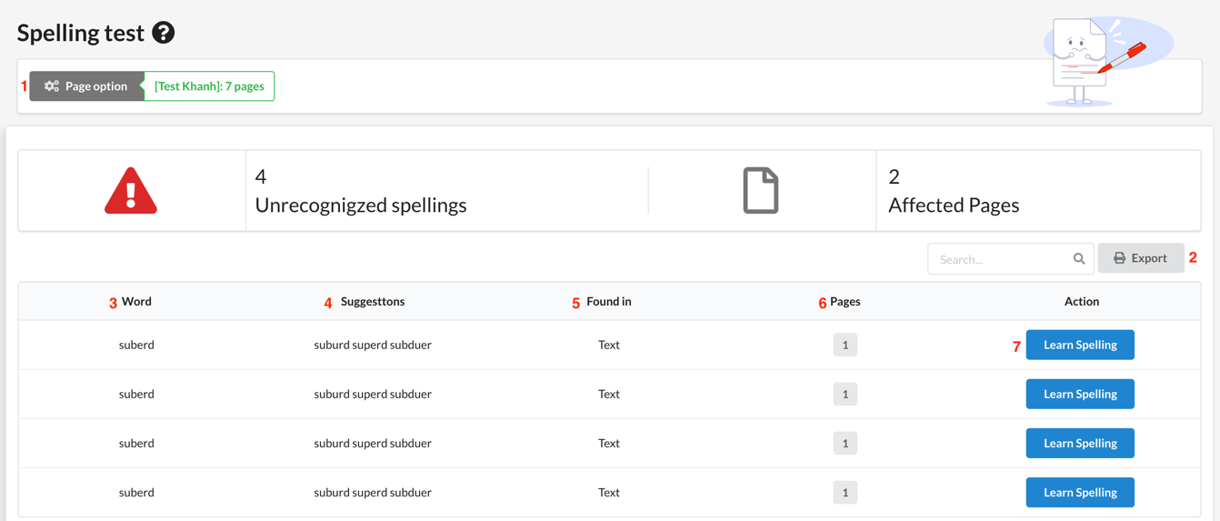**Fields**

|  |  |  |  |  |  |  |
| --- | --- | --- | --- | --- | --- | --- |
| **No** | **Field Name** | **Description** | **Read only** | **Mandatory** | **Control Type** | **Data Type** |
| 3 | Word | Word | Yes | Yes | Text | String |
| 4 | Suggestion | Suggestion word | Yes | Yes | Text | String |
| 5 | Found in | Found in | Yes | Yes | Text | String |
| 6 | Pages | Pages | Yes | Yes | Text | String |

Table 92 <Fields> Spelling Test

**Buttons/Hyperlinks:**

|  |  |  |  |  |
| --- | --- | --- | --- | --- |
| **No** | **Function** | **Description** | **Validation** | **Outcome** |
| 1 | Page Option | Page option | N/A | Navigate to page option page. |
| 5 | Export | Export excel | N/A | Export to excel |
| 7 | Learn Spelling | Learn spelling | N/A | Reload table result |

Table 93 <Buttons/Hyperlinks> Grammar Test

## Grammar test

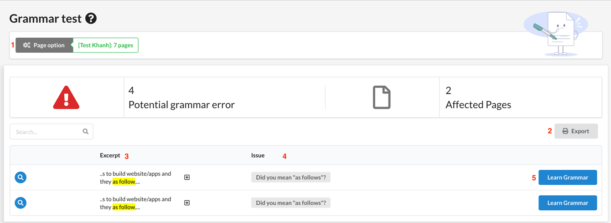

Figure 73 Grammar Test

**Fields**

|  |  |  |  |  |  |  |
| --- | --- | --- | --- | --- | --- | --- |
| **No** | **Field Name** | **Description** | **Read only** | **Mandatory** | **Control Type** | **Data Type** |
| 3 | Excerpt | Excerpt | Yes | Yes | Text | String |
| 4 | Issue | Issue | Yes | Yes | Text | String |

Table 94 <Fields> Grammar Test

**Buttons/Hyperlinks:**

|  |  |  |  |  |
| --- | --- | --- | --- | --- |
| **No** | **Function** | **Description** | **Validation** | **Outcome** |
| 1 | Page Option | Page option | N/A | Navigate to page option page. |
| 5 | Export | Export excel | N/A | Export to excel |
| 7 | Learn Grammar | Learn this grammar | N/A | Reload table result |

Table 95 <Buttons/Hyperlinks> Grammar Test

## Broken page test

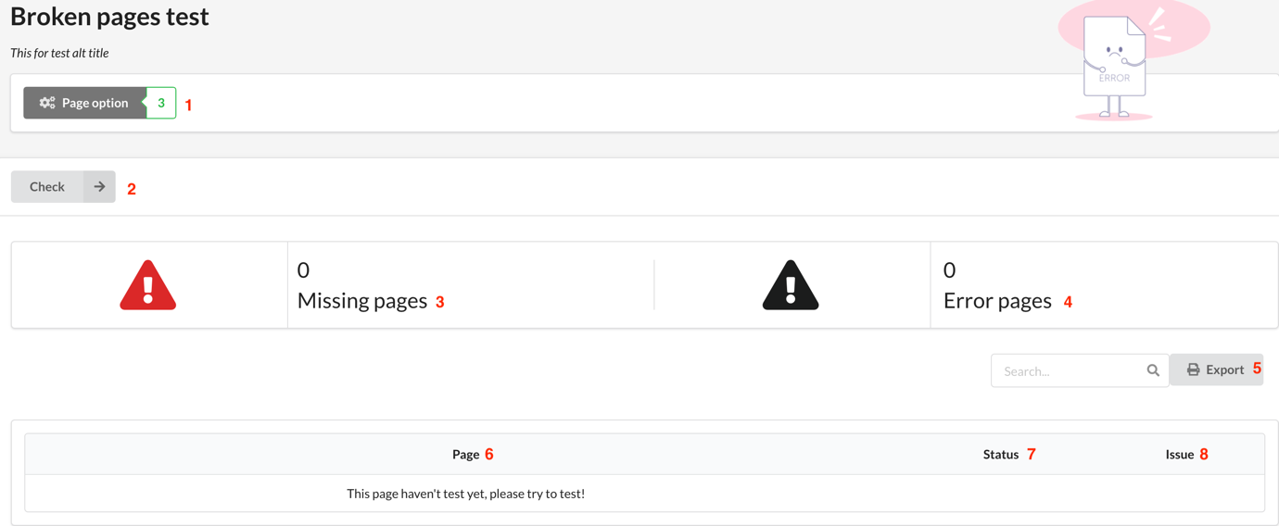

Figure 74 Broken Pages Test

**Fields**

|  |  |  |  |  |  |  |
| --- | --- | --- | --- | --- | --- | --- |
| **No** | **Field Name** | **Description** | **Read only** | **Mandatory** | **Control Type** | **Data Type** |
| 3 | Missing pages | Missing pages | Yes | Yes | Text | String |
| 4 | Error pages | Error pages | Yes | Yes | Text | String |
| 6 | Pages | Page’s url | Yes | Yes | Text | String |
| 7 | Status | http code response | Yes | Yes | Text | String |
| 8 | Issues | Broken page’s issues | Yes | Yes | Text | String |

Table 96 <Fields> Broken Pages Test

**Buttons/Hyperlinks:**

|  |  |  |  |  |
| --- | --- | --- | --- | --- |
| **No** | **Function** | **Description** | **Validation** | **Outcome** |
| 1 | Page Option | Page option | N/A | Navigate to page option page. |
| 2 | Check | Check | N/A | Reload table |
| 5 | Export | Export excel | N/A | Export to excel |

Table 97 <Buttons/Hyperlinks> Broken Pages Test

## Broken links test

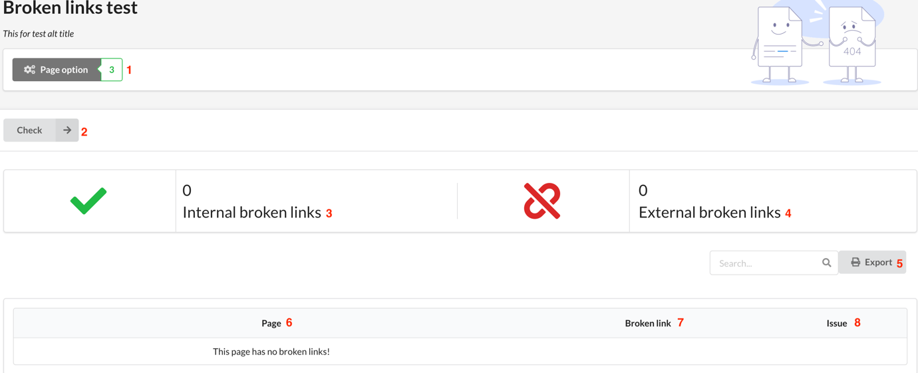

Figure 75 Broken Links Test

**Fields**

|  |  |  |  |  |  |  |
| --- | --- | --- | --- | --- | --- | --- |
| **No** | **Field Name** | **Description** | **Read only** | **Mandatory** | **Control Type** | **Data Type** |
| 3 | Internal Broken Links | Internal Broken Links | Yes | Yes | Text | String |
| 4 | External Broken Links | External Broken Links | Yes | Yes | Text | String |
| 6 | Pages | Page’s url | Yes | Yes | Text | String |
| 7 | Broken link | Broken link | Yes | Yes | Text | String |
| 8 | Issues | Broken link’s issues | Yes | Yes | Text | String |

Table 98 <Fields> Broken Links Test

**Buttons/Hyperlinks:**

|  |  |  |  |  |
| --- | --- | --- | --- | --- |
| **No** | **Function** | **Description** | **Validation** | **Outcome** |
| 1 | Page Option | Page option | N/A | Navigate to page option page. |
| 2 | Check | Check | N/A | Reload table |
| 5 | Export | Export excel | N/A | Export to excel |

Table 99 <Buttons/Hyperlinks> Broken Links Test

## Missing file test

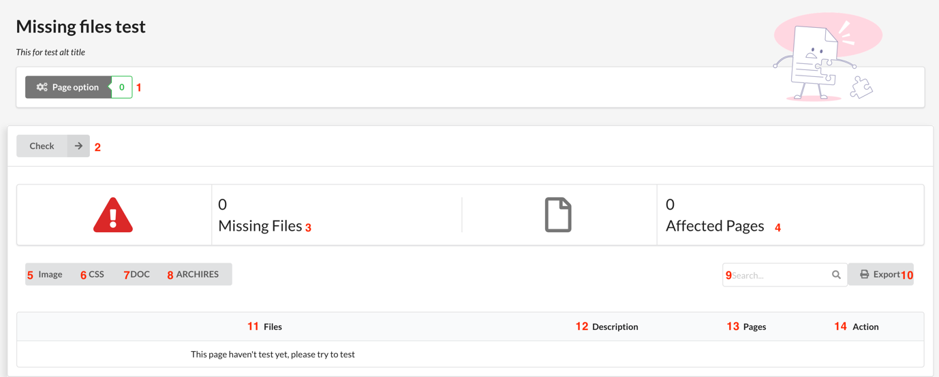

Figure 76 Missing File Test

**Fields**

|  |  |  |  |  |  |  |
| --- | --- | --- | --- | --- | --- | --- |
| **No** | **Field Name** | **Description** | **Read only** | **Mandatory** | **Control Type** | **Data Type** |
| 3 | Number of missing files | Numbers of missing file | Yes | Yes | Text | String |
| 4 | Number of affected pages | Number of affected pages | Yes | Yes | Text | String |
| 9 | Search | Search field | No | Yes | TextBox | String |
| 11 | Files | File missing | Yes | Yes | Text | String |
| 12 | Description | Description missing | Yes | Yes | Text | String |
| 13 | Pages | Pages affected | Yes | Yes | Text | String |
| 14 | Action | Edit | Yes | Yes | Text | String |

Table 100 <Fields> Missing File Test

**Buttons/Hyperlinks:**

|  |  |  |  |  |
| --- | --- | --- | --- | --- |
| **No** | **Function** | **Description** | **Validation** | **Outcome** |
| 1 | Page Option | Page option | N/A | Navigate to page option page. |
| 2 | Check | Check | N/A | Reload table |
| 5 | Image | Image option | N/A | Button image is active |
| 6 | CSS | CSS option | N/A | Button css is active |
| 7 | DOC | DOC option | N/A | Button doc is active |
| 8 | Archires | Archires option | N/A | Button arrhires is active |
| 10 | Export | Export excel | N/A | Export to excel |

Table 101 <Buttons/Hyperlinks> Missing File Test

## Prohibited content test

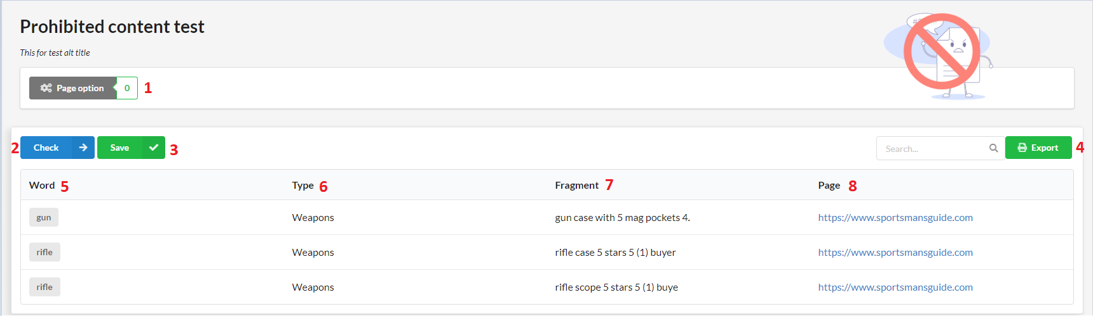

Figure 77 Prohibited content test

**Fields**

|  |  |  |  |  |  |  |
| --- | --- | --- | --- | --- | --- | --- |
| **No** | **Field Name** | **Description** | **Read only** | **Mandatory** | **Control Type** | **Data Type** |
| 5 | Word | Prohibited word | Yes | Yes | Text | String |
| 6 | Type | Type of prohibited word | Yes | Yes | Text | String |
| 7 | Fragment | Fragment includes prohibited word | Yes | Yes | Text | String |
| 8 | Page | Page’s url | Yes | Yes | Text | String |

Table 102 <Fields> Prohibited Content Test

**Buttons/Hyperlinks:**

|  |  |  |  |  |
| --- | --- | --- | --- | --- |
| **No** | **Function** | **Description** | **Validation** | **Outcome** |
| 1 | Page Option | Page option | N/A | Navigate to page option page. |
| 2 | Check | Check | N/A | Reload table |
| 3 | Save | Save | N/A | Reload table |
| 4 | Export | Export excel | N/A | Export to Excel |

Table 103 <Buttons/Hyperlinks> Prohibited Content Test

## Mobile layout test

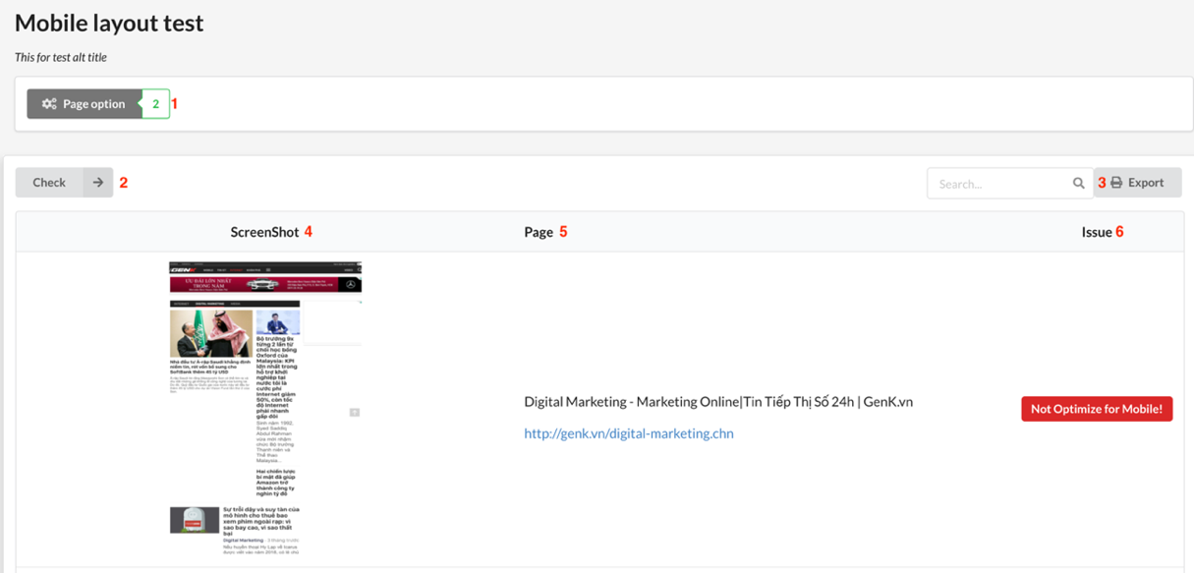

Figure 78 Mobile Layout Test

**Fields**

|  |  |  |  |  |  |  |
| --- | --- | --- | --- | --- | --- | --- |
| **No** | **Field Name** | **Description** | **Read only** | **Mandatory** | **Control Type** | **Data Type** |
| 4 | Screenshoot | Screenshoot website mobile layout | Yes | Yes | Text | String |
| 5 | Pages | Page’s url | Yes | Yes | Text | String |
| 6 | Issues | Mobile layout’s issue | Yes | Yes | Text | String |

Table 104 <Fields> Mobile Layout Test

**Buttons/Hyperlinks:**

|  |  |  |  |  |
| --- | --- | --- | --- | --- |
| **No** | **Function** | **Description** | **Validation** | **Outcome** |
| 1 | Page Option | Page option | N/A | Navigate to page option page. |
| 2 | Check | Check | N/A | Reload table |
| 3 | Export | Export excel | N/A | Export to excel |

Table 105 <Buttons/Hyperlinks> Mobile Layout Test

## Speed test

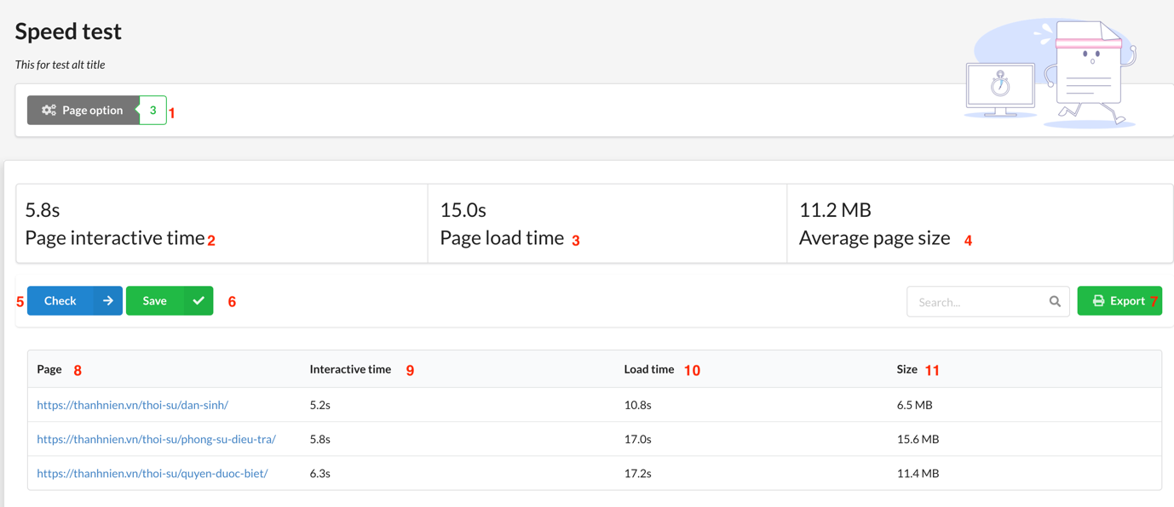

Figure 79 Speed Test

**Fields**

|  |  |  |  |  |  |  |
| --- | --- | --- | --- | --- | --- | --- |
| **No** | **Field Name** | **Description** | **Read only** | **Mandatory** | **Control Type** | **Data Type** |
| 2 | Page Interactive time | Average page interactive time | Yes | Yes | Text | String |
| 3 | Page load time | Average page load time | Yes | Yes | Text | String |
| 4 | Average page size | Average page size | Yes | Yes | Text | String |
| 8 | Page | Page’s url | Yes | Yes | Text | String |
| 9 | Interactive time | Page interactive time | Yes | Yes | Text | String |
| 10 | Load time | Page load time | Yes | Yes | Text | String |
| 11 | Size | Page size | Yes | Yes | Text | String |

Table 106 <Fields> Speed Test

**Buttons/Hyperlinks:**

|  |  |  |  |  |
| --- | --- | --- | --- | --- |
| **No** | **Function** | **Description** | **Validation** | **Outcome** |
| 1 | Page Option | Page option | N/A | Navigate to page option page. |
| 5 | Check | Check | N/A | Reload table |
| 6 | Save | Save | N/A | Reload table |
| 7 | Export | Export excel | N/A | Export to excel |

Table 107 <Buttons/Hyperlinks> Speed Test

## Javascript error test

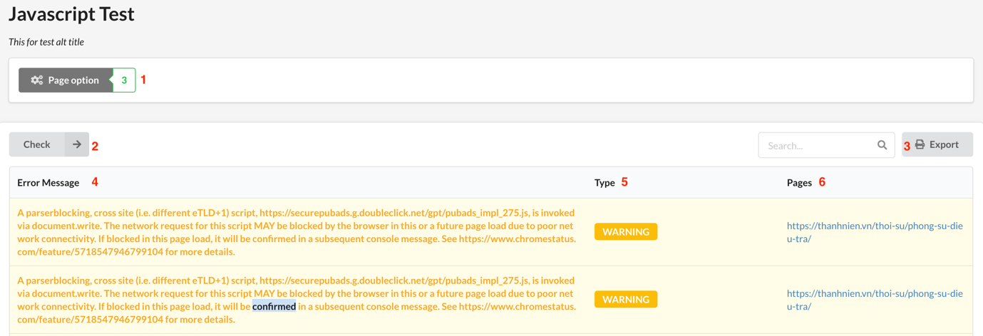

Figure 80 - JavaScript Errors Test

**Fields**

|  |  |  |  |  |  |  |
| --- | --- | --- | --- | --- | --- | --- |
| **No** | **Field Name** | **Description** | **Read only** | **Mandatory** | **Control Type** | **Data Type** |
| 4 | Error Message | Javascript Error’s information | Yes | Yes | Text | String |
| 5 | Type | Error type | Yes | Yes | Text | String |
| 6 | Pages | Page’s url | Yes | Yes | Text | String |

Table 108 <Fields> JavaScript Errors Test

**Buttons/Hyperlinks:**

|  |  |  |  |  |
| --- | --- | --- | --- | --- |
| **No** | **Function** | **Description** | **Validation** | **Outcome** |
| 1 | Page Option | Page option | N/A | Navigate to page option page. |
| 2 | Check | Check | N/A | Reload table |
| 3 | Export | Export excel | N/A | Export to excel |

Table 109 <Buttons/Hyperlinks> JavaScript Errors Test

## Favicon test

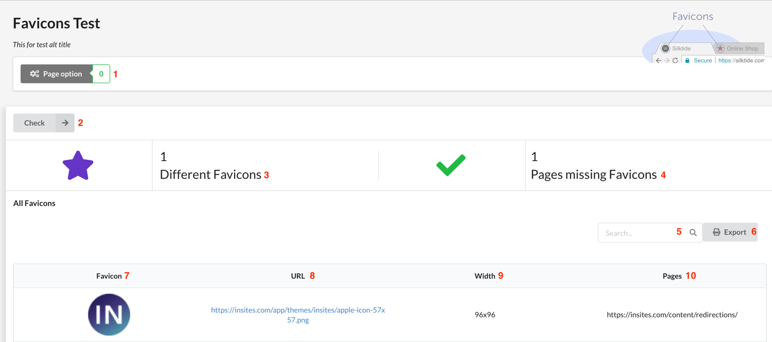

Figure 81 Favicon Test

**Fields**

|  |  |  |  |  |  |  |
| --- | --- | --- | --- | --- | --- | --- |
| **No** | **Field Name** | **Description** | **Read only** | **Mandatory** | **Control Type** | **Data Type** |
| 3 | Number of different favicons | Numbers of different favicons | Yes | Yes | Text | String |
| 4 | Number of pages missing favicons | Number of pages missing favicon | Yes | Yes | Text | String |
| 5 | Search | Search field | No | Yes | TextBox | String |
| 7 | Favicon | Favicon image | Yes | Yes | Text | String |
| 12 | URL | Favicon URL | Yes | Yes | Text | String |
| 13 | Width | Favicon width | Yes | Yes | Text | String |
| 14 | Pages | Pages affected | Yes | Yes | Text | String |

Table 110 <Fields> Favicon Test

**Buttons/Hyperlinks:**

|  |  |  |  |  |
| --- | --- | --- | --- | --- |
| **No** | **Function** | **Description** | **Validation** | **Outcome** |
| 1 | Page Option | Page option | N/A | Navigate to page option page. |
| 2 | Check | Check | N/A | Reload table |
| 6 | Export | Export excel | N/A | Export to excel |

Table 111 <Buttons/Hyperlinks> Favicon Test

## Cookie test

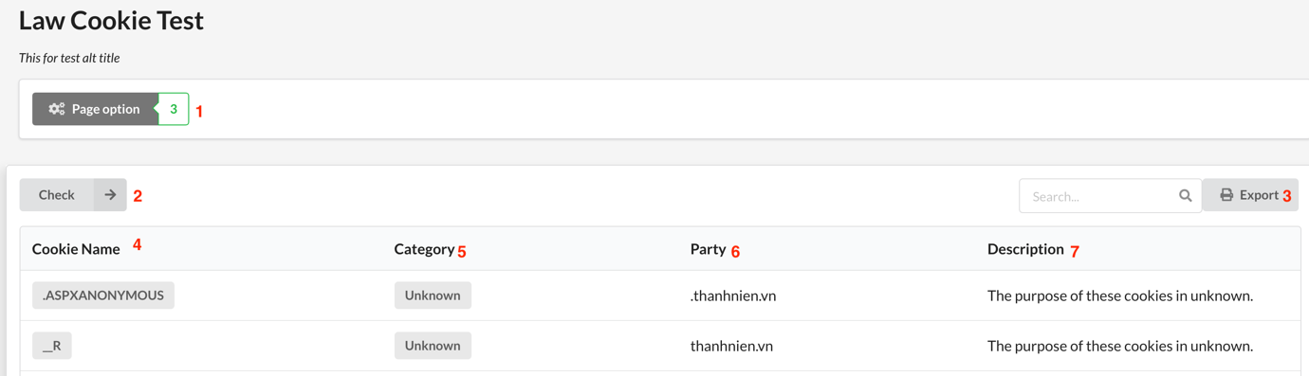

Figure 82 Cookie Test

**Fields**

|  |  |  |  |  |  |  |
| --- | --- | --- | --- | --- | --- | --- |
| **No** | **Field Name** | **Description** | **Read only** | **Mandatory** | **Control Type** | **Data Type** |
| 4 | Cookie name | Cookie name | Yes | Yes | Text | String |
| 5 | Category | Cookie category | Yes | Yes | Text | String |
| 6 | Party | Cookie party | Yes | Yes | Text | String |
| 7 | Description | Cookie description | Yes | Yes | Text | String |

Table 112 <Fields> Cookie Test

**Buttons/Hyperlinks:**

|  |  |  |  |  |
| --- | --- | --- | --- | --- |
| **No** | **Function** | **Description** | **Validation** | **Outcome** |
| 1 | Page Option | Page option | N/A | Navigate to page option page. |
| 2 | Check | Check | N/A | Reload table |
| 3 | Export | Export excel | N/A | Export to excel |

Table 113 <Buttons/Hyperlinks> Cookie Test

## Server behavior test

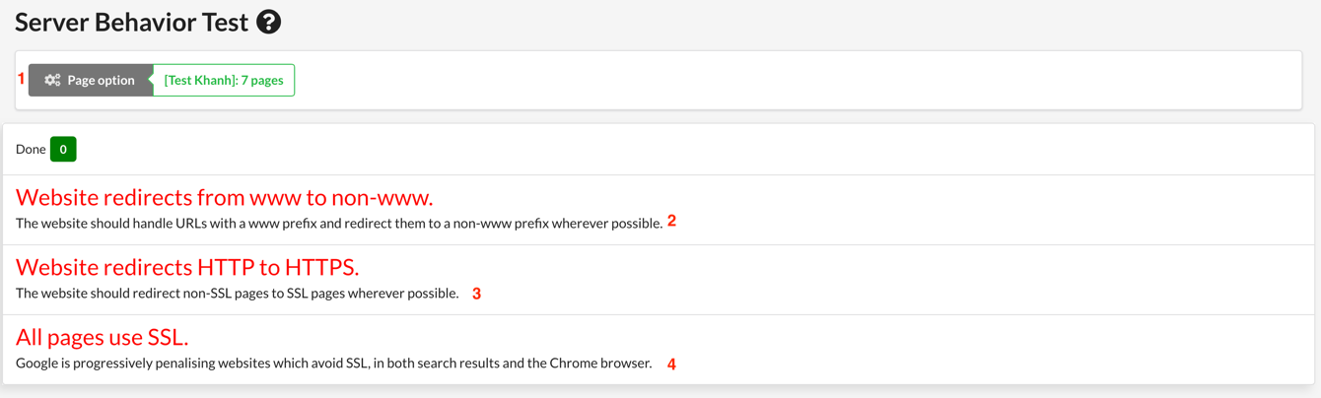

Figure 83 Server Behavior

**Fields**

|  |  |  |  |  |  |  |
| --- | --- | --- | --- | --- | --- | --- |
| **No** | **Field Name** | **Description** | **Read only** | **Mandatory** | **Control Type** | **Data Type** |
| 2 | Website redirects from www to non-www | Website redirects from www to non-www | Yes | Yes | Text | String |
| 3 | Website redirects from HTTP to HTTPS | Website redirects from HTTP to HTTPS | Yes | Yes | Text | String |
| 4 | All page use SSL | All page use SSL | Yes | Yes | Text | String |

Table 114 <Fields> Server Behavior

**Buttons/Hyperlinks:**

|  |  |  |  |  |
| --- | --- | --- | --- | --- |
| **No** | **Function** | **Description** | **Validation** | **Outcome** |
| 1 | Page Option | Page option | N/A | Navigate to page option page. |

Table 115 <Buttons/Hyperlinks> Server Behavior

## Contact detail test

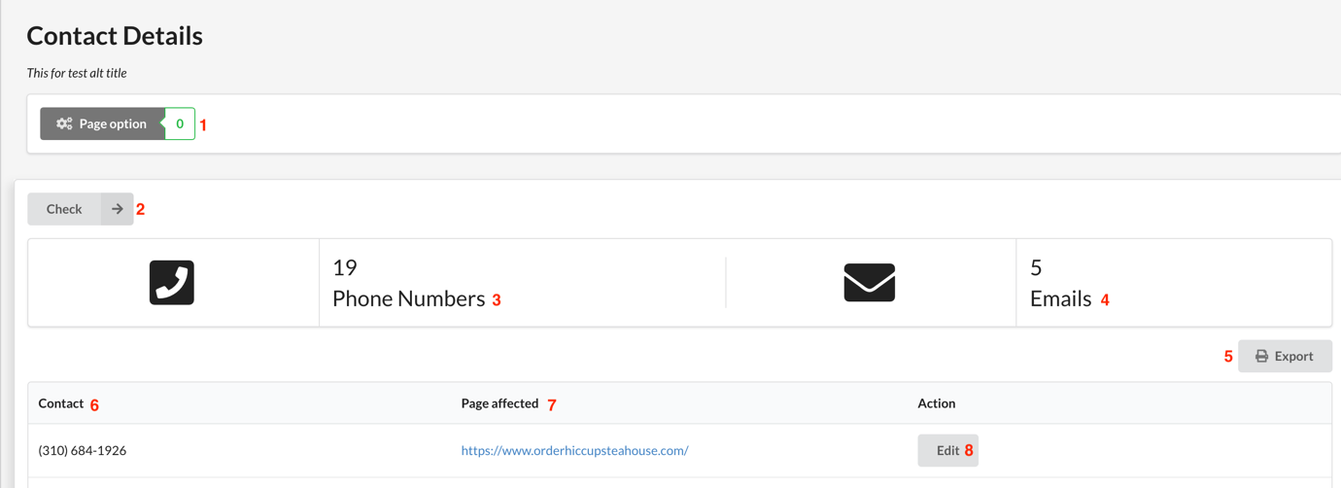

Figure 84 - Contact Details Test

**Fields**

|  |  |  |  |  |  |  |
| --- | --- | --- | --- | --- | --- | --- |
| **No** | **Field Name** | **Description** | **Read only** | **Mandatory** | **Control Type** | **Data Type** |
| 3 | Number of phone numbers | Numbers of phone numbers | Yes | Yes | Text | String |
| 4 | Number of emails | Number of emails | Yes | Yes | Text | String |
| 6 | Contact | Email or phone numbers | Yes | Yes | Text | String |
| 7 | Page affected | Page’s URL affected | Yes | Yes | Text | String |

Table 116 <Fields> Contact Details

**Buttons/Hyperlinks:**

|  |  |  |  |  |
| --- | --- | --- | --- | --- |
| **No** | **Function** | **Description** | **Validation** | **Outcome** |
| 1 | Page Option | Page option | N/A | Navigate to page option page. |
| 2 | Check | Check | N/A | Reload table |
| 5 | Export | Export excel | N/A | Export to excel |
| 8 | Edit | Edit | N/A | Reload table |

Table 117 <Buttons/Hyperlinks> Contact Details Test

## Redrection test

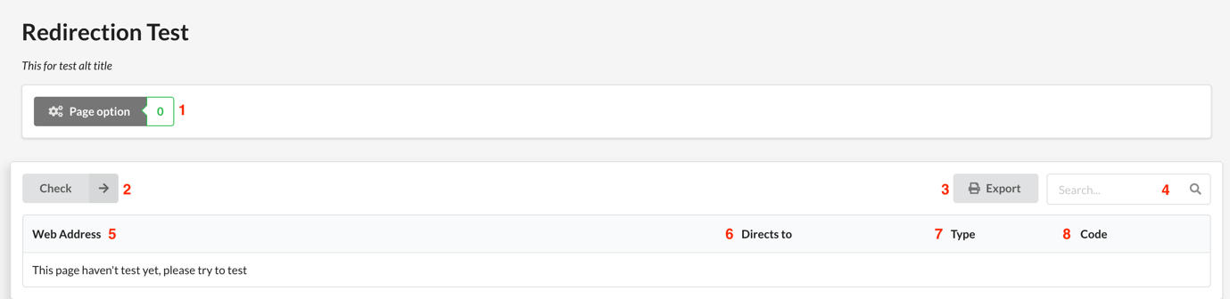

Figure 85 - Redirection Test

**Fields**

|  |  |  |  |  |  |  |
| --- | --- | --- | --- | --- | --- | --- |
| **No** | **Field Name** | **Description** | **Read only** | **Mandatory** | **Control Type** | **Data Type** |
| 4 | Search | Search fields | No | Yes | TextBox | String |
| 5 | Web address | Website address | Yes | Yes | Text | String |
| 6 | Directs to | Direct to URL | Yes | Yes | Text | String |
| 7 | Type | Type redirection | Yes | Yes | Text | String |
| 8 | Code | HTTP code response | Yes | Yes | Text | String |

Table 118 <Fields> Redirection Test

**Buttons/Hyperlinks:**

|  |  |  |  |  |
| --- | --- | --- | --- | --- |
| **No** | **Function** | **Description** | **Validation** | **Outcome** |
| 1 | Page Option | Page option | N/A | Navigate to page option page. |
| 2 | Check | Check | N/A | Reload table |
| 3 | Export | Export excel | N/A | Export to excel |

Table 119 <Buttons/Hyperlinks> Redirection Test

## Page test

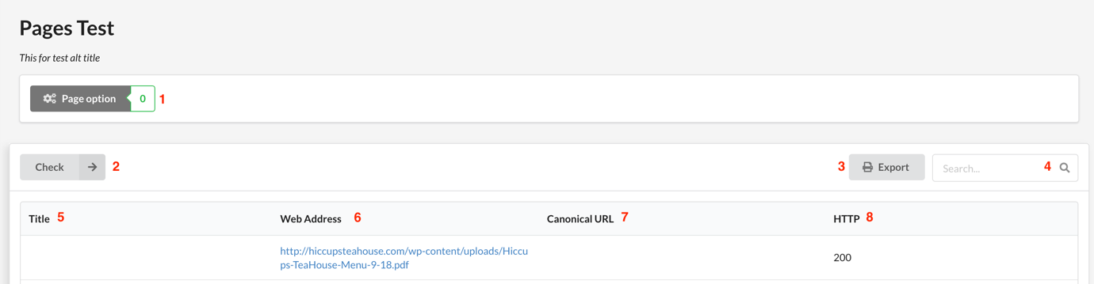

Figure 86 Page Test

**Fields**

|  |  |  |  |  |  |  |
| --- | --- | --- | --- | --- | --- | --- |
| **No** | **Field Name** | **Description** | **Read only** | **Mandatory** | **Control Type** | **Data Type** |
| 4 | Search | Search fields | No | Yes | TextBox | String |
| 5 | Title | Website title | Yes | Yes | Text | String |
| 6 | Web address | Website address | Yes | Yes | Text | String |
| 7 | Canonical URL | Canonical URL | Yes | Yes | Text | String |
| 8 | HTTP | HTTP code response | Yes | Yes | Text | String |

Table 120 <Fields> Page Test

**Buttons/Hyperlinks:**

|  |  |  |  |  |
| --- | --- | --- | --- | --- |
| **No** | **Function** | **Description** | **Validation** | **Outcome** |
| 1 | Page Option | Page option | N/A | Navigate to page option page. |
| 2 | Check | Check | N/A | Reload table |
| 3 | Export | Export excel | N/A | Export to excel |

Table 121 <Buttons/Hyperlinks> Page Test

## Database Design

## Entity relationship diagram (ERD)



Figure 87 Entity Relationship Diagram

## Data Dictionary

|  |  |
| --- | --- |
| Entity Data Dictionary: describe content of all entities | |
| Entity name | Description |
| Account | Contains the account’s information. |
| Role | Contains the role’s information. |
| Sitemap | Contains the sitemap’s information. |
| Version | Show the version of Sitemap. |
| Page | Contains the page’s information. |
| Website | Contains the website’s information. |
| Dictionary | Contains the dictionary’s information. |
| Topic | Contains the topic’s information. |
| WarningWord | Contains the warningWord’s information |
| WarningWordReport | Contains the warningWordReport’s information. |
| SpellingReport | Contains the spellingReport information |
| GrammarReport | Contains the grammarReport’s information. |
| BrokenLinkReport | Contains the brokenLinkReport’s information. |
| BrokenPageReport | Contains the brokenPageReport’s information. |
| MissingFileReport | Contains the missingFileReport information. |
| FaviconReport | Contains the faviconReport’s information. |
| SpeedReport | Contains the speedReport’s information. |
| JavaScriptReport | Contains the javaScriptReport’s information. |
| MobileLayoutReport | Contains the mobileLayoutReport’s information. |
| CookieReport | Contains the cookieReport’s information. |
| ServerBehaviorReport | Contains the serverBehaviorReport’s information. |
| RedirectionReport | Contains the redirectionReport’s information. |
| ContactReport | Contains the contactReport’s information. |
| PageReport | Contains the pageReport s information. |

Table 122 Entity Relationship Diagram Dictionary

|  |  |  |  |  |
| --- | --- | --- | --- | --- |
| Entity Name | Attributes | Description | Domain | Null |
| account | id | Id of account | BIGINT(20) | NO |
| position | Position of account | VARCHAR(255) | NO |
| address | Address of account | VARCHAR(255) | NO |
| fullname | Fullname of account | VARCHAR(255) | NO |
| password | Password of account | VARCHAR(255) | NO |
| username | Username of account | VARCHAR(255) | NO |
| role | id | Role id of account | BIGINT(20) | NO |
| role_name | Role name of account | VARCHAR(255) | NO |
| sitemap | id | Id of site map | BIGINT(20) | NO |
| map | Map of site map | VARCHAR(255) | NO |
| type_map | Type of site map | VARCHAR(255) | NO |
| url_map | Url of site map | VARCHAR(255) | NO |
| version | id | Id of version | BIGINT(20) | NO |
| version | Number of version. | BIGINT(20) | NO |
| time | Time created version | DATETIME | NO |
| page | id | Id of page | BIGINT(20) | NO |
| type | Type of page | BIGINT(20) | NO |
| url | Url of page | VARCHAR(255) | NO |
| website | id | Id of website | BIGINT(20) | NO |
| name | Name of website | VARCHAR(255) | NO |
| url | Url of website | VARCHAR(255) | NO |
| time_register | Time register of website | DATETIME | NO |
| time_modified | Time Modified of website | DATETIME | NO |
| topic | id | Id of topic | BIGINT(20) | NO |
| name | Name of topic | VARCHAR(255) | NO |
| description | Description of topic | VARCHAR(255) | NO |
| warningWord | id | Id of warning word | BIGINT(20) | NO |
| word | Warning word | VARCHAR(255) | NO |
| dictionary | id | Id of dictionary | BIGINT(20) | NO |
| word | Word in dictionary | VARCHAR(255) | NO |
| word_form | Word form of dictionary | VARCHAR(255) | NO |
| definition | Definition of word | VARCHAR(255) | NO |
| warningWordReport | id | Id of warning word report | BIGINT(20) | NO |
| found_word | Word found | VARCHAR(255) | NO |
| appearance_info | Appearance info | VARCHAR(255) | NO |
| solution | Solution | VARCHAR(255) | NO |
| creator | Who create | DATETIME | NO |
| time_created | Time to create | DATETIME | NO |
| spellingReport | id | Id of spelling report | BIGINT(20) | NO |
| found_at | Position found | VARCHAR(255) | NO |
| wrong_word | Wrong word | VARCHAR(255) | NO |
| appearance_info | Appearance info | VARCHAR(255) | NO |
| reason | Reason wrong | VARCHAR(255) | NO |
| solution | Solution | VARCHAR(255) | NO |
| creator | Who create | DATETIME | NO |
| time_created | Time to create | DATETIME | NO |
| grammarReport | id | Id of grammar report | BIGINT(20) | NO |
| excerpt | Excerpt of grammar report | VARCHAR(255) | NO |
| found_at | Where found error | VARCHAR(255) | NO |
| appearanceInfo | Appearance info | VARCHAR(255) | NO |
| reason | Reason wrong | VARCHAR(255) | NO |
| solution | Solution | VARCHAR(255) | NO |
| creator | Who create | DATETIME | NO |
| time_created | Time to create | DATETIME | NO |
| brokenLinkReport | id | Id of broken link report | BIGINT(20) | NO |
| url | url of broken link | VARCHAR(255) | NO |
| issue | Issue of broken link | VARCHAR(255) | NO |
| creator | Who create | DATETIME | NO |
| time_created | Time to create | DATETIME | NO |
| brokenPageReport | id | Id of broken page report | BIGINT(20) | NO |
| url | issue of broken page | VARCHAR(255) | NO |
| issue | Issue of broken page | VARCHAR(255) | NO |
| creator | Who create | DATETIME | NO |
| time_created | Time to create | DATETIME | NO |
| missingFileReport | id | Id of missing file report | BIGINT(20) | NO |
| file_link | Link file error | VARCHAR(255) | NO |
| file_type | Type file error | VARCHAR(255) | NO |
| issue | Issue of file error | VARCHAR(255) | NO |
| creator | Who create | DATETIME | NO |
| time_created | Time to create | DATETIME | NO |
| faviconReport | id | Id of favicon Report | BIGINT(20) | NO |
| favicon_type | Type of favicon | VARCHAR(255) | NO |
| issue | Issue of favicon | VARCHAR(255) | NO |
| creator | Who create | DATETIME | NO |
| time_created | Time to create | DATETIME | NO |
| speedReport | id | Id of speed report | BIGINT(20) | NO |
| load_time | Time to load | VARCHAR(255) | NO |
| interactive_time | Time to interactive | VARCHAR(255) | NO |
| creator | Who create | DATETIME | NO |
| time_created | Time to create | DATETIME | NO |
| JavaScriptReport | id | Id of JavaScript report | BIGINT(20) | NO |
| message | Message error | VARCHAR(255) | NO |
| appearance_info | Appearance info | VARCHAR(255) | NO |
| creator | Who create | DATETIME | NO |
| time_created | Time to create | DATETIME | NO |
| mobileLayoutReport | id | Id of mobile layout report | BIGINT(20) | NO |
| issue | Issue of mobile layout | VARCHAR(255) | NO |
| appearance_info | Appearance info | VARCHAR(255) | NO |
| suggestion | Suggestion for user | VARCHAR(255) | NO |
| creator | Who create | DATETIME | NO |
| time_created | Time to create | DATETIME | NO |
| cookieReport | id | Id of cookie report | BIGINT(20) | NO |
| name | Message content | VARCHAR(255) | NO |
| category | Category of cookie | VARCHAR(255) | NO |
| party_name | Party name of cookie | VARCHAR(255) | NO |
| purpose_discription | Purpose of cookie | VARCHAR(255) | NO |
| legality | Legality of file | VARCHAR(255) | NO |
| creator | Who create | DATETIME | NO |
| time_created | Time to create | DATETIME | NO |
| serverBehaviorReport | Id | Id of server behavior report | BIGINT(20) | NO |
| issue | Issue of server | VARCHAR(255) | NO |
| description | Description server behavior | VARCHAR(255) | NO |
| creator | Who create | DATETIME | NO |
| time_created | Time to create | DATETIME | NO |
| redirectionReport | id | Id of redirection Report | BIGINT(20) | NO |
| url | url of link | VARCHAR(255) | NO |
| redirect_to | url redirect to | VARCHAR(255) | NO |
| http_code | Http code of link | VARCHAR(255) | NO |
| creator | Who create | DATETIME | NO |
| time_created | Time to create | DATETIME | NO |
| contactReport | id | Id of contact report | BIGINT(20) | NO |
| contact_type | Type of contact | VARCHAR(255) | NO |
| appearance_info | Appearance info | VARCHAR(255) | NO |
| creator | Who create | DATETIME | NO |
| time_created | Time to create | DATETIME | NO |
| pageReport | id | Id of page report | BIGINT(20) | NO |
| url | url of page | VARCHAR(255) | NO |
| canonical_url | Canonical url of page | VARCHAR(255) | NO |
| title | Title of page | VARCHAR(255) | NO |
| httpCode | Http code of page | BIGINT(20) | NO |
| creator | Who create | DATETIME | NO |
| time_created | Time to create | DATETIME | NO |

## Algorithms

1. **Sitemap Generator**
   1. **Defininition:**

Enqueue each level of a tree sequentially as the root of any subtree is encountered. There are 2 cases in the iterative algorithm:

* **Root case**: The traversal queue is initially empty so the root node must be added before the general case.
* **General case**: Process any items in the queue, while also expanding their children. Stop if the queue is empty. The general case will halt after processing the bottom level as leaf nodes have no children.

**Input**: the root URL of a website

**Output**: The sitemap.

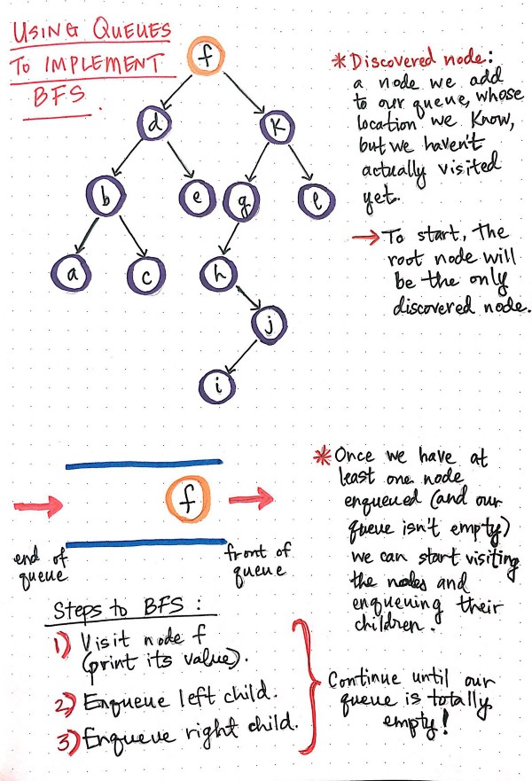****

Figure 88 Define Sitemap

* **Implementation**

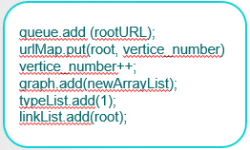

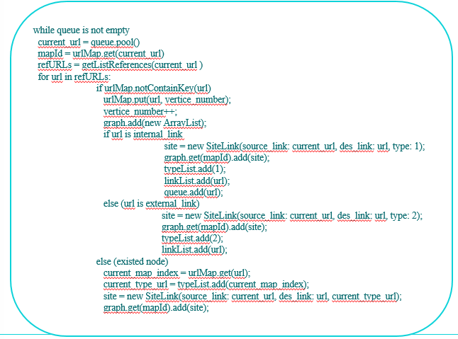

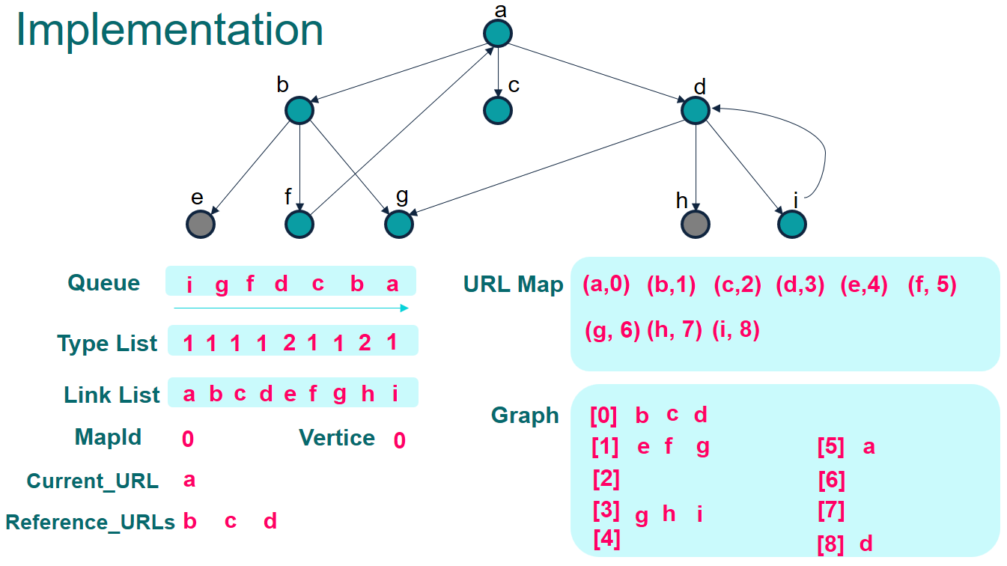

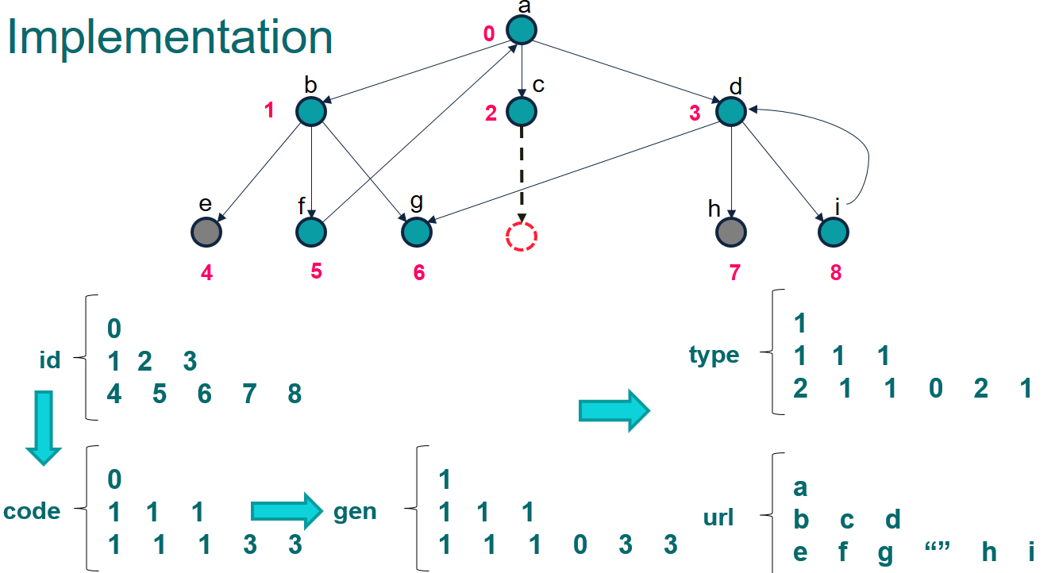

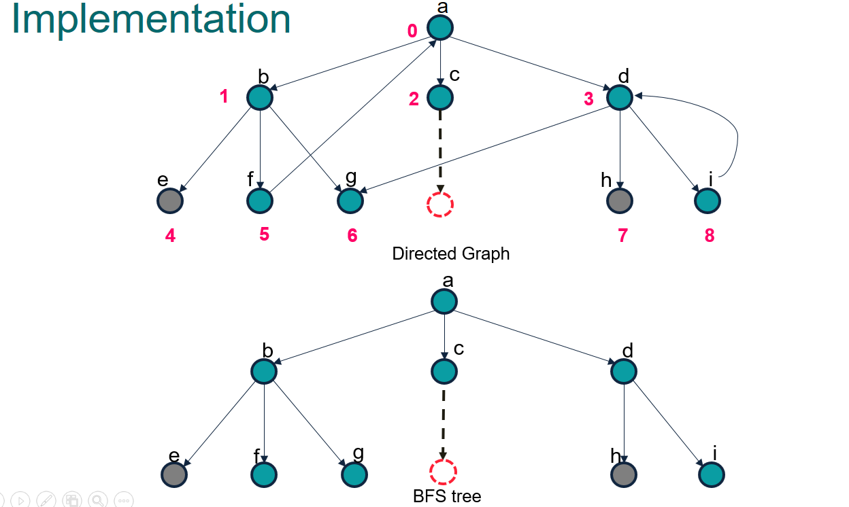

* 1. **Sitemap Structures**
* SiteLink: object with attributes:
  + src: source link
  + des: destination link
  + desType: type of destination link (internal, external)
* HashMap<String, Integer> urlMap: Number URLSs into distinct integers, which is also the vertex index on the graph.
* List<List<SiteLink>> graph: adjacency list
* List<List<SiteLink>> invGraph: adjacency list represents graph with all inverse edges from origin graph.
* List<Integer> urlType: get type of link from vertice index.
* List<String> links: inverse mapping with urlMap, allow get url link from vertice index.
* codeGraph: string encoded of graph to create visual image.

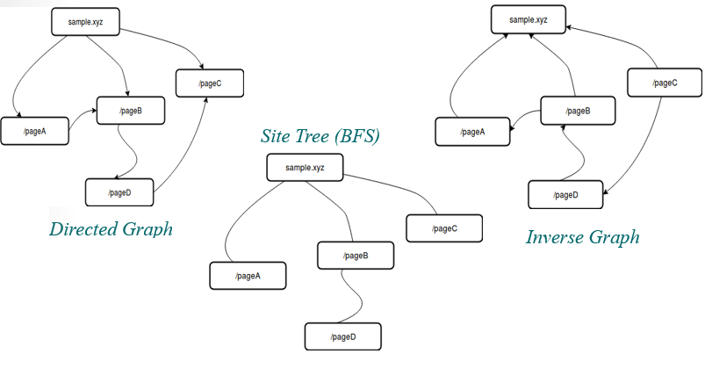**Define some functions**

* CreateEdge(u, v): create edge from u to v and add to graph, also create an inverse edge v to u and store to invGraph.
* getListReferences(url): crawl with url and list all others url links in that page. We could also get more information like urlType.
* getUniqueID(): get new unique integer number.

**Pseudo code for BFS**

1: **function** BFS(rootURL)

2: **Queue q → init empty**

3: urlMap.mark(rootURL) = **getUniqueID**()

4: **while** q is not empty

5: URL = q.pool()

6: refURLs = **getListReferences**(URL)

7: f**or** url **in** refURLs:

8: **createEdge**(URL, urlMap) // create edge of graph

9: **if** urlMap.notContainKey(url)

10: urlMap.mark(url) = **getUniqueID**()

11: q.add (url)

Note:

* The depth of the sitemap-tree is always minimal
* A tree path from one vertex to another is a way to get to the desired link through the link.

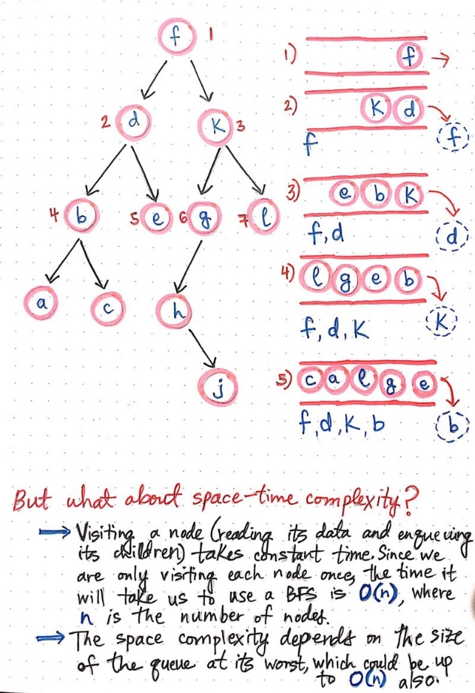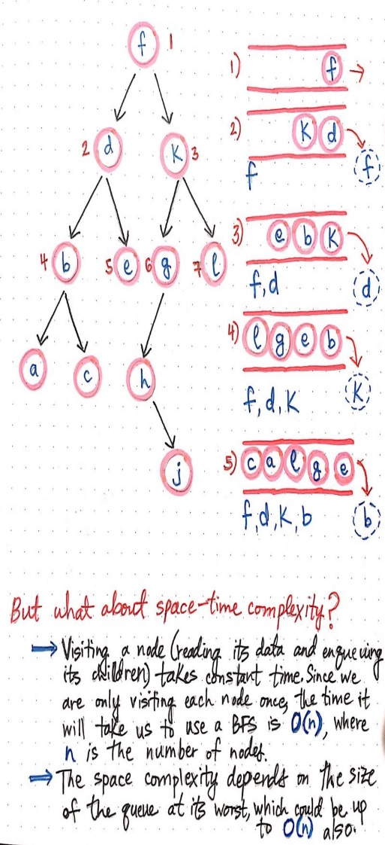

1. **Spelling test**
   1. **Definition Trie Tree**

A **trie** is a tree-like data structure whose nodes store the letters of an alphabet. By structuring the nodes in a particular way, words and strings can be retrieved from the structure by traversing down a branch path of the tree.

We know that tries are often used to represent words in an alphabet. In the illustration shown here, we can start to get a sense of how exactly that representation works.

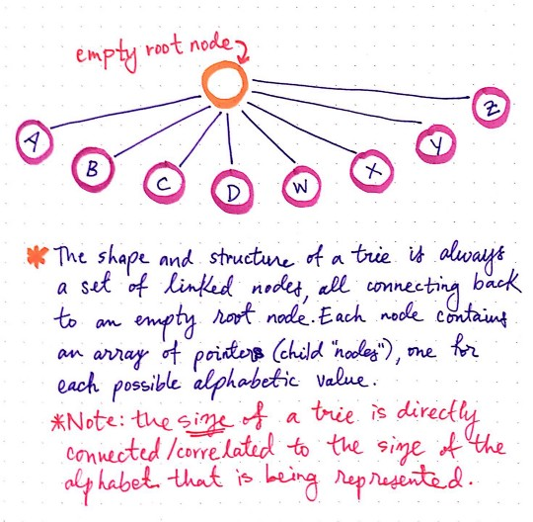

Figure 89 Trie Tree

Each trie has an empty root node, with links (or references) to other nodes — one for each possible alphabetic value.

The shape and the structure of a trie is always a set of linked nodes, connecting back to an empty root node. An important thing to note is that the number of child nodes in a trie depends completely upon the total number of values possible. For example, if we are representing the English alphabet, then the total number of child nodes is directly connected to the total number of letters possible. In the English alphabet, there are 26 letters, so the total number of child nodes will be 26.

* 1. **Structures of Trie node**

- isLeaf: determine true if the path from root to current node could build a correct word in dictionary.

- eWeight: the frequently of failure when user type wrong.

- refNode: List of reference link to another Trie Node, normally, Trie Node has 26 reference links corresponding to 'a' --> 'z', we can extend the number of reference link if the collection of character has larger.

A single node in a trie contains just two things:

1. A value, which might be null
2. An array of references to child nodes, all of which also might be null

Each node in a trie, including the root node itself, has only these two aspects to it. When a trie representing the English language is created, it consists of a single root node, whose value is usually set to an empty string: "".

That root node will also have an array that contains 26 references, all of which will point to null at first. As the trie grows, those pointers start to get filled up with references to other nodes nodes.

The way that those pointers or references are represented is particularly interesting. We know that each node contains an array of references/links to other nodes. What’s cool about this is that we can use the array’s indexes to find specific references to nodes. For example, our root node will hold an array of indexes 0 through 25, since there are 26 possible slots for the 26 letters of the alphabet. Since the alphabet is in order, we know that the reference to the node that will contain the letter A will live at index 0.

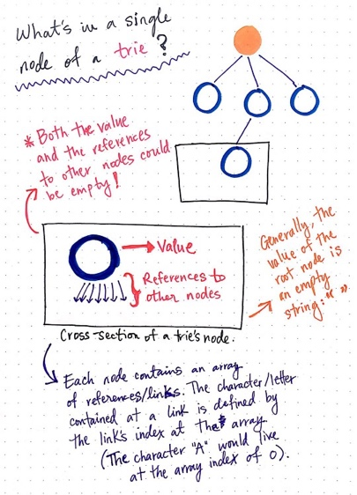

Figure 90 Structure Trie Tree

Looking at our trie, we can see that we have an empty root node, as is typical for a trie structure. We also have six different words that we’re representing in this trie: Peter, piper, picked, peck, pickled, and peppers.

To make this trie easier to look at, I’ve only drawn the references that actually have nodes in them; it’s important to remember that, even though they’re not illustrated here, every single node has 26 references to possible child nodes.

Notice how there are six different “branches” to this trie, one for each word that’s being represented. We can also see that some words are sharing parent nodes. For example, all of the branches for the words Peter, peck, and peppers share the nodes for p and for e. Similarly, the path to the word picked and pickled share the nodes p, i, c, and k.

So, what if we wanted to add the word pecked to this list of words represented by this trie? We’d need to do two things in order to make this happen:

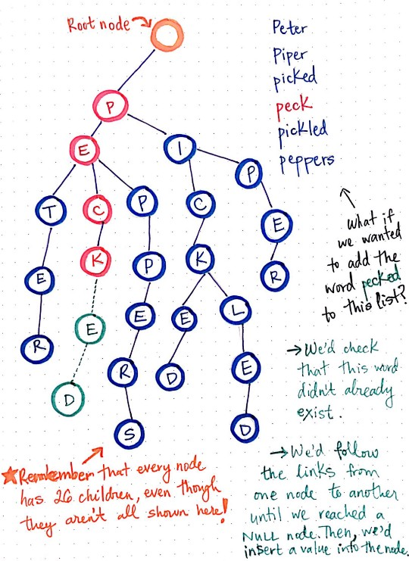

First, we’d need to check that the word pecked doesn’t already exist in this trie.

Next, if we’ve traversed down the branch where this word ought to live and the words doesn’t exist yet, we’d insert a value into the node’s reference where the word should go. In this case, we’d insert e and d at the correct references.

But how do we actually go about checking if the word exists? And how do we insert the letters into their correct places?

* **Idea of inserting method:** go through each character of word, check if has reference link correspond with this character. If not, we make new reference link. If the link has, just follow the path. Finally, mark the current node as a Leaf - that mean path from root to this node form correct word in dictionary.

**Pseudo code for Insert word to Trie Tree**

1: **function** mapPosition(char letter)

2: **return** (letter - 'a')

3:

4: **function** insertWord(String word)

5: Node currentNode = root

6: **for each** char w **of** word:

7: position = mapPosition(w)

8: **if** currentNode.getRefNode(position) = null **then**

9: currentNode.setRefNode(position, new Node())

10: currentNode = currentNode.getRefNode(position)

11: currentNode.isLeaf = True

* **Idea id searching on Trie Tree:** The method is quite same the insert method but when we check in some Trie Node if doesn't contain reference link, just return with False result. If could find the path, check if this Trie Node is Leaf.

**Pseudo code for Search word in Trie Tree**

1: **function** searchWord(String word)

2: Node currentNode = root

3: **for each** char w **of** word:

4: position = mapPosition(w)

5: **if** currentNode.getRefNode( position) = null **then**

6: **return** False

7: currentNode = currentNode.getRefNode(position)

8: **return** currentNode.isLeaf

* 1. **Spelling generator using recursion**

We come up with the smallest case: wrong one letter.

That mean, if the needed check word has wrong one letter (missing, redundant, difference), the system will provide some suggestion words in dictionary.

Normal method is “brute force”, we can generate all cases of a word could be, by adding one letter to word: happ → happ + y, by changing one word: ha**p**p → ha**r**p, or remove one letter: ha**p**p → hap.

We make generator use recursion:

Let function **Generator** (word, position, currentGenWord, changed) is a state when we generate word with:

* word: the word we need to generate to all posible
* position: we stand at word.charAt(position), if position > word.length the method terminate.
* currentGenWord: current word that we are constructing, when postion reach the end of word, then currentGenWord is finished made.
* changed: the flag to verify that if currentGenWord is differ one letter with original word.

Transform state:

* if **changed** = False:
  + - We couldn’t make any change to origin **word**, so just add:
    - currentGenWord → currentGenWord + word.charAt(position)
    - position → position + 1
* if **changed** = True:
  + We could do nothing one word, it’s same case above when **changed** is False. The difference that **changed** still get True.
  + We could remove current letter by just increase **position** and go the another state:
    - position → position + 1
    - changed → False
  + We could add one letter to current **position** and make no change **position**:
    - currentGenWord → currentGenWord + (any char from ‘a’ to ‘z’)
    - changed → False
* We could change current letter:
  + - curretnGenWord → currentGenWord + replaceOther(word.charAt(position) )
    - changed → False

Finally, we get the generator for wrong one letter. We could improve the method to flexible extend by changing the flag **changed** from boolean value to int value with mean, the remain of change we could make on origin **word**. Then if we check wrong for two or three letters, just pass the param **changed** = 2 or 3 when call the recursion.

After have generator, we combine with any searching method, we could make a list of suggestion words. Currently, we compare the speed with two searches method:

* Linear Search
* Trie Tree Search

The Trie Tree Search’s speed dominate of Linear Search, faster than about 150 times with 10 input words. Because the time to search one word in Trie Tree equal length of input word when we have to iterator all words in dictionary if using Linear Search.

But, we still could improve method better by combine Trie Tree Search on recursion generator: we keep a Trie Node go follow with recursion. We can terminate if it current Trie Node is null.

The recursion method now look like: **Generator** (word, position, currentGenWord, changed, currentTrieNode).

**Pseudo code for Generator combine Trie Tree search**

1: **function** Generator(word, position, currentGenWord, changed, currentTrieNode)

2: **if** currentTrieNode = null **return** // terminate condition

3: **if** position > word.length **return** // terminate condition

4: **for** all **of** possible states:

**Generator** (word, new position, new currentGenWord, new changed, new TrieNode)

Note that: new TrieNode could get simple by follow the modify letter: if we add letter ‘a’, the new TrieNode will equal link from current Trie Node to refNode.get(‘a’).

The method after optimizing is quite fast than normal search. We could see that the method will stop when could not found on tree that prevent to generate all cases that wasted a lot of time.

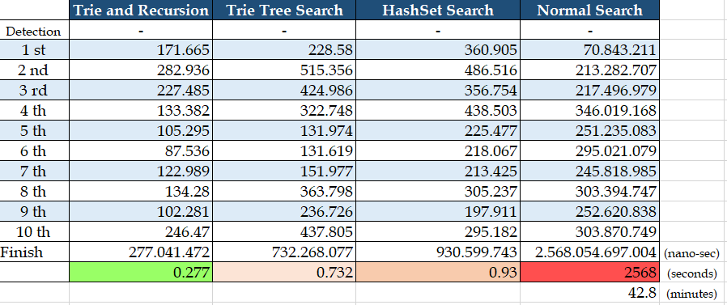

# System Implementation & Test

## Introduction

* 1. **Overview**

This section describes approach and methodologies used by our team to plan, organize and manage testing process of WCS.

It provides all necessary information about implementation and testing procedure of the system including test plans, test cases, test results and pass/fail criteria as well as testing flow to cover all possible cases.

* 1. **Test Approach**
* **Goal:** Test main features in the whole WCS based on core flow
* **Method:** Black-box testing

## Data Relationship Diagram

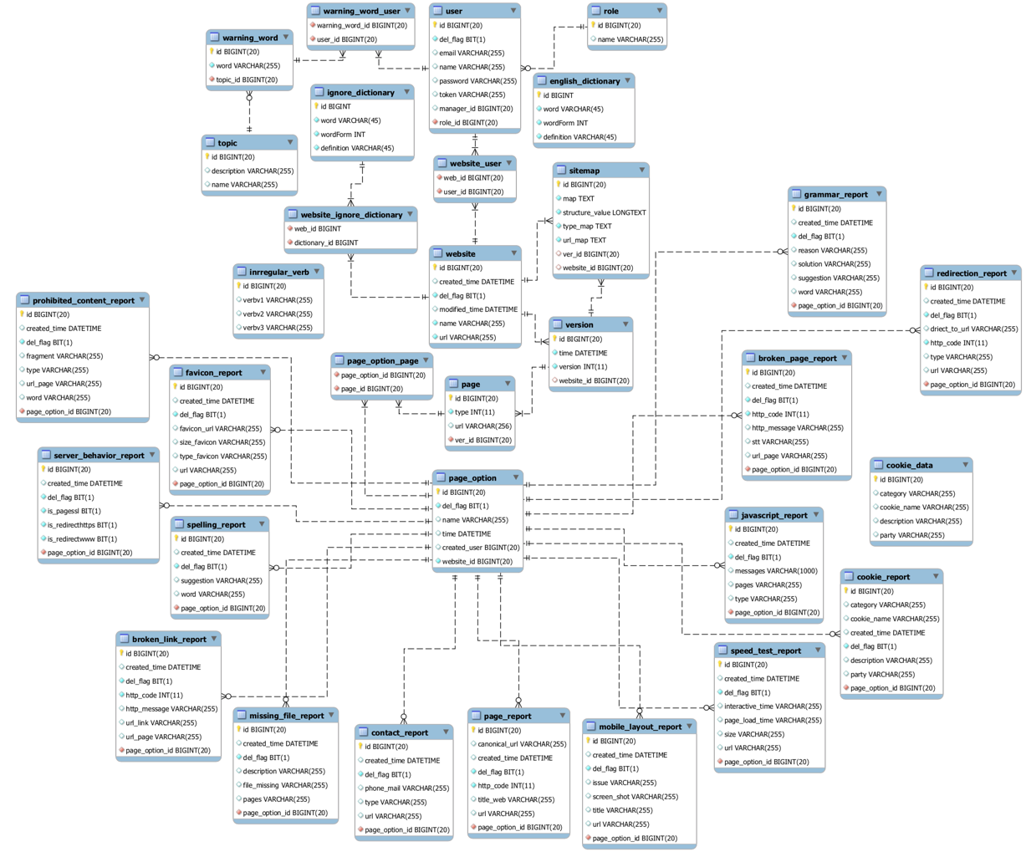

Figure 91 Physical Diagram

|  |  |  |
| --- | --- | --- |
| **Entity Data Dictionary: Describe content of all tables** | | |
| **No.** | **Table Name** | **Description** |
| 1 | user | Contain account information. |
| 2 | roles | Contain role information. |
| 3 | website | Contain website information. |
| 4 | website_user | Contain information about relationship between a user with a website. |
| 5 | sitemap | Contain sitemap information. |
| 6 | version | Contain version information. |
| 7 | page | Contain page information. |
| 8 | page_option | Contain page option information. |
| 9 | page_option_page | Contain information about relationship between a page with a page option |
| 10 | warning_word | Contain warning word information. |
| 11 | warning_word_user | Contain information about relationship between a user with a warning word. |
| 12 | topic | Contain topic information. |
| 13 | spelling_report | Contain spelling test report information. |
| 14 | speed_test_report | Contain speed test report information. |
| 15 | server_behavior_report | Contain server behavior report information. |
| 16 | cookie_report | Contain cookie report information. |
| 17 | broken_link_report | Contain broken link test report information. |
| 18 | missing_file_report | Contain missing file report information. |
| 19 | javascript_report | Contain javascript report information. |
| 20 | prohibited_content_report | Contain prohibited content report information. |
| 21 | mobile_layout_report | Contain mobile layout report information. |
| 22 | broken_page_report | Contain broken page report information. |
| 23 | page_report | Contain page report information. |
| 24 | redirection_report | Contain redirection report information. |
| 25 | favicon_report | Contain favicon report information. |
| 26 | grammar report | Contain grammar report information. |
| 27 | contact_report | Contain contact report information. |

Table 123 Physical Diagram Dictionary

## Test Plan

The overall purpose of testing is to ensure WCS meets its entire technical, functional and business requirement. The purpose of this document is to describe the test plan and strategy for testing the WCS. The following part will describe which features to be tested and which will not.

## Features To Be Tested

* Staff:
* Manage page option
* Spelling test
* Grammar test
* Broken links test
* Broken pages test
* Missing files test
* Prohibited content test
* Mobile layout test
* Speed test
* JavaScript errors test
* Favicons test
* Cookie law test
* Server behavior test
* Pages test
* Contact details test
* Redirections test

## Features Not To Be Tested

* Guest: Login, sign up.
* Manager:
* Manage Staff
* Manage Website
* Manager word list

## System Testing Test Case

***4.1 Staff Test Case  
 4.1.1 Manage page option***

|  |  |  |  |  |  |  |  |
| --- | --- | --- | --- | --- | --- | --- | --- |
| ID | Test Case Description | Test case procedure | Expected output | *Inter Dependence -test Case* | Result | Test Date | Note |
| *MPO_1* | Staff create a page option with blank name. | 1. Staff click “+” button.  2. Staff input blank.  3. Staff send create page option. | System shows error message “Please input something”. | N/A | Pass | 26/11/2018 |  |
| *MPO_2* | Staff delete a page option. | 1. Staff double click to page option name  2. Staff send delete page option. | Page option will be deleted. | N/A | Pass | 26/11/2018 |  |
| *MPO_3* | Staff select pages for page option. | 1. Staff click Toggle to select or unselect page for page option.  2. Staff send select pages for page option. | Page option include pages selected will be created. | N/A | Pass | 26/11/2018 |  |

Table 124 <Test case> Manage Page Option

***4.1.2 Broken links test***

|  |  |  |  |  |  |  |  |
| --- | --- | --- | --- | --- | --- | --- | --- |
| ID | Test Case Description | Test case procedure | Expected output | *Inter Dependence -test Case* | Result | Test Date | Note |
| *BLT_1* | Staff send broken links test command with page option unselected. | 1. Staff click “Check” button. | System return test result with information: “Page”, “Broken Link”, “Issue” of root page. | N/A | Pass | 26/11/2018 |  |
| *BLT_2* | Staff send broken links test command with page option selected. | 1. Staff select page option.  2. Staff click “Check” button. | System return test result with information: “Page”, “Broken Link”, “Issue” of all page in page option. | N/A | Pass | 26/11/2018 |  |

Table 125<Test case> Broken Links Test

***4.1.3 Broken pages test***

|  |  |  |  |  |  |  |  |
| --- | --- | --- | --- | --- | --- | --- | --- |
| ID | Test Case Description | Test case procedure | Expected output | *Inter Dependence -test Case* | Result | Test Date | Note |
| *BPT_1* | Staff send broken pages test command with page option unselected. | 1. Staff click “Check” button. | System return test result with information: “Page”, “Status”, “Issue” of root page. | N/A | Pass | 26/11/2018 |  |
| *BPT_2* | Staff send broken pages test command with page option selected. | 1. Staff select page option.  2. Staff click “Check” button. | System return test result with information: “Page”, “Status”, “Issue” of all page in page option. | N/A | Pass | 26/11/2018 |  |

Table 126 <Test case> Broken Pages Test

***4.1.4 Prohibited content test***

|  |  |  |  |  |  |  |  |
| --- | --- | --- | --- | --- | --- | --- | --- |
| ID | Test Case Description | Test case procedure | Expected output | *Inter Dependence -test Case* | Result | Test Date | Note |
| *PCT_1* | Staff send prohibited content test command with page option unselected. | 1. Staff click “Check” button. | System return test result with information: “Word”, “Type”, “Fragment” and “URL” of root page. | N/A | Pass | 26/11/2018 |  |
| *PCT_2* | Staff send prohibited content test command with page option selected. | 1. Staff select page option.  2. Staff click “Check” button. | System return test result with information: “Word”, “Type”, “Fragment”, “URL” of all page in page option. | N/A | Pass | 26/11/2018 |  |

Table 127 <Test case> Prohibited Content Test

***4.1.5 Mobile layout test***

|  |  |  |  |  |  |  |  |
| --- | --- | --- | --- | --- | --- | --- | --- |
| ID | Test Case Description | Test case procedure | Expected output | *Inter Dependence -test Case* | Result | Test Date | Note |
| *MLT_1* | Staff send mobile layout test command with page option unselected. | 1. Staff click “Check” button. | System return test result with information: “Screenshot”, “Page”, “Issue” of root page. | N/A | Pass | 26/11/2018 |  |
| *MLT_2* | Staff send mobile layout test command with page option selected. | 1. Staff select page option.  2. Staff click “Check” button. | System return test result with information: “Screenshot”, “Page”, “Issue” of all page in page option. | N/A | Pass | 26/11/2018 |  |

Table 128 <Test case> Mobile Layout Test

***4.1.6 Speed test***

|  |  |  |  |  |  |  |  |
| --- | --- | --- | --- | --- | --- | --- | --- |
| ID | Test Case Description | Test case procedure | Expected output | *Inter Dependence -test Case* | Result | Test Date | Note |
| *ST_1* | Staff send speed test command with page option unselected. | 1. Staff click “Check” button. | System return test result with information: “Page”, “Interactive time”, “Load time”, “Size” of root page. | N/A | Pass | 26/11/2018 |  |
| *ST_2* | Staff send speed test command with page option selected. | 1. Staff select page option.  2. Staff click “Check” button. | System return test result with information: “Page”, “Interactive time”, “Load time”, “Size” of all page in page option. | N/A | Pass | 26/11/2018 |  |

Table 129 <Test case> Speed Test

***4.1.7 JavaScript test***

|  |  |  |  |  |  |  |  |
| --- | --- | --- | --- | --- | --- | --- | --- |
| ID | Test Case Description | Test case procedure | Expected output | *Inter Dependence -test Case* | Result | Test Date | Note |
| *JST_1* | Staff send JavaScript test command with page option unselected. | 1. Staff click “Check” button. | System return test result with information: “Error message”, “Type”, “Page” of root page. | N/A | Pass | 26/11/2018 |  |
| *JST_2* | Staff send JavaScript test command with page option selected. | 1. Staff select page option.  2. Staff click “Check” button. | System return test result with information: “Error message”, “Type”, “Page” of all page in page option. | N/A | Pass | 26/11/2018 |  |

Table 130 <Test case> Javascript Errors Test

***4.1.8 Cookie law test***

|  |  |  |  |  |  |  |  |
| --- | --- | --- | --- | --- | --- | --- | --- |
| ID | Test Case Description | Test case procedure | Expected output | *Inter Dependence -test Case* | Result | Test Date | Note |
| *CLT_1* | Staff send cookie law test command with page option unselected. | 1. Staff click “Check” button. | System return test result with information: “Name”, “Category”, “Party” and “Description” of root page. | N/A | Pass | 26/11/2018 |  |
| *CLT_2* | Staff send cookie law test command with page option selected. | 1. Staff select page option.  2. Staff click “Check” button. | System return test result with information: “Name”, “Category”, “Party”, “Description” of all page in page option. | N/A | Pass | 26/11/2018 |  |

Table 131 <Test case> Cookie Law Test

***4.1.9 Server behavior test***

|  |  |  |  |  |  |  |  |
| --- | --- | --- | --- | --- | --- | --- | --- |
| ID | Test Case Description | Test case procedure | Expected output | *Inter Dependence -test Case* | Result | Test Date | Note |
| *SBT_1* | Staff send server behavior test command with page option unselected. | 1. Staff click “Check” button. | System return test result of root page. | N/A | Pass | 26/11/2018 |  |
| *SBT_2* | Staff send server behavior test command with page option selected. | 1. Staff select page option.  2. Staff click “Check” button. | System return test result of all page in page option. | N/A | Pass | 26/11/2018 |  |

Table 132 <Test case> Server Behavior Test

***4.1.10 Missing File test***

|  |  |  |  |  |  |  |  |
| --- | --- | --- | --- | --- | --- | --- | --- |
| ID | Test Case Description | Test case procedure | Expected output | *Inter Dependence -test Case* | Result | Test Date | Note |
| *MFT_1* | Staff send missing file test command with page option unselected. | 1. Staff click “Check” button. | System return test result with information: “Files”, “Description”, “Pages” and “Action” of root page. | N/A | Pass | 26/11/2018 |  |
| *MFT_2* | Staff send missing file test command with page option selected. | 1. Staff select page option.  2. Staff click “Check” button. | System return test result with information: “Files”, “Description”, “Pages” and “Action” of all page in page option. | N/A | Pass | 26/11/2018 |  |
| *MFT_3* | Staff send missing file test command with page option unselected and select specific type to test. | 1. Staff select type to test.  2. Staff click “Check” button. | System return test result with information: “Files”, “Description”, “Pages” and “Action” of root page and type selected. | N/A | Pass | 26/11/2018 |  |
| *MFT_3* | Staff send missing file test command with page option selected and select specific type to test. | 1. Staff select page option.  2. Staff select type to test.  3. Staff click “Check” button | System return test result with information: “Files”, “Description”, “Pages” and “Action” of all page in page option and type selected. | N/A | Pass | 26/11/2018 |  |

Table 133 <Test case> Missing File Test

***4.1.11 Favicons test***

|  |  |  |  |  |  |  |  |
| --- | --- | --- | --- | --- | --- | --- | --- |
| ID | Test Case Description | Test case procedure | Expected output | *Inter Dependence -test Case* | Result | Test Date | Note |
| *CLT_1* | Staff send favicons test command with page option unselected. | 1. Staff click “Check” button. | System return test result with information: “Favicon”, “URL”, “Width”, “Type” and “Pages” of root page. | N/A | Pass | 26/11/2018 |  |
| *CLT_2* | Staff send favicons test command with page option selected. | 1. Staff select page option.  2. Staff click “Check” button. | System return test result with information: “Favicon”, “URL”, “Width”, “Type” and “Pages” of all page in page option. | N/A | Pass | 26/11/2018 |  |

Table 134 <Test case> Favicon Test

***4.1.12 Contact Details test***

|  |  |  |  |  |  |  |  |
| --- | --- | --- | --- | --- | --- | --- | --- |
| ID | Test Case Description | Test case procedure | Expected output | *Inter Dependence -test Case* | Result | Test Date | Note |
| *CDT_1* | Staff send contact details test command with page option unselected. | 1. Staff click “Check” button. | System return test result with information: “Contact”, “Page affected” and “Action” of root page. | N/A | Pass | 26/11/2018 |  |
| *CDT_2* | Staff send contact details test command with page option selected. | 1. Staff select page option.  2. Staff click “Check” button. | System return test result with information: “Contact”, “Page affected” and “Action” of all page in page option. | N/A | Pass | 26/11/2018 |  |

Table 135 <Test case> Contact Details Test

***4.1.14 Redirection test***

|  |  |  |  |  |  |  |  |
| --- | --- | --- | --- | --- | --- | --- | --- |
| ID | Test Case Description | Test case procedure | Expected output | *Inter Dependence -test Case* | Result | Test Date | Note |
| *RET_1* | Staff send redirection test command with page option unselected. | 1. Staff click “Check” button. | System return test result with information: “Web Address”, “Directs to”, “Type” and “Code” of root page. | N/A | Pass | 26/11/2018 |  |
| *RET_2* | Staff send redirection test command with page option selected. | 1. Staff select page option.  2. Staff click “Check” button. | System return test result with information: “Web Address”, “Directs to”, “Type” and “Code” of all page in page option. | N/A | Pass | 26/11/2018 |  |

Table 136 <Test case> Redirection Test

***4.1.14 Pages test***

|  |  |  |  |  |  |  |  |
| --- | --- | --- | --- | --- | --- | --- | --- |
| ID | Test Case Description | Test case procedure | Expected output | *Inter Dependence -test Case* | Result | Test Date | Note |
| *CDT_1* | Staff send pages test command with page option unselected. | 1. Staff click “Check” button. | System return test result with information: “Title”, “Web Address”, “Canonical URL” and “HTTP” of root page. | N/A | Pass | 26/11/2018 |  |
| *CDT_2* | Staff send pages test command with page option selected. | 1. Staff select page option.  2. Staff click “Check” button. | System return test result with information: “Title”, “Web Address”, “Canonical URL” and “HTTP” of all page in page option. | N/A | Pass | 26/11/2018 |  |

Table 137 <Test case> Pages Test

***4.1.15 Spelling test***

|  |  |  |  |  |  |  |  |
| --- | --- | --- | --- | --- | --- | --- | --- |
| ID | Test Case Description | Test case procedure | Expected output | *Inter Dependence -test Case* | Result | Test Date | Note |
| *SPT_1* | Staff send spelling test command with page option unselected. | 1. Staff click “Check” button. | System return test result with information: “Word”, “Suggestions”, “Found in”, “Page” and “Action” of root page. | N/A |  |  |  |
| *SPT_2* | Staff send spelling test command with page option selected. | 1. Staff select page option.  2. Staff click “Check” button. | System return test result with information: “Word”, “Suggestions”, “Found in”, “Page” and “Action” of all page in page option. | N/A |  |  |  |

Table 138 <Test case> Spelling Test

***4.1.16 Grammar test***

|  |  |  |  |  |  |  |  |
| --- | --- | --- | --- | --- | --- | --- | --- |
| ID | Test Case Description | Test case procedure | Expected output | *Inter Dependence -test Case* | Result | Test Date | Note |
| *GRT_1* | Staff send grammar test command with page option unselected. | 1. Staff click “Check” button. | System return test result with information: “Excerpt”, “Issue”, and “Action” of root page. | N/A |  |  |  |
| *GRT_2* | Staff send grammar test command with page option selected. | 1. Staff select page option.  2. Staff click “Check” button. | System return test result with information: “Excerpt”, “Issue”, and “Action” of all page in page option. | N/A |  |  |  |

Table 139 <Test case> Grammar Test

# Software User’s Manual

1. **Installation Guide**
   1. **Setting up enviroment at server side**
      1. **Hardware requirements**

|  |  |  |
| --- | --- | --- |
| **Server** | **Minimum Requirements** | **Recommended** |
| **Internet Connection** | Cable, Wi-Fi (8 Mbps) | Cable, Wi-Fi (50 Mbps or more) |
| **Operating System** | XP, Vista, 7, 10, Window Server 2008 | 10, Window Server 2008 |
| **Computer Processor** | Intel® Xeon ® 1.4GHz | Intel® Xeon ® Quad Core (12M Cache, 2.50 GHz) |
| **Computer Memory** | 4GB RAM | 32GB or more |
| **Storage space** | 1GB | 5GB or more |

Table 140 - Hardware requirement for server

* + 1. **Software requirements**

|  |  |  |
| --- | --- | --- |
| **Name** | **Name/Version** | **Description** |
| **Environment** | Java EE 8.0,Node v10,npm v6 | Specification for developing web application |
| **Operating System** | Window 10 | Operating system and platform for development |
| **Modeling tool** | StarUML | Used to design diagram |
| **IDE** | IntelliJ IDEA 2018.1.5, Visual Studio Code 1.27.2 | Programming tools |
| **DBMS** | MySQL 8.0 | Used to create & manage the database for system |
| **Web server** | Apache Tomcat 8 | Deployment environment |
| **Web browser** | Chrome 69 or above. | Testing browser |

Table 141 - Software requirement for server

* 1. **Deployment at server side**

**1.2.1 Prepare deployement package**

**Step 1:** Download and Install Java 8

Link download: <http://www.oracle.com/technetwork/java/javase/downloads/java-archive-javase8-2177648.html>

**Step 2:** Download and setup Tomcat 8

Link download: <https://tomcat.apache.org/download-80.cgi>

**Step 3:** Download and Install Node v10

Link download: https://nodejs.org/en/download/

**Step 4:** Download and Install IntelliJ IDE

Link download: <https://www.jetbrains.com/idea/download/#section=windows>

**Step 5:** Download, Install and configure MySQL 8.0

Link download: <https://dev.mysql.com/downloads/installer/>

**1.2.2 Configure server before deploy**

Step 1: Go to %Tomcat folder%\conf\

Step 2: Edit port to 8080 in server.xml at

<Connector port="8080" protocol="HTTP/1.1"

connectionTimeout="20000"

redirectPort="8443" />

Step 3: Delete all files and folders in %Tomcat folder%\webapps

Step 4: Rename production java build to ROOT.WAR and copy to

%Tomcat folder%\webapps.

* 1. **Setting up enviroment at client side**

The client devices should have one of the following browsers to access the website:

* + - Google Chrome

Link download: <https://www.google.com/chrome/>

* + - Firefox

Link download: <https://www.mozilla.org/vi/firefox/channel/desktop/>

**2. User Guide**

**2.1 Manager**

**2.1.1 Add Staff**

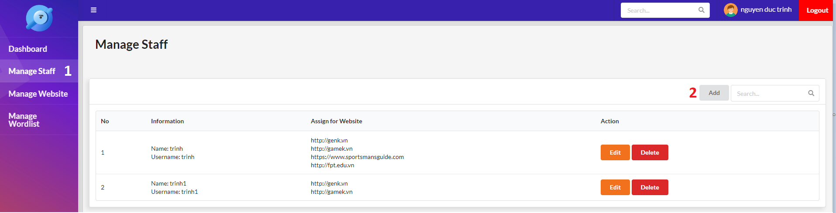

Figure 92 - Add Staff UI

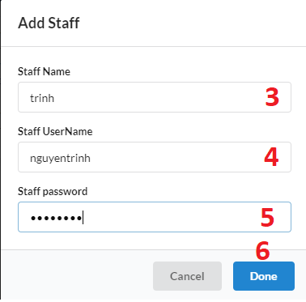

Figure 93 - Add Staff Popup

|  |  |
| --- | --- |
| **Step** | **Description** |
| Pre-condition | Login as Manager |
| 1 | Click “Manage Staff” in the navigation bar |
| 2 | Click “Add” button |
| 3 | Fill the field “Staff Name” |
| 4 | Fill the field “Staff Username” |
| 5 | Fill the field “Staff Password” |
| 6 | Click “Done” button |

Table 142 - Add Staff Steps

**2.1.2 Edit Staff**

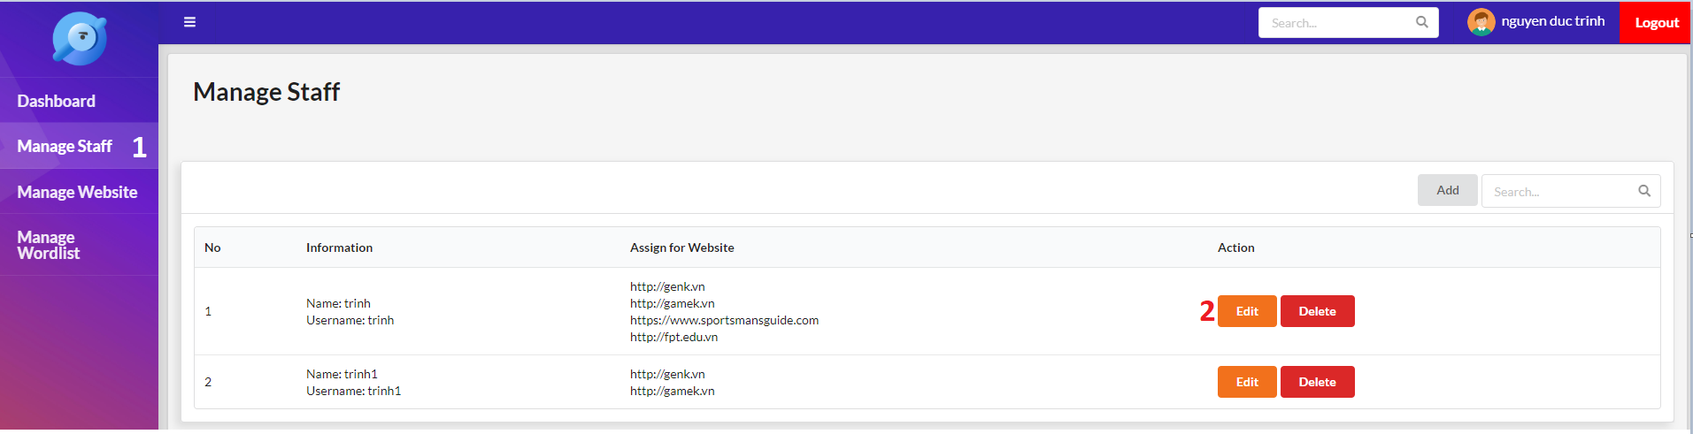

Figure 94 - Edit Staff UI

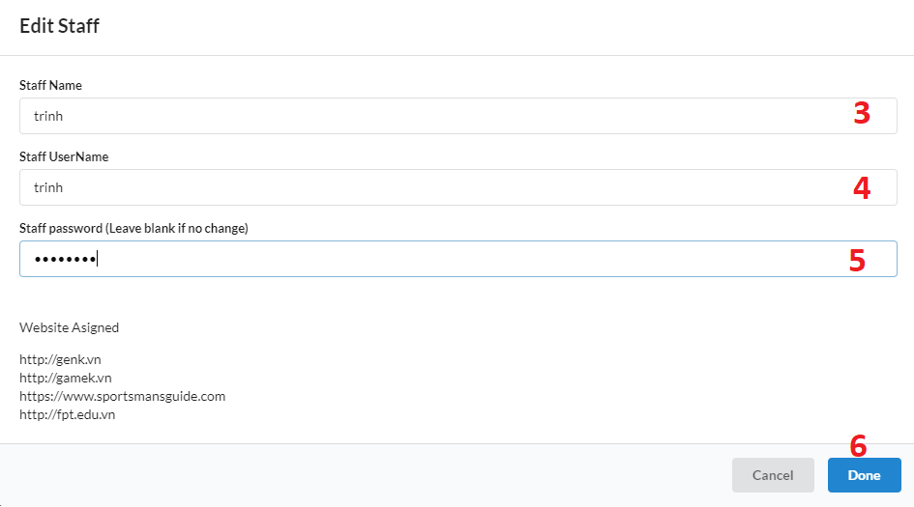

Figure 95 - Edit Staff Popup

|  |  |
| --- | --- |
| **Step** | **Description** |
| Pre-condition | Login as Manager |
| 1 | Click “Manage Staff” in the navigation bar |
| 2 | Click “Edit” button |
| 3 | Fill the field “Staff Name” |
| 4 | Fill the field “Staff Username” |
| 5 | Fill the field “Staff Password” |
| 6 | Click “Done” button |

Table 143 - Edit Staff Steps

**2.1.3 Delete Staff**

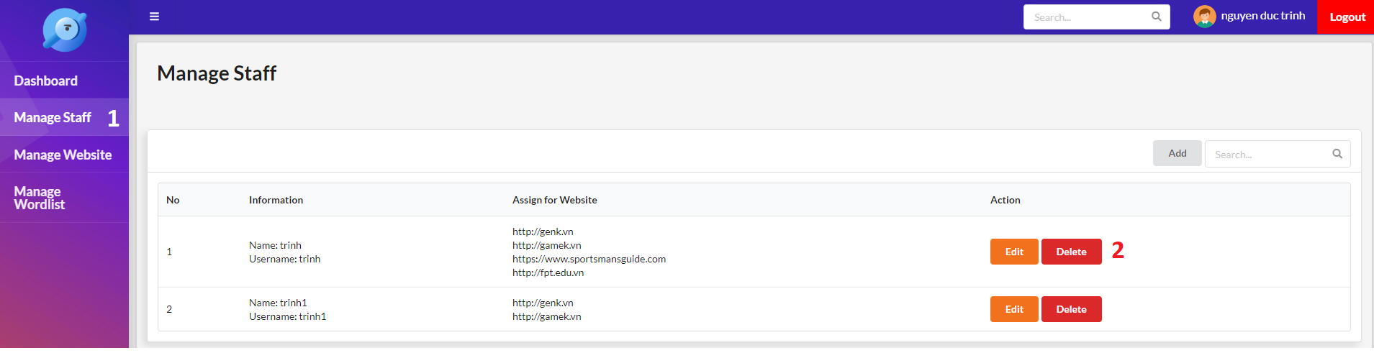

Figure 96 - Delete Staff UI

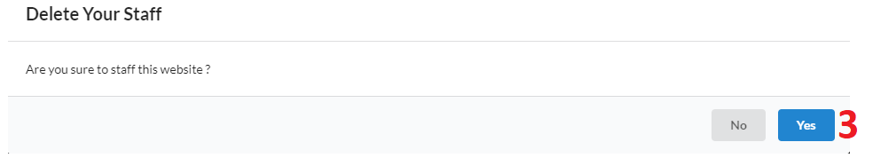

Figure 97 - Delete Staff Popup

|  |  |
| --- | --- |
| **Step** | **Description** |
| Pre-condition | Login as Manager |
| 1 | Click “Manage Staff” in the navigation bar |
| 2 | Click “Delete” button |
| 3 | Click “Yes” button |

Table 144 - Delete Staff Steps

**2.1.4 Make new version of the website**

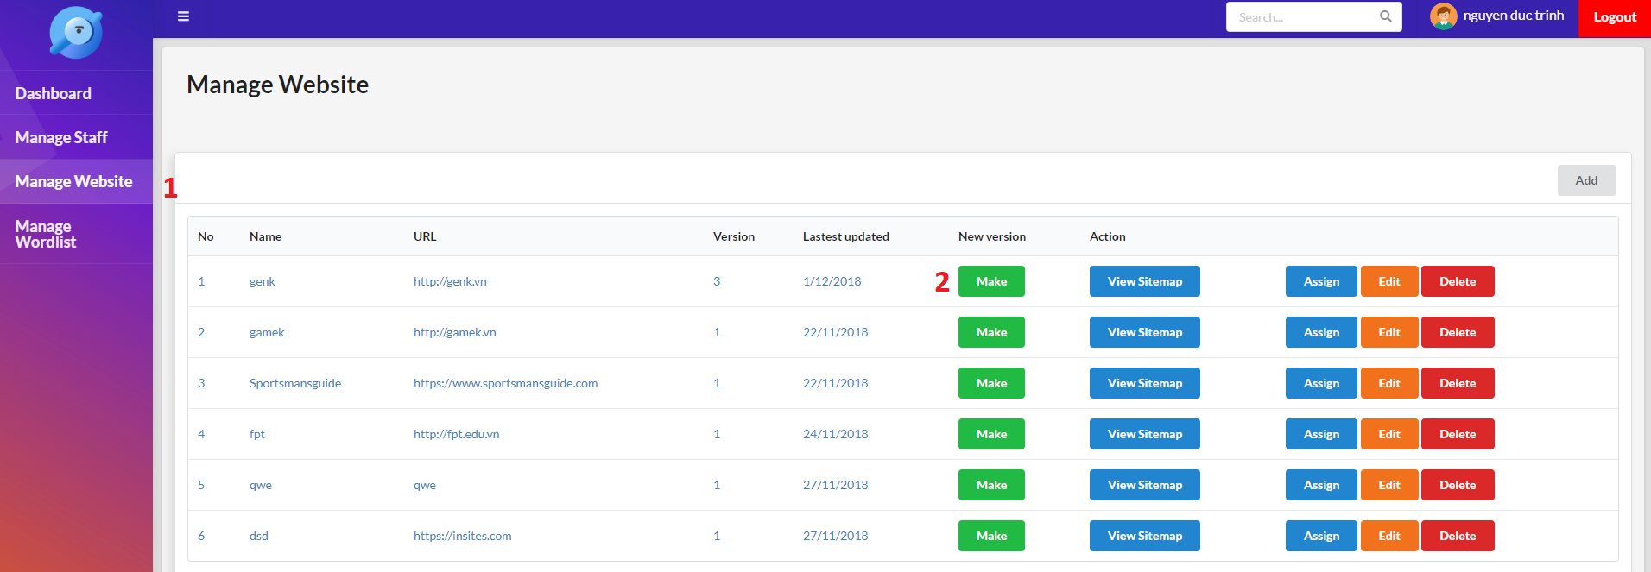

Figure 98 - Make new version UI

|  |  |
| --- | --- |
| **Step** | **Description** |
| Pre-condition | Login as Manager |
| 1 | Click “Manage Website” in the navigation bar |
| 2 | Click “Make” button |

Table 145 - Make new version Steps

**2.1.5 View Sitemap**

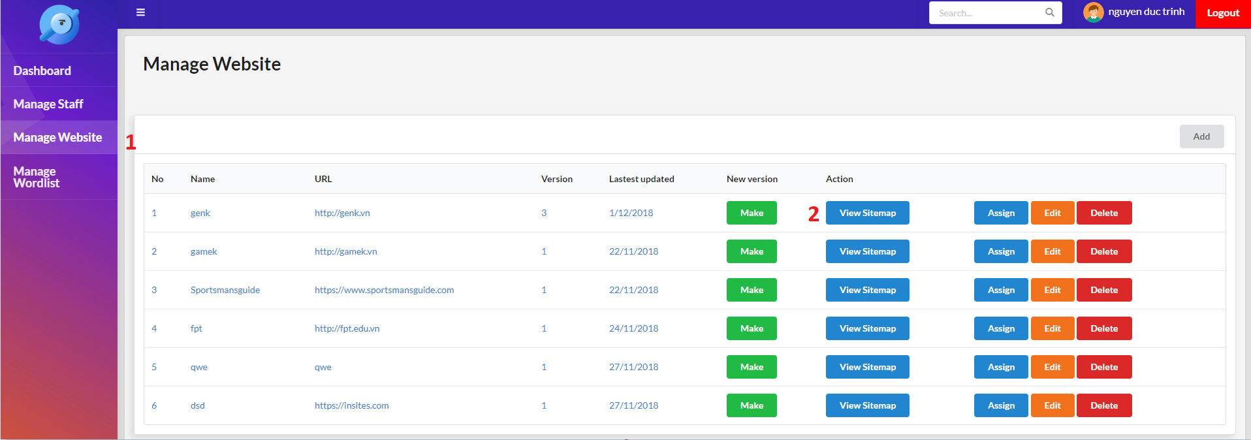

Figure 99 - View Sitemap UI

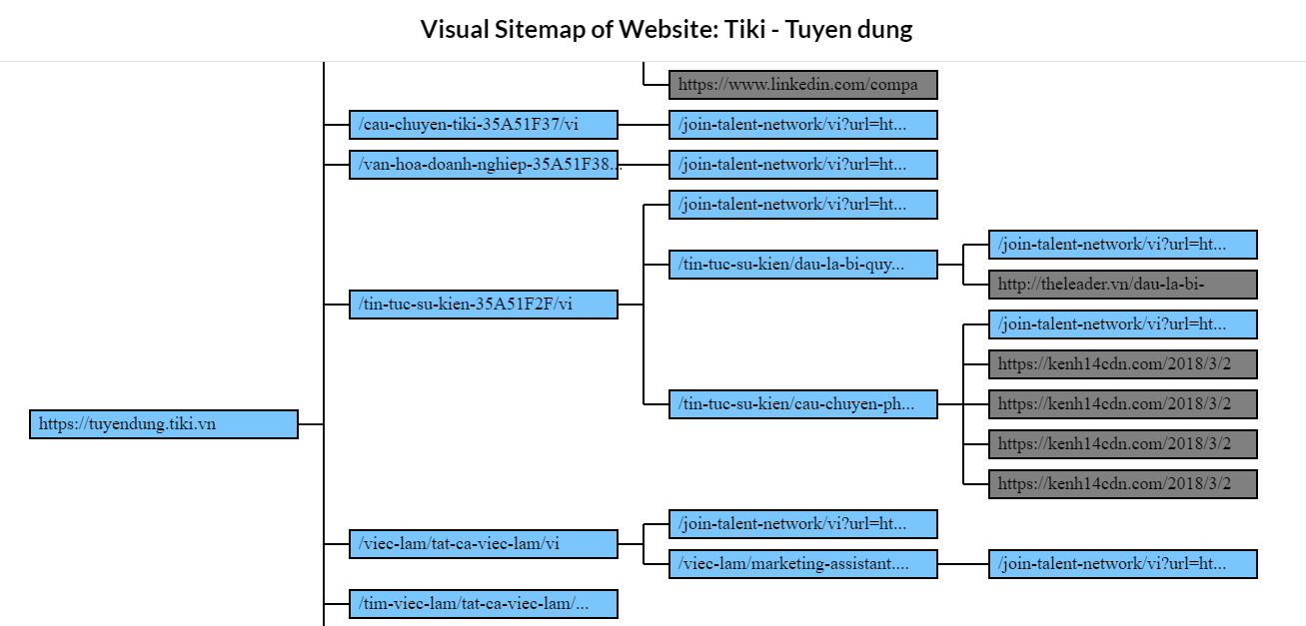

Figure 100 - Sitemap Screen

|  |  |
| --- | --- |
| **Step** | **Description** |
| Pre-condition | Login as Manager |
| 1 | Click “Manage Website” in the navigation bar |
| 2 | Click “View Sitemap” button |

Table 146 - View Sitemap Steps

**2.1.6 Assign website for Staff**

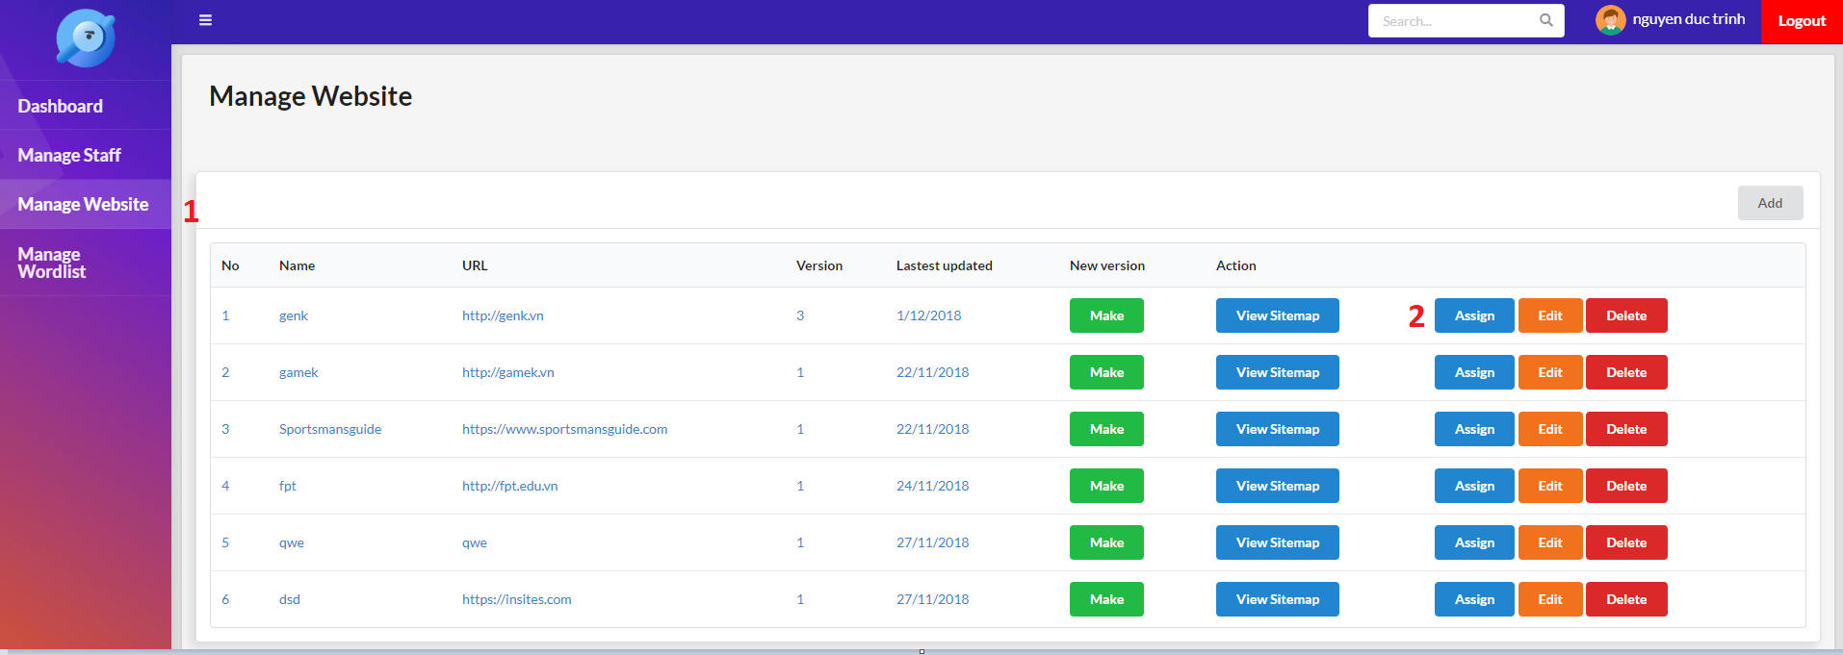

Figure 101 - Assign website UI

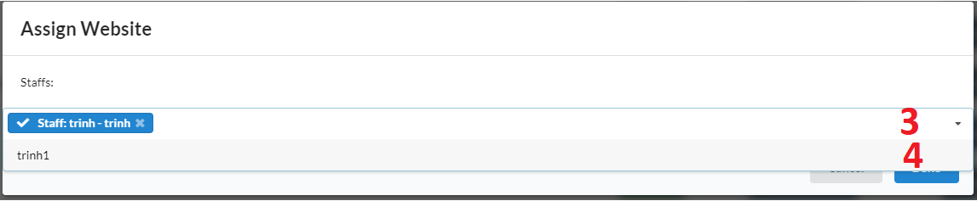

Figure 102 - Assign website popup

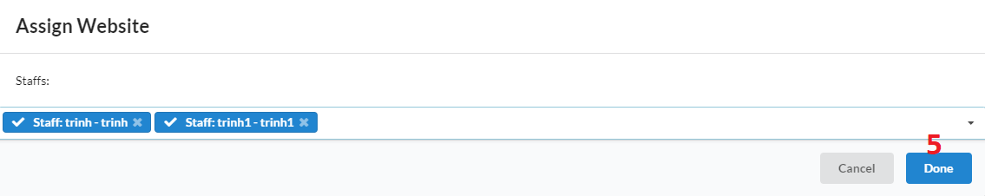

Figure 103 - Assign website popup

|  |  |
| --- | --- |
| **Step** | **Description** |
| Pre-condition | Login as Manager |
| 1 | Click “Manage Website” in the navigation bar |
| 2 | Click “Assign” button |
| 3 | Click “Staffs” dropdown |
| 4 | Select Staff |
| 5 | Click “Done” button |

Table 147 - Assign website steps

**2.1.7 Add warning word**

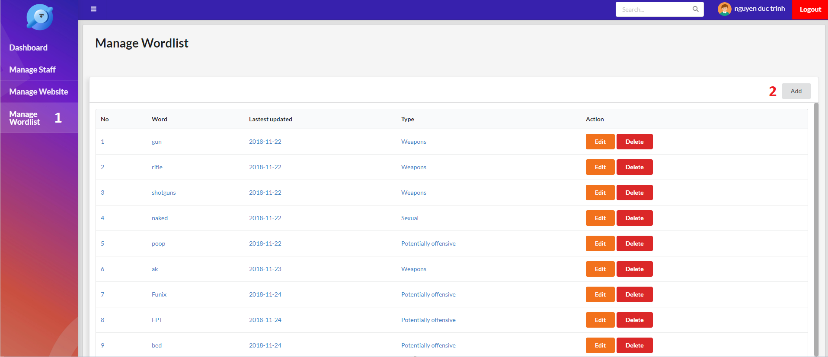

Figure 104 - Add warning word UI

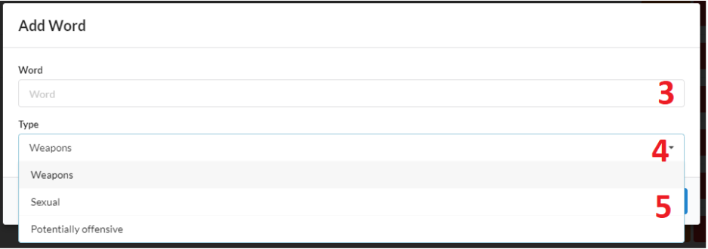

Figure 105 - Add warning word popup

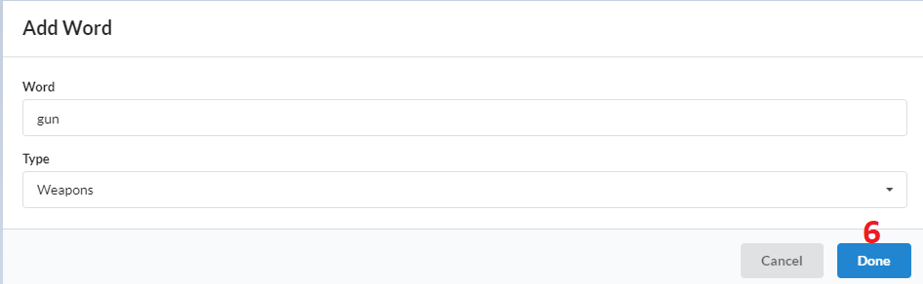

Figure 106 - Add warning word popup

|  |  |
| --- | --- |
| **Step** | **Description** |
| Pre-condition | Login as Manager |
| 1 | Click “Manage Wordlist” in the navigation bar |
| 2 | Click “Add” button |
| 3 | Fill the field “Word” |
| 4 | Click “Type” dropdown |
| 5 | Select Type |
| 6 | Click “Done” button |

Table 148 - Add warning word steps

**2.1.8 Edit warning word**

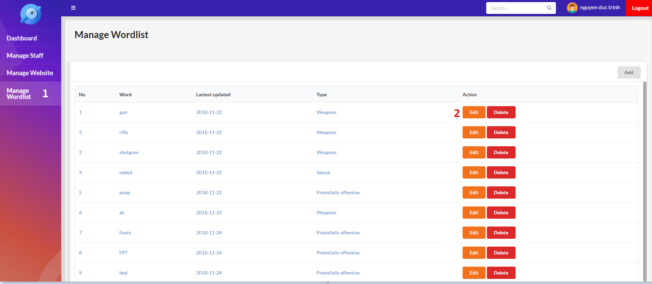

Figure 107 - Edit warning word UI

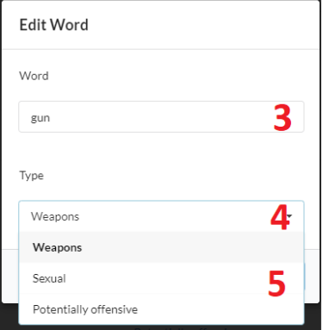

Figure 108 - Edit warning word popup

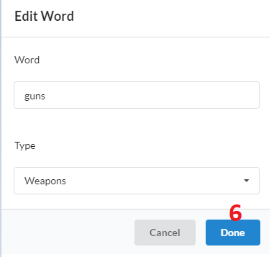

Figure 109 - Edit warning word popup

|  |  |
| --- | --- |
| **Step** | **Description** |
| Pre-condition | Login as Manager |
| 1 | Click “Manage Wordlist” in the navigation bar |
| 2 | Click “Edit” button |
| 3 | Fill the field “Word” |
| 4 | Click “Type” dropdown |
| 5 | Select Type |
| 6 | Click “Done” button |

Table 149 - Edit warning word steps

**2.2 Staff**

**2.2.1 Select website to test**

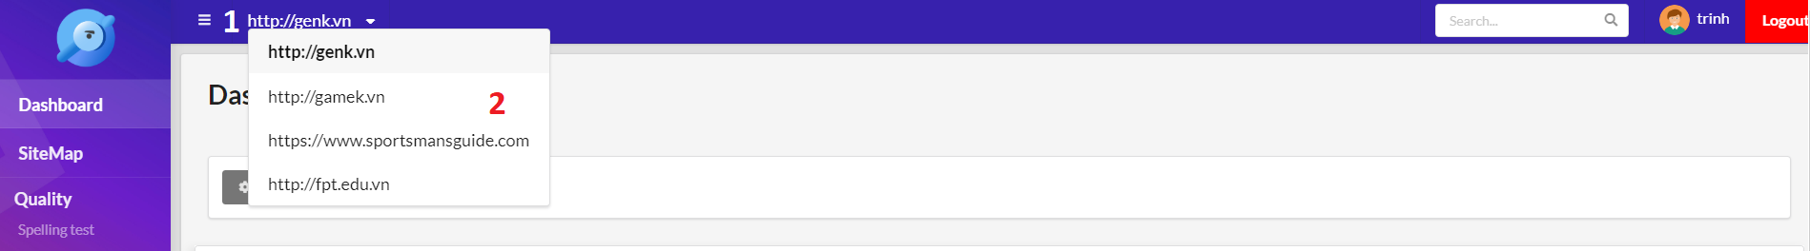

Figure 110 - Select website UI

|  |  |
| --- | --- |
| **Step** | **Description** |
| Pre-condition | Login as Staff |
| 1 | Click “Website” dropdown in the header |
| 2 | Select website |

Table 150 - Select website steps

**2.2.2 Add page option**

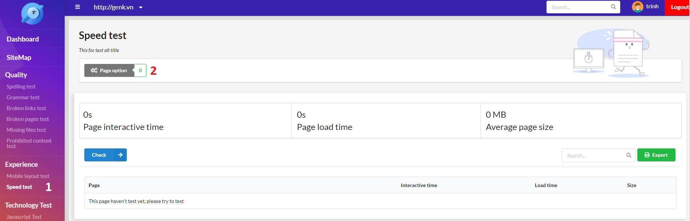

Figure 111 - Select page option UI

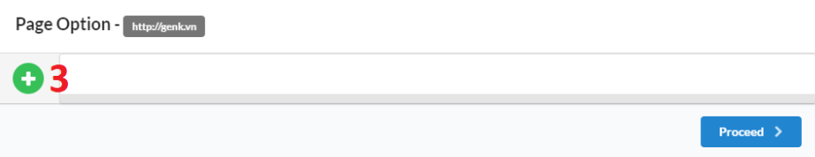

Figure 112 - Add page option popup

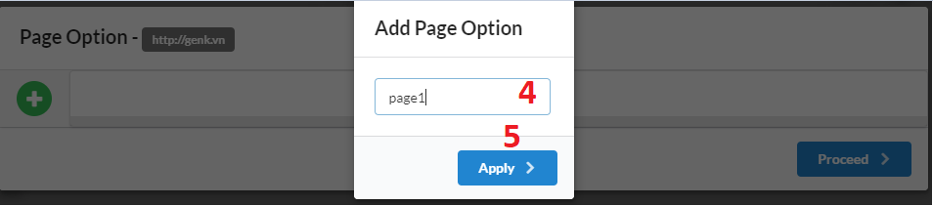

Figure 113 - Add page option popup

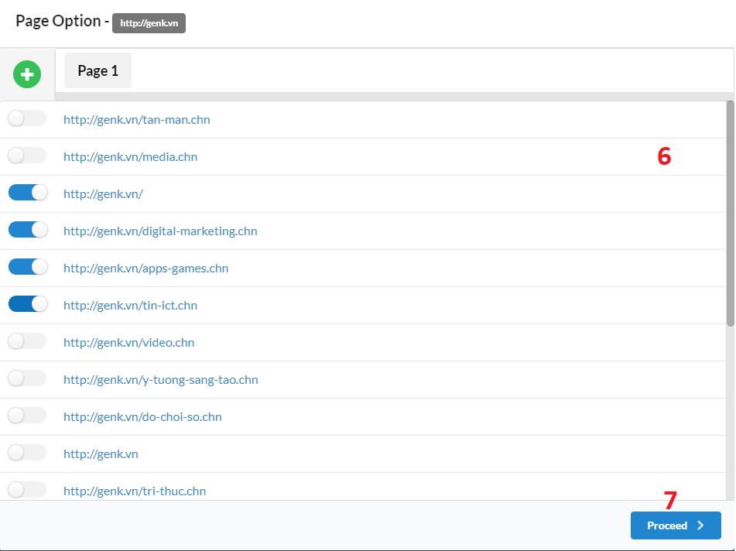

Figure 114 - Add page option popup

|  |  |
| --- | --- |
| **Step** | **Description** |
| Pre-condition | Login as Staff |
| 1 | Select any test function in the navigation bar |
| 2 | Click “Page Option” button |
| 3 | Click “Plus” button |
| 4 | Fill the field “Page option name” |
| 5 | Click “Apply” button |
| 6 | Select page for page option |
| 7 | Click “Proceed” button |

Table 151 - Add page option steps

**2.2.3 Rename or Delete page option**



Figure 115 - Select page option UI

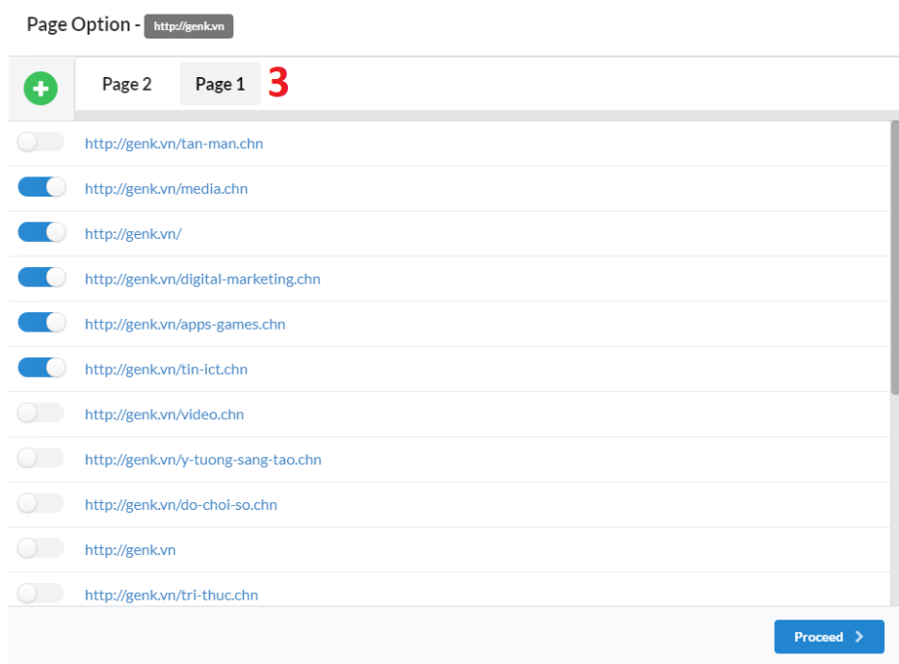

Figure 116 - Select page option popup

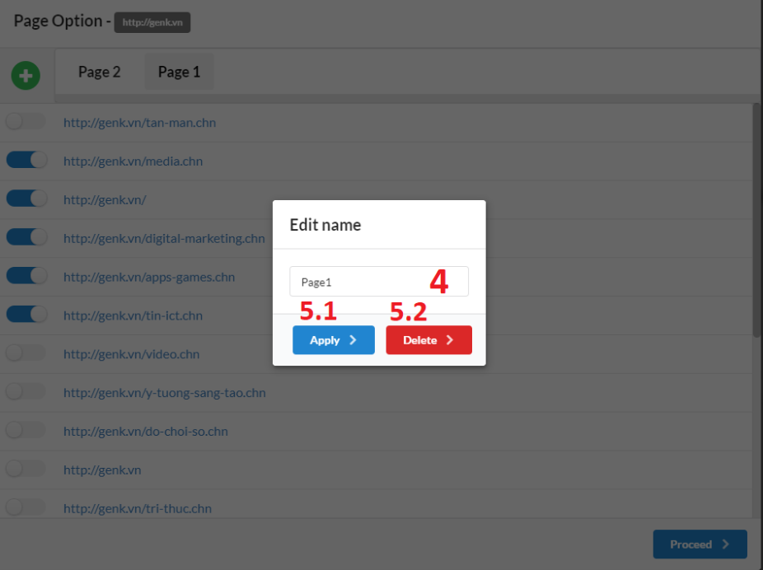

Figure 117 - Rename or Delete page option popup

|  |  |
| --- | --- |
| **Step** | **Description** |
| Pre-condition | Login as Staff |
| 1 | Select any test function in the navigation bar |
| 2 | Click “Page Option” button |
| 3 | Double click page option name |
| 4 | Fill the field “Page option name” |
| 5.1 | Click “Apply” button to rename page option |
| 5.2 | Click “Apply” button to delete page option |

Table 152 - Rename or Delete page option steps

**2.2.4 Do a test function**



Figure 118 - Select page option UI

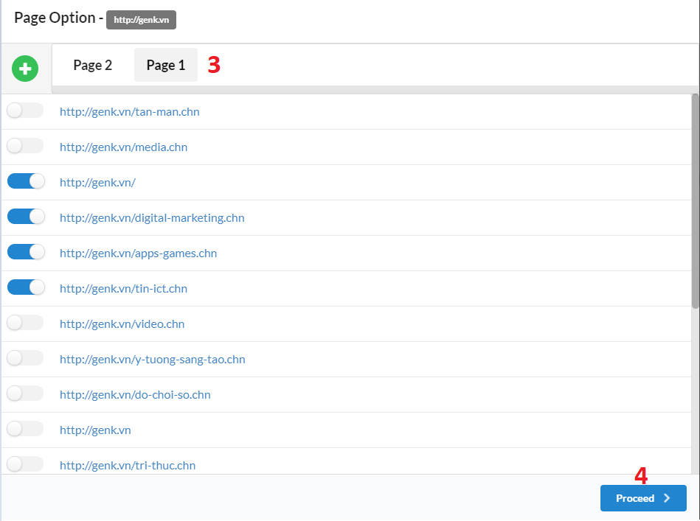

Figure 119 - Select page option popup

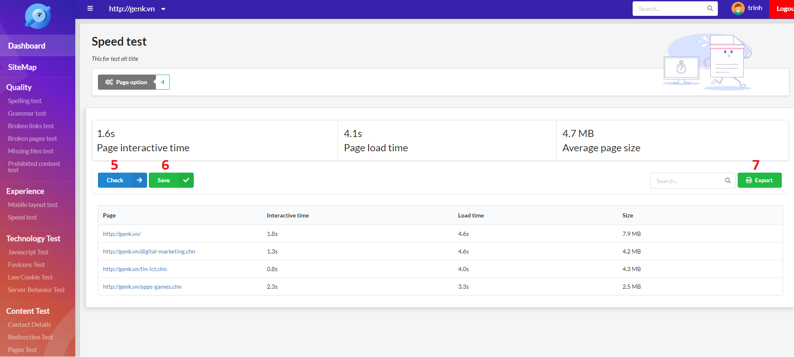

Figure 120 - Test function UI

|  |  |
| --- | --- |
| **Step** | **Description** |
| Pre-condition | Login as Staff |
| 1 | Select any test function in the navigation bar |
| 2 | Click “Page Option” button |
| 3 | Click to choose page option |
| 4 | Click “Proceed” button |
| 5 | Click “Test” button |
| 6 | Click “Save” button to save result |
| 7 | Click “Export” button to export result |

Table 153 - Do a test function steps

# Appendix

* + - 1. **Spring Framework** *[Online]* Available: [https:/spring.io/docs/reference](https://spring.io/docs/reference).
      2. **The Unified Certification** *[Online]* Available: <https://www.omg.org/ocup-2/index.htm>.
      3. **MySQL** *[Online]* Available: <https://dev.mysql.com/doc/>.
      4. **ReactJS** *[Online]* Available: <https://reactjs.org/docs/getting-started.html>
      5. **IntelliJ IDEA** *[Online]* Available: <https://www.jetbrains.com/idea/documentation/>
      6. **Visual Studio Code** *[Online]* Available: <https://code.visualstudio.com/docs>
      7. **Jsoup** *[Online]* Available: <https://jsoup.org/apidocs/overview-summary.html>
      8. **Selenium** *[Online]* Available: https://www.seleniumhq.org/docs/
      9. **Nodejs** *[Online]* Available: <https://nodejs.org/en/docs/>
      10. **HtppCode** *[Online]* Available: <https://www.w3.org/Protocols/rfc2616/rfc2616-sec10.html>
      11. **Regular Expression** *[Online]* Available: <https://docs.oracle.com/javase/7/docs/api/java/util/regex/Pattern.html>
      12. **Cookie Law** *[Online]* Available: <https://www.cookielaw.org/faq/>
      13. **DFS and BFS Algorithms using Stacks and Queues, Professor Lawrence L. Larmore** *[Online]* Available: <http://web.cs.unlv.edu/larmore/Courses/CSC477/bfsDfs.pdf>
      14. **The Breadth-First Search Algorithm, Khan Academy** *[Online]* Available: <https://www.khanacademy.org/computing/computer-science/algorithms/breadth-first-search/a/the-breadth-first-search-algorithm>
      15. **Data Structure — Breadth First Traversal, TutorialsPoint** *[Online]* Available: <https://www.tutorialspoint.com/data_structures_algorithms/breadth_first_traversal.htm>
      16. **Binary tree: Level Order Traversal, mycodeschool** *[Online]* Available: <https://www.youtube.com/watch?v=86g8jAQug04>
      17. **Breadth-First Traversal of a Tree, Computer Science Department of Boston University** *[Online]* Available: <https://www.cs.bu.edu/teaching/c/tree/breadth-first/>
      18. **Digit-based sorting and data structures, Professor Avrim Blum** *[Online]* Available: <https://www.cs.cmu.edu/~avrim/451f11/recitations/rec0921.pdf>
      19. **Lecture Notes on Tries, Professor Frank Pfenning** *[Online]* Available: <https://www.cs.cmu.edu/~fp/courses/15122-f10/lectures/18-tries.pdf>
      20. **Algorithms: Tries, Robert Sedgewick and Kevin Wayne** *[Online]* Available: <https://algs4.cs.princeton.edu/lectures/52Tries.pdf>
      21. **Tries, Brilliant Learning** *[Online]* Available: <https://brilliant.org/wiki/tries/>
      22. **Tries, Daniel Ellard** *[Online]* Available: <http://ellard.org/dan/www/libsq/cb_1998/c06.pdf>
      23. **Tries, Harvard CS50** *[Online]* Available: <https://www.youtube.com/watch?v=TRg9DQFu0kU>
      24. **Sitemap, Garenne Bigby** *[Online]* Available: https://dynomapper.com/blog/16-sitemap-generator/164-top-50-sitemap-generators-for-creating-sitemaps